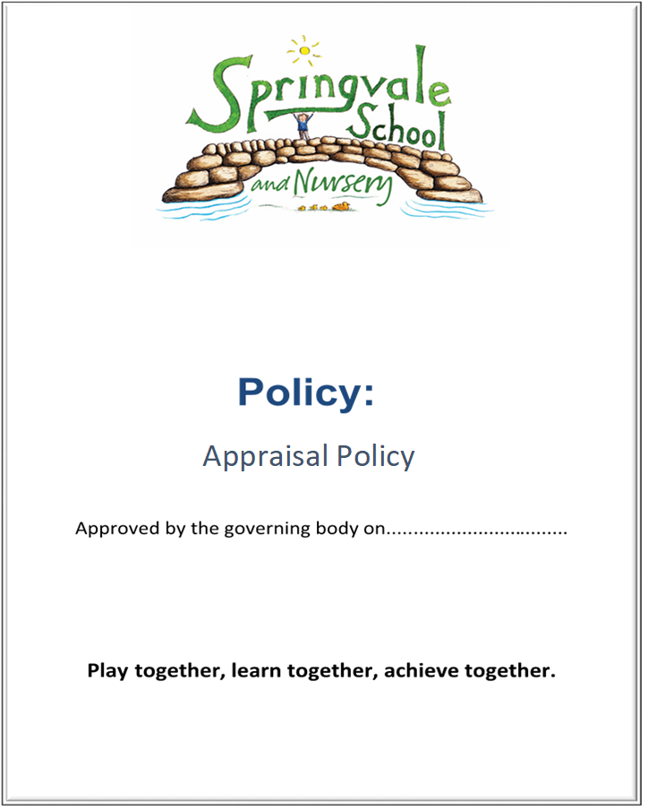

Contents
1. Introduction and School Aims
2. Policy
- Purpose
- Application of the Policy
3. Appraisal
- Appraisal Period
- Appointment of Appraisers
- Objective setting
- Reviewing performance
  - Observation
  - Development and Support
  - Feedback
  - Transition to Capability
- Assessment
4. General principles underlying the policy
Introduction
This policy was created after a period of consultation with relevant stakeholders within school. It has been formally adopted by governors and reflects our approach at Springvale Primary School.
Aims and Principles
The policy is underpinned by the central aims of the school and values held by the staff at the school:
Aims of the school
- Springvale is committed to promoting high standards of academic achievement for all learners in all subjects.
- As a school we will continue to develop and instil key life skills and values in our pupils.
- We will encourage positive relationships and communications between home, our community and the wider world.
In particular, Springvale School has an inclusive approach to our provision. Our aim is always to involve all our children and stakeholders in all areas of the curriculum and school life. In accordance with our Disability Equality Scheme we recognise that this may mean making special adaptations or arrangements from time to time for children with specific disabilities. We welcome the involvement of disabled adults in all areas of school life.
Appraisal
Revised appraisal arrangements came into force with effect from 1 September 2012. They are set out in the Education (School Teachers’ Appraisal) (England) Regulations 2012 (the Appraisal Regulations) which replace the Education (School Teacher Performance Management) (England) Regulations 2006 (the 2006 Regulations).

The Appraisal Regulations set out the principles that apply to teachers in all maintained schools and unattached teachers employed by a local authority, in each case where they are employed for one term or more. They retain the key elements of the 2006 Regulations but allow schools more freedom to design arrangements to suit their own individual circumstances. They provide the minimum national framework within which schools should operate and say nothing, or very little, on many subjects on which the 2006 Regulations made detailed provision. If they wish, schools may include in their own policies details that are no longer covered by the Appraisal Regulations.

Schools and local authorities must stay within the legal framework set out in the Appraisal Regulations and in other relevant legislation that affects all employers (for example legislation on equality, employment protection and data protection).

Schools and local authorities must have an Appraisal Policy for teachers and a policy, covering all staff, which deals with lack of capability. This model policy applies only to teachers, including headteachers, but schools might wish to adapt it for use with all staff. It has been written in the context of schools, but the same principles apply to unattached teachers. It is good practice for schools to consult staff on their appraisal and capability policies.

The Appraisal Process

This Appraisal Policy covers appraisal only and replaces the informal stage of the capability procedure which is dealt with in the related Capability Procedure for Teachers Policy. This policy should be used as a reference point by school and others as we review our policies to reflect the Appraisal Regulations. On 1 September 2012 it superseded the previous performance management model policy and guidance, which had been designed to support the 2006 Regulations.

In this policy:

Text in bold indicates statutory requirements contained in the Appraisal Regulations or the School Staffing Regulations.

Text in italics does not form part of the policy itself, but acts as additional advice for Springvale Primary School from the Local Authority.
Model policy for appraising teacher performance

The Governing Body of Springvale Primary School adopted this policy in November 2017
Purpose
This policy sets out the framework for a clear and consistent assessment of the overall performance of all staff and for supporting their development within the context of the school’s plan for improving educational provision and performance. This Policy will also set the standards expected of teachers. It also details the arrangements that will apply when teachers fall below the levels of competence that are expected of them.

Application of the policy

The policy, which covers appraisal, applies to the headteacher and to all teachers employed by the school or local authority, except those on contracts of less than one term and those undergoing induction (ie NQTs)

Appraisal

The Appraisal procedure at Springvale Primary School will be a supportive and developmental process designed to ensure that all teachers have the skills and support they need to carry out their role effectively. It will help to ensure that teachers are able to continue to improve their professional practice and to develop as teachers.

The appraisal period

The appraisal period will run for twelve months from:
October to October for school leaders and teaching staff (before 31st October)
February to February for support staff and non-teachi9ing staff (before 28th February)

Teachers who are employed on a fixed term contract of less than one year will have their performance managed in accordance with the principles underpinning this policy. The length of the period will be determined by the duration of their contract.

(There is flexibility to have a longer or shorter appraisal period when teachers begin or end employment with a school or local authority or when unattached teachers change post within the same authority).

Appointing appraisers

The headteacher will be appraised by the Governing Body, supported by a suitably skilled and/or experienced external adviser who has been appointed by the Governing Body for that purpose.

In this school the task of appraising the headteacher, including the setting of objectives, will be delegated to a sub-group consisting of two members of the Governing Body.

The headteacher will decide who will appraise other teachers. All appointed appraisers will have access to appropriate training and development in the role.

Setting objectives

The headteacher’s objectives will be set by the Governing Body after consultation with the external adviser.

A reasonable number of objectives for each teacher will be set before, or as soon as practicable after, the start of each appraisal period. The objectives set for each teacher, will be Specific, Measurable, Achievable, Realistic and Time-bound and will be appropriate to the teacher’s role and level of experience. The appraiser and teacher will seek to agree the objectives but, if that is not possible, the appraiser will determine the objectives. Objectives may be revised if circumstances change that are beyond the control of the teacher/appraiser.

The objectives set for each teacher will, if achieved, contribute to the school’s plans for improving the school’s educational provision and performance and improving the education of pupils at that school. This will be ensured by amongst other things quality assuring all objectives against the school improvement plan.

Before, or as soon as practicable after, the start of each appraisal period, each teacher will be informed of the standards against which that teacher’s performance in that appraisal period will be assessed. School will ensure that they have systems in place to allow all teachers to be assessed against the set of standards contained in the document called “Teachers’ Standards” published in September 2012 and against other sets of standards published by the Secretary of State that are relevant to them ie. Post Threshold/Leadership.

Reviewing performance

Observation

This school believes that observation of classroom practice and other responsibilities is important both as a way of assessing teachers’ performance in order to identify any particular strengths and areas for development they may have and of gaining useful information which can inform school improvement more generally. All observation will be carried out with the aim of celebrating and sharing good practice as well as to provide developmental, supportive next steps to improve provision further.

At Springvale Primary School, teachers’ performance will be regularly observed but the amount and type of classroom observation will depend on the individual circumstances of the teacher and the overall needs of the school. Classroom observation will be carried out only by those with QTS. In addition to formal observation, the headteacher/SLT member and/or subject leaders with responsibility for teaching standards will “drop in” in order to evaluate the standards of teaching and to check that high standards of professional performance are established and maintained. The length and frequency of “drop in” observations will vary depending on specific circumstances.

Teachers (including the headteacher) who have responsibilities outside the classroom should also expect to have their performance of those responsibilities observed and assessed.

Development and support

Appraisal is a supportive process which will be used to inform continuing professional development. The school wishes to encourage a culture in which all teachers take responsibility for improving their teaching through appropriate professional development. Professional development will be linked to school improvement priorities and to the ongoing needs and priorities of individual teachers.

Feedback

Teachers will receive constructive and confidential feedback on their performance throughout the year and as soon as practicable after observation/learning walks/work scrutiny has taken place or other evidence has come to light. Feedback will highlight particular areas of strength as well as any areas that need attention. Where there are concerns about any aspects of the teacher’s performance the appraiser will meet the teacher formally to:

- give clear feedback to the teacher about the nature and seriousness of the concerns;
- give the teacher the opportunity to comment and discuss the concerns;
- agree any support (eg coaching, mentoring, structured observations), that will be provided to help address those specific concerns;
- make clear how, and by when, the appraiser will review progress (it may be appropriate to revise objectives, and it will be necessary to allow sufficient time for improvement. The amount of time will be agreed in accordance with the seriousness of the concerns);
- explain the implications and process if no – or insufficient – improvement is made.

When progress is reviewed, if the appraiser is satisfied that the teacher has made, or is making, sufficient improvement and continuing to meet the relevant standards, the appraisal process will continue as normal, with any remaining issues continuing to be addressed though that process.

If school leaders are concerned about a lack of progress against expectations/current appraisal targets, they will meet with the teacher to create an action plan to set interim developmental targets and plan a course of CPD that will address the concerns. Teachers are expected to work in partnership with school leaders to address any area of concern as soon as possible.

Transition to capability
If the appraiser is not satisfied with progress, the teacher will be notified in writing that the appraisal system will no longer apply and that their performance will be managed under the Capability Procedure, and will be invited to a formal capability meeting. The Capability Procedures will be conducted as detailed in the associated Capability Procedure for Teachers.

Annual assessment

Each teacher's performance will be formally assessed in respect of each appraisal period. In assessing the performance of the Headteacher, the Governing Body must consult the external adviser.
This assessment is the end point to the annual appraisal process, but performance and development priorities will be reviewed and addressed on a regular basis throughout the year in interim meetings which will take place as part of an ongoing professional dialogue. All staff will also hold an informal mid-term review (February for leaders/teachers and July for support staff) to re-engage with the targets and log any progress so far.

The teacher will receive a written appraisal report as soon as practicable following the end of each appraisal period. The teacher will have an opportunity to comment on the report in writing. At Springvale Primary School, teachers will receive their written appraisal reports by 31 October or as soon as practicable on their return to work following any periods of absence.

The appraisal report will include:

- details of the teacher’s objectives for the appraisal period in question
- an assessment of the teacher’s performance of their role and responsibilities against their objectives and the relevant standards
- an assessment of the teacher’s training and development needs and identification of any action that should be taken to address them
- a recommendation on pay where that is relevant ie. progression from UPS 1 through to UPS 2. (NB – pay recommendations need to be made by 31 October for other leaders/teachers)

The assessment of performance and of training and development needs will inform the planning process for the following appraisal period, as well as the overarching School Development Plan.

General Principles Underlying This policy
Confidentiality
The appraisal and capability processes will be treated with confidentiality. However, the desire for confidentiality does not override the need for the headteacher and governing body to quality-assure the operation and effectiveness of the appraisal system. Where the headteacher has delegated the responsibility for appraisal to another member of staff, the headteacher will check the consistency of approach and expectation between different appraisers. The headteacher will also be made aware of any pay recommendations that have been made.

Consistency of Treatment and Fairness
The Governing Body is committed to ensuring consistency of treatment and fairness and will abide by all relevant equality legislation.

Delegation
Normal rules apply in respect of the delegation of functions by governing bodies, headteachers and local authorities.

Monitoring and Evaluation
The governing body and headteacher will monitor the operation and effectiveness of the school’s appraisal arrangements.

Retention
The governing body and headteacher will ensure that all written appraisal records are retained in a secure place for six years and then destroyed.

Appeals
Teachers and headteachers may choose to exercise an individual right of appeal against the implementation/operation of the schools Appraisal Policy and this would be via the schools standard Grievance Procedure.

You can download this booklet online at: http://publications.education.gov.uk/
Search using the ref: DfE v1.0 13/01/2012
© Crown copyright 2012

You may re-use this information (excluding logos) free of charge in any format or medium, under the terms of the Open Government Licence. To view this licence, visit http://www.nationalarchives.gov.uk/doc/open-government-licence/ or e-mail: psi@nationalarchives.gsi.gov.uk.

Where we have identified any third party copyright information you will need to obtain permission from the copyright holders concerned.

