Springvale Primary School
Steps to Success

Cross the bridge by following our 7 steps to success that make a great learner!

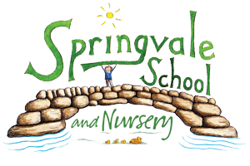

- Aim high and aspire to be the best
- Always show respect to people, the environment and property
- Think creatively and try new things
- Be resilient and determined- take on new challenges
- Be honest, be kind, care for others and always show good manners
- Believe in yourself and enjoy your learning
- Try hard when working independently and work well as part of a team

