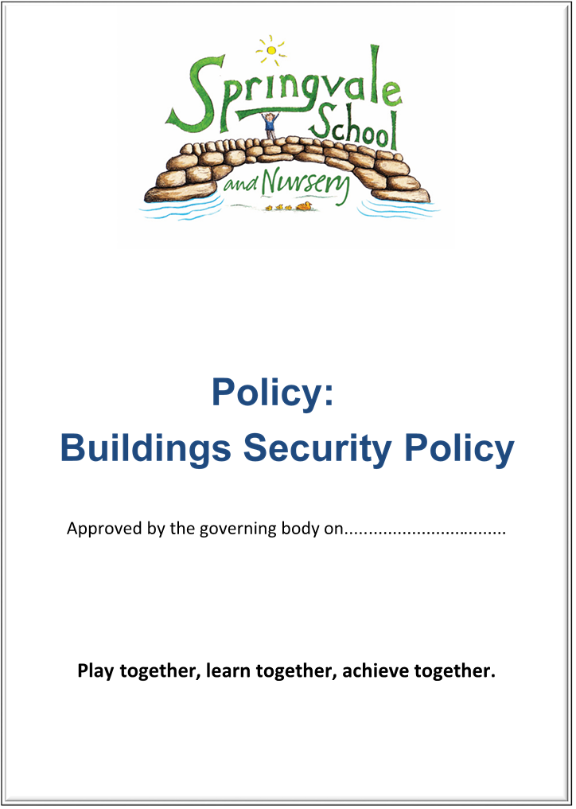
Behaviour

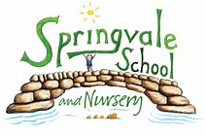BEHAVIOUR POLICY

- Introduction
This policy was created after a period of consultation with relevant stakeholders within school. It has been formally adopted by governors and reflects our approach at Springvale Primary School.
- Aims and Principles
The policy is underpinned by the central aims of the school and values held by the staff at the school:
- Aims of the school
- Springvale is committed to promoting high standards of academic achievement for all learners in all subjects.
- As a school we will continue to develop and instil key life skills and values in our pupils.
- We will encourage positive relationships and communications between home, our community and the wider world.
In particular, Springvale School has an inclusive approach to our provision. Our aim is always to involve all our children and stakeholders in all areas of the curriculum and school life. In accordance with our Disability Equality Scheme we recognise that this may mean making special adaptations or arrangements from time to time for children with specific disabilities. We welcome the involvement of disabled adults in all areas of school life.

Ethos and Rationale

Behaviour and attitudes to learning at our school are good. The children work hard and make us proud every day. It is important however that we continue to maintain the current high standards and that we have clear guidelines in place for any occasions where these high standards are not adhered to. This policy has been developed through consultation to ensure that we have outstanding behaviour and attitudes to learning.

A child’s education is a partnership between school and family. Our home/school agreement (see Appendix A) ensures that work together to make Springvale a safe and nurturing environment where all children can play together, learn together and achieve together. When a child’s education is effective and successful it is because the school and family have supported each other and worked towards a common goal. As we now have parental choice and opportunities for pupils to move freely between schools we believe that children should not choose to come to Springvale for geographical reasons alone. We want our families to be proud of our school and we insist that the parents that choose us must do so because they trust that we will work with them to produce children who can play, learn and achieve together appropriately and successfully. This policy will be agreed by all stakeholders to ensure that we have a significant degree of consistent and effective behaviour management in our school.

We strive to promote a happy, thriving school community which is calm, purposeful and caring, based on mutual respect. We want children to leave our school as well-rounded citizens with a respect for themselves, their peers, their family, property and members of the public who share their community. We aim to show children that we can improve our lives through sharing strengths, helping others, caring about each other and having fun. Our overall ethos of ‘play together, learn together, achieve together’ will support pupils to improve their behaviour and consider the feelings and safety of others.

Promoting outstanding ‘behaviours for learning’ is the key to successful progress and attainment. Teaching time should and must not be lost to inappropriate behaviour no matter how insignificant. If children are engaged in their learning and want to improve then behaviour will always be outstanding. We encourage children to learn collaboratively wherever possible to ensure that children are confident enough to communicate and solve problems with a wide range of staff and class mates.

E. ‘Steps to Success’ (on display around school and in classrooms)

Children must live out our steps to success at all times in and out of school:
1. Aim high and aspire to be the best
2. Always show respect to people, the environment and property
3. Think creatively and try new things
4. Be resilient and determined- take on new challenges
5. Be honest, be kind, care for others and always show good manners
6. Believe in yourself and enjoy your learning
7. Try hard when working independently and work well as part of a team

F. Rewarding Consistently Good Behaviour

We encourage children to strive to ‘be the best that they can be’ to earn house points (team rewards) and merit points (individual rewards). The behaviour system was introduced at a presentation evening for parents (4.10.17) and was developed through consultation with parents, pupils and staff/Governors over the following month. Children are rewarded for excellence and consistency in their high standards in many facets of school life including attendance, appearance, attitude and empathy for others. We also believe that children respond best to positive reinforcement and modelled good behaviour. We will always use good examples and talk about what a child should do rather than focus on any negatives of what did or might have happened.

Children who follow our steps to success may receive:
- Praise/stamps/stickers
- Special Mentions or Star Awards
- Exposure to parents and the wider community through our Twitter feed (@SpringvalePS)
- Team points or trophies
- Special visits or events
- Invites to after school clubs or opportunities to represent their school
- A ‘GOOD to be GREEN’ text message home and entry to a weekly prize draw

At lunchtimes we ask that our catering and SMSA team promote good manners by praising the use of ‘please’ and ‘thank you’. Children who impress our SMSA team with their lunchtime behaviour and/or table manners will be invited to a weekly reward by dining at a special ‘Captain’s Table’ where they receive a special dining experience with a member of the Senior Leadership Team. Children will receive an invite on a Thursday to dine the following day so that parents are aware of the reward.

G. Unacceptable/Inappropriate Behaviour

THERE IS NO PLACE FOR RACISM, VIOLENCE, BULLYING OF ANY KIND e.g. PHYSICAL, VERBAL, CYBER BULLYING, VANDALISM, RUDENESS OR BAD LANGUAGE WITHIN OUR SCHOOL AND THESE WILL ALWAYS BE DISCOURAGED, ADDRESSED AND ERADICATED.

Racism will never be tolerated. The school has an anti-racism policy and a racism log and senior leaders must report any incident that is racially motivated. These incidents are communicated with parents and followed-up immediately.

Bullying is perceived to be taking place when a child is repeatedly targeted in a manner that makes them uncomfortable, unhappy or feel unsafe. We are careful not to use the word bullying for isolated incidents of unacceptable behaviour spread over longer periods of time. If you suspect that your child is being bullied, and have significant reason to believe that this is the case, then you should contact your child’s class teacher for an appointment at the earliest opportunity.

Physical behaviours like hitting, kicking or biting are not accepted in school. Children can be incredibly boisterous and many see ‘fighting’ as an activity of play. This cannot be accepted and we urge parents to ensure that all pupils follow our simple guide statement, ‘keep your hands and feet to yourself.’ Pushing, shoving, hitting, kicking and biting will all be punished instantly. Where there is an incident when a child has been physically harmed, and we are aware of this, we will make every effort to contact both parents as soon as possible.

Accidents can happen. On occasions children can get mixed up about what has happened during the day. Parents sometimes become frustrated about an incident that seems to have happened in school and can become upset. Please contact school if you feel that your child has been hurt or involved in an incident so that we can get to the bottom of it together. From experience, 90% of all incidents where parents are upset are usually due to a breakdown in communication between school, the child and home rather than the seriousness of an incident.

Cyberbullying is becoming an increasing issue in society. Our older children occasionally fall out about the content of Facebook pages and text messages, for example. The school supports the legal view that Primary aged children should not access these communication tools until they are responsible young adults but, where parents insist, we are keen to educate our pupils about the dangers of Cyber-bullying so that they can be safe and happy. Please record any details if you or your child is being bullied through modern technologies or social media. On some occasions we cannot act (as the content is likely to be from out of school hours) but we can advise you about what to do next. On some occasions the school may contact the police about Cyber bullying. Please refer to our e-safety policy for full details about Cyberbullying.

At Springvale we always take pride in the manners and respect that our children display. We will continue to take pride in table manners, politeness and general attitudes to staff, children and adults. Simple reinforcement and praise are the way to promote effective attitudes. We encourage children to welcome visitors, to hold doors open for each other and staff and to always show manners when collecting resources or, perhaps, their school meal from the catering team.

Foul and inappropriate language is not welcome in our school. We have pupils as young as 3 on site and we need to respect the sanctity of youth and keep such language out of our school. When such an incident is reported we will always explore it being speaking to the child and any witnesses.

H. Consequences for unacceptable behaviour

On average, over 240 children attend our school every day. It is quite natural that some children will fall out with each other and there are occasions when injuries or incidents occur by accident. Unfortunately we do have a small number of isolated incidents where children’s unacceptable behaviour leads to injury/upset for other pupils. Our steps to success and expectations are quite simple and repeated/referred to on a daily basis- we expect the steps to be lived out each day by every child.

Children who follow the steps all week will remain GOOD to be GREEN! This means that they will be rewarded and they will receive the wide range of privileges on offer in the school such as merit/house points, privileges and prizes.

If a child presents:
*Disruptive behaviour *Lack of effort *Low level behaviour *Name calling or not sharing at playtimes
then they will have their name placed on AMBER. This means that they have received an instant warning that their behaviour is not acceptable and we expect that it will improve rapidly. Children can be moved back to green as soon as they rectify their behaviour and show that they are now following the steps!

If a child:
*Fails to improve after an amber warning *Any proven physical behaviour- hitting, kicking, biting
*Proven inappropriate language
then they will have their name placed on RED. This means that they will receive notification of the strike they are on.

Strike one means missing 30 minutes of lunchtime and writing a letter of apology to the appropriate person/people.
Strike two means that the child will miss a privilege to be decided by the teacher/SLT. This could be a club, a disco, a dress down day, a party, a reward visit (not a curriculum visit), a competitive sporting fixture, etc.
Strike three means that all privileges listed above will be removed for the next half-term. A clean slate will then be applied and the strike system will start again.

When a red light is applied, the SLT will be informed on the same day and a log will be kept by the Headteacher. Behaviour summaries will be shared with parents (when necessary or requested) and with the Governing Body and staff team once per term.

This policy will apply to all children from F2 to Y6. Nursery children will have their own instant rewards and consequences in place. See Nursery transition pack for parents.

We will make reasonable adjustments for our youngest pupils so that the punishment will normally take place on the same day where possible so that the instant nature of the punishment has greater meaning.

As we have aspirations for all of our pupils, where children have a diagnosis of a special or medical need that may contribute to their behaviour; we still believe that pupils need to learn right from wrong and on all occasions an appropriate consequence will need to be allocated. We will work with medical professionals and parents to ascertain suitable punishments to meet the needs of the children and families. Physical behaviour will always be taken seriously, communicated with parents and a significant consequence applied accordingly. Children with significant social and emotional needs may have adapted systems (still based on rewards and consequence) that are more instant and based on shorter periods of learning time.

I. Communication with families

If a child has been on GREEN all week, we will text parents to celebrate their achievement. The child will also receive an extra merit point for their tally! We may also invite families (via text message) to assembly to celebrate special achievements.

If a child has been on AMBER then we will may either speak briefly with the parent or send home a short note in your child’s book bag before the end of the week. The note will use the same wording/format as the home school agreement to clarify the behaviour that has been identified.

If a child has been on RED then we will either contact the parent immediately, verbally on collection of your child or we may send home a red letter in your child’s book bag (with a slip for parents to acknowledge the letter). The note will use the same wording/format as the home school agreement to clarify the behaviour that has been identified. The note will also confirm the stage of the consequence that the child has reached and which date the child will miss breaks on or which privilege(s) will be missed as a consequence. If a club is to be missed then we will give at least one week’s grace for childcare reasons. It is the responsibility of the parent to make alternative arrangements for collection on the evening affected.

As part of our PHSCE curriculum, we can now offer pupils who have displayed inappropriate behaviours the opportunity to take part in a range of social and emotional activities or games to support their understanding of what school expectations and appropriate games/friendships look like. Please contact us if you are concerned about the nature of this support so that we can discuss the content of the sessions and agree a plan that will have a positive impact on the child’s future attitude/behaviour.

Where pupils display consistently physical behaviours at lunchtimes, risk the safety of staff/pupils or are defiant towards our dinner staff, families will be invited in to meet about our concerns. If the matter does not improve then a child can be sent home at lunchtimes for one day in the first instance and then one full week (starting the following Monday) if concerns persist. As well as this, and potentially losing other privileges, the school has a clear policy on exclusion.

J. Links between school and home

We are very fortunate at Springvale that our parents support the aims and values of our school. While it is natural for parents to become frustrated with issues in school from time to time, we believe that school staff should be trusted to deal with issues fairly and consistently. School leaders make themselves available to discuss any issues and offer support at the earliest opportunity. Schools should be safe and welcoming environments for children and, for this reason, we will act to safeguard our community from the following:
- Casual swearing
- Threatening behaviour
- Raised voices
- Aggression or violence
- Unpleasant personal comments
- Unpleasant or defamatory comments about individuals on social media platforms

Please be aware that children will often keep information to themselves (or get confused about the finer details of what happened and who was involved) at school and share details of an incident when they get home. Staff may be unaware of the incident that has upset a pupil and the best way to deal with this is contact school to share your concerns. Please encourage your child to be open with staff and bring incidents to us immediately so that we can help/offer support. Teaching time must be protected to ensure that all children are learning and making good progress but staff will pass on concerns to senior leaders if necessary. If children do not share their concerns at school but they do explain their worries at home then please contact us as soon as possible so that we can address them.

We would ask that families remember that our school is for children and that we must ensure that we all contribute to a safe and secure environment. In any case where we feel that our children, staff or parents are at risk, the school will write to parents about our expectations in and around school and where this message is not heeded we will follow the procedures set in place by the Local Authority to ban parents from the premises indefinitely.

K. Use of CCTV
As a PFI building our school has CCTV in operation in key areas in school to increase security of the building. To increase the efficiency of dealing with behaviour or safety issues images from the CCTV footage may be used to support the leadership team. We will, on occasion, use the footage to help us to address inconsistencies in reported issues by child, parents and/or staff. Footage may be shared with parents to highlight our concerns. When the footage involves other pupils we will always contact the relevant families for permission to share the footage. If this permission is not given we will report verbally on what staff can see.

Please note that expectations on all staff are made clear, linked to safeguarding and child protection, through our ‘Professional Code of Conduct Policy’.

Springvale Primary School
Appendix A
Home/School Agreement

Children must live out our steps to success at all times in and out of school:
1. Aim high and aspire to be the best
2. Always show respect to people, the environment and property
3. Think creatively and try new things
4. Be resilient and determined- take on new challenges
5. Be honest, be kind, care for others and always show good manners
6. Believe in yourself and enjoy your learning
7. Try hard when working independently and work well as part of a team

We will contact parents with a note home if the following issues are raised. We contact parents to make them aware of the issue and to ensure that they support the school to help us to raise standards for all learners.
Standards
- Concerning attendance
- Lateness between 8.50-9.30am which disrupts the learning of a whole class
- Lateness after 9.30am (classed as absence) which disrupts the whole class and affects dinner orders for the oldest pupils
- Incorrect uniform- please see our policy online
- Repeatedly forgetting homework or reading records, not being independent and ready to learn
- No PE kit on a specified PE day
- Jewellery being worn

Behaviour

- Inappropriate behaviour or disrespectful attitude
- Dangerous behaviour
- Defiance/disrespect
- Not following the steps to success despite a verbal warning
- Lack of effort to complete work
- Damaging/not respecting property
- Suspected or proven dishonesty

It’s GOOD to be GREEN- stay on green and earn merit points for yourself and house points for your team!
Children will start each day on a green traffic light. They will be moved to an amber light and instantly and verbally reprimanded if any step to success is not followed. If this behaviour continues or a child breaks other school rules then they will move onto a red light and miss privileges which may include break-times, lunch time, games, clubs or special events (discos, sporting fixtures, dress down days, etc) depending on the severity and frequency of the behaviour.

I have read and understand the behaviour policy at Springvale (written and approved during the Autumn Term 2017 in consultation with the whole school community) and will support the core values of it. I understand that families and school must work together to raise standards and I agree to the implementation of the policy by staff to raise standards and support all learners.

Child’s Name ___________________________ Class ____________ Signed _________________

