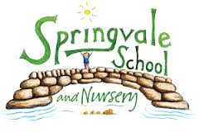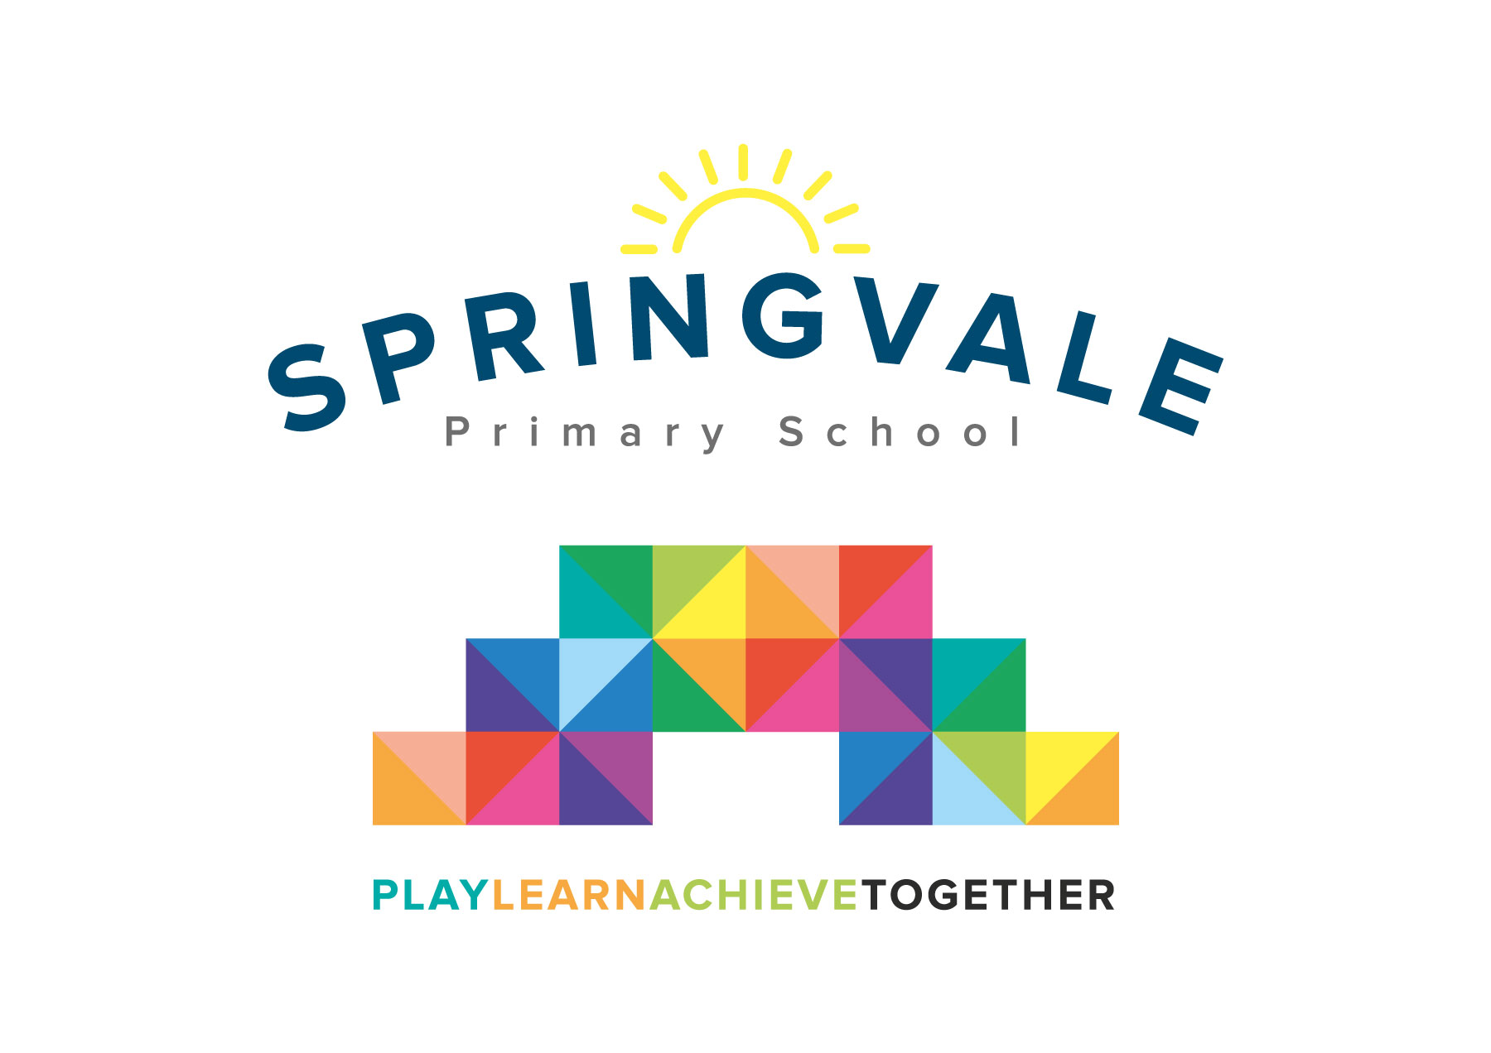
SPRINGVALE PRIMARY SCHOOL
01226 760930
Headteacher: Mr L McClure
l.mcclure@springvaleprimary.org
www.springvaleprimary.org
@SpringvalePS

Purple Mash- Home Learning Monday 18th December 2017

Dear families,

As part of our ethos statement to ‘learn together’ we are very keen to further extend opportunities to learn well at home, as well as during the school day.

For several years we have purchased licenses for pupils to access games and activities that supplement our lessons in school. The system is called Purple Mash and it allows children to access games online at home. Research shows that a short follow-up activity after a lesson in school can help to revise the key themes and secure the facts/knowledge in long-term memory for future use. The system can be accessed through tablets, laptops or desktop devices.

The licenses cost the school a significant amount of money so we are very keen to ensure that the facility is well used and having the desired impact.

Attached to this letter is your child’s log in information (if in EYFS) or a reminder of your details if higher up school. We will monitor usage of the system online before deciding whether to renew the licenses for the next financial year.

If you would like any help to explain how to use the system, or are having any issues logging in, please do let us know.

Kind Regards

Mr L McClure

Headteacher

