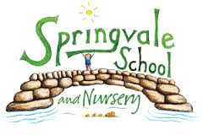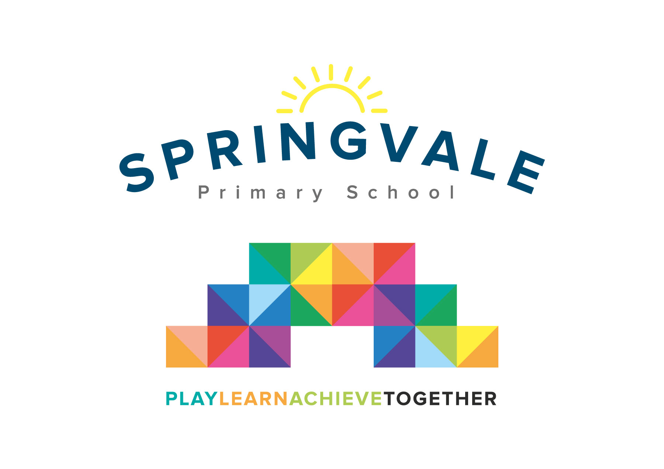
SPRINGVALE PRIMARY SCHOOL
01226 760930
Headteacher: Mr L McClure
l.mcclure@springvaleprimary.org
www.springvaleprimary.org
@SpringvalePS

Newsletter- Week 14 Monday 11th December 2017

Christmas Fayre: As this is my first Christmas at Springvale, I have to say how amazed I am at how supportive our families and the wider community are towards our School. The Fayre was a roaring success and everyone had a great time whilst raising lost of money for school. The final amount raised was £850 on stalls and £450 so far on the raffle which I’m sure you will agree is tremendous. A very special mention for the team of parents, led by Tracey Beaumont, for their many, many hours of work, phone calls and folding/painting/sticking, etc! What a team! The money raised will make a real difference to our children across 2018 and it will support many special events and experiences. Thank you to everyone who came along, volunteered, donated bottles or prizes or even bought a raffle ticket! On behalf of the children and staff thank you for your support. What a special community! #achievetogether

Christmas Shows: This week is show week. Everyone should now have their tickets organised for the events (where applicable) and we really look forward to seeing you all. I will be present for all of the shows and I look forward to welcoming everyone, telling you about what has been going on in school this term and watching the shows for the first time with you. To save a little time at each show please note the following:
- Pictures and videos can be taken but they must not be shared on social media if other children are included in the image/clip as some children do not have media release permission
- Please ensure that mobile phones are turned off or on silent before the show begins
- If there is a fire drill during the shows please allow us to clear all of the children first and then follow our staff to the car park to the assembly point
- Parents watching the PM EYFS show can take children straight home afterwards

Club Update: This term we have offered a wider range of clubs than ever before! We’ve also signed up to lots of new ones in the future including ‘Creation Station’ (arts and crafts) and a new tennis coach.

Please note that the following clubs have now finished for the term- many of them will return soon- look out for a letter early in the Spring Term!
Football (Monday), JAM, patchwork (Tuesday), KS1 Multiskills (Wednesday), Cricket and KS2 Choir (Thursday)

Finishing this week: Y1-4 choir (Friday lunch) and cross-country (Friday)
Finishing next week: Bruce Dyer (Tuesday AM), archery/fencing (Tues/Fri) and Cartoon club (Wednesday)

Sports News: Well done to our fantastic footballers for their excellent performance against Silkstone Primary in their friendly last week. The girls lost 3-0 and the boys lost 2-1 in two excellent games! They were absolutely brilliant and showed, once again, how much progress they are making week on week! Well done everyone! A special mention also for our brilliant sports hall athletics team who represented school so brilliantly last week at the Barnsley finals after qualifying a few weeks ago with a great performance at PGS! I’m delighted to announce that this year we will hold a special Sports Awards evening for the first time! The event will be for all Y6 pupils and any children who receive a special commendation from the rest of school. Parents will also be invited to the event. Look out for more details closer to the time but we are planning the event on Thursday 12th July 2018 at 6pm.

Have a great week and thank you, once again, for your fantastic support!
Kind Regards
Mr L McClure
Headteacher

Week 13 Information | 2017/18 Average | Week 14 Diary Dates
Attendance: 97.5%  Late marks: 2  GREEN LIGHTS: 99.1% | Attendance: 97.4%  Late marks: 1  GREEN LIGHTS: 98.9% | Monday 11th: Y4/5 enterprise finals, KS2 dress rehearsal  Tuesday 12th: Cinema Visits EYFS/KS1 (AM) and KS2 (PM)  Wednesday 13th: KS2 shows 9.30am and 6pm  Thursday 14th: KS1 shows 9.30am and 6pm  Friday 15th: EYFS shows 10.30am and 2pm  Friday 15th: 2.30pm Y5/6 League Match (H) v Mapplewell Primary
Classes of the Week: 100% in F2 Scottish Stars

