AFTER SCHOOL CLUB OPPORTUNITY

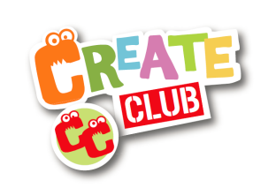
Yippee! You can now be part of the exciting new Art & Craft after school club for children at Springvale Primary – running for 6 weeks across the Spring Term.

Create Club is an exciting new club designed to provide your child with a range of art and crafts experiences that will develop new skills, build confidence and above all be lots of fun, with great masterpieces created!

Each week for one hour Create Club will cover a range of techniques and activities inspired by artists, nature and the children themselves. The after school Create Club is run by myself a former primary school teacher, who will manage the club set up and session each week. I am DBS checked, Safeguarding trained and also emergency first aid trained. Detailed art and craft activity plans to nurture and inspire each child’s imagination, along with tried and tested materials and tools are used each week, giving you, your staff and the parents the reassurance that we are committed to safe, compliant and securely managed art and craft experiences for the children and all others involved. The sessions will take place in the Community Room each week.

Create Club will run for Y1 and Y2 pupils on a Thursday from 3.15 to 4.15 for six weeks. Starting date is Thursday 25th January 2018, weekly, until Thursday 15th March 2018 (either side of half term). Please note that there is no club on Thursday 8th February due to a prior engagement. The price for the 6 weeks is £24 (£4 per session).

Places are limited to 20. To book your place please complete the form below and return to the school office ASAP. Please note, this DOES NOT automatically secure your place. A member of staff will let you know when the places are now full.

Many Thanks,

Brad Thompson | The Creation Station Penistone and Denby Dale
www.thecreationstation.co.uk/brad-thompson
bradthompson@thecreationstation.co.uk

Your child’s name ____________________________ Your child’s class ______________

I would like to book my place on the Create Club (Thursdays 3.15-4.15) and I enclose payment of £24.

Contact telephone ___________________________________________________________

Contact Email ___________________________________________________________

Parent signature ___________________________________________________________

Please print name ___________________________________________________________

