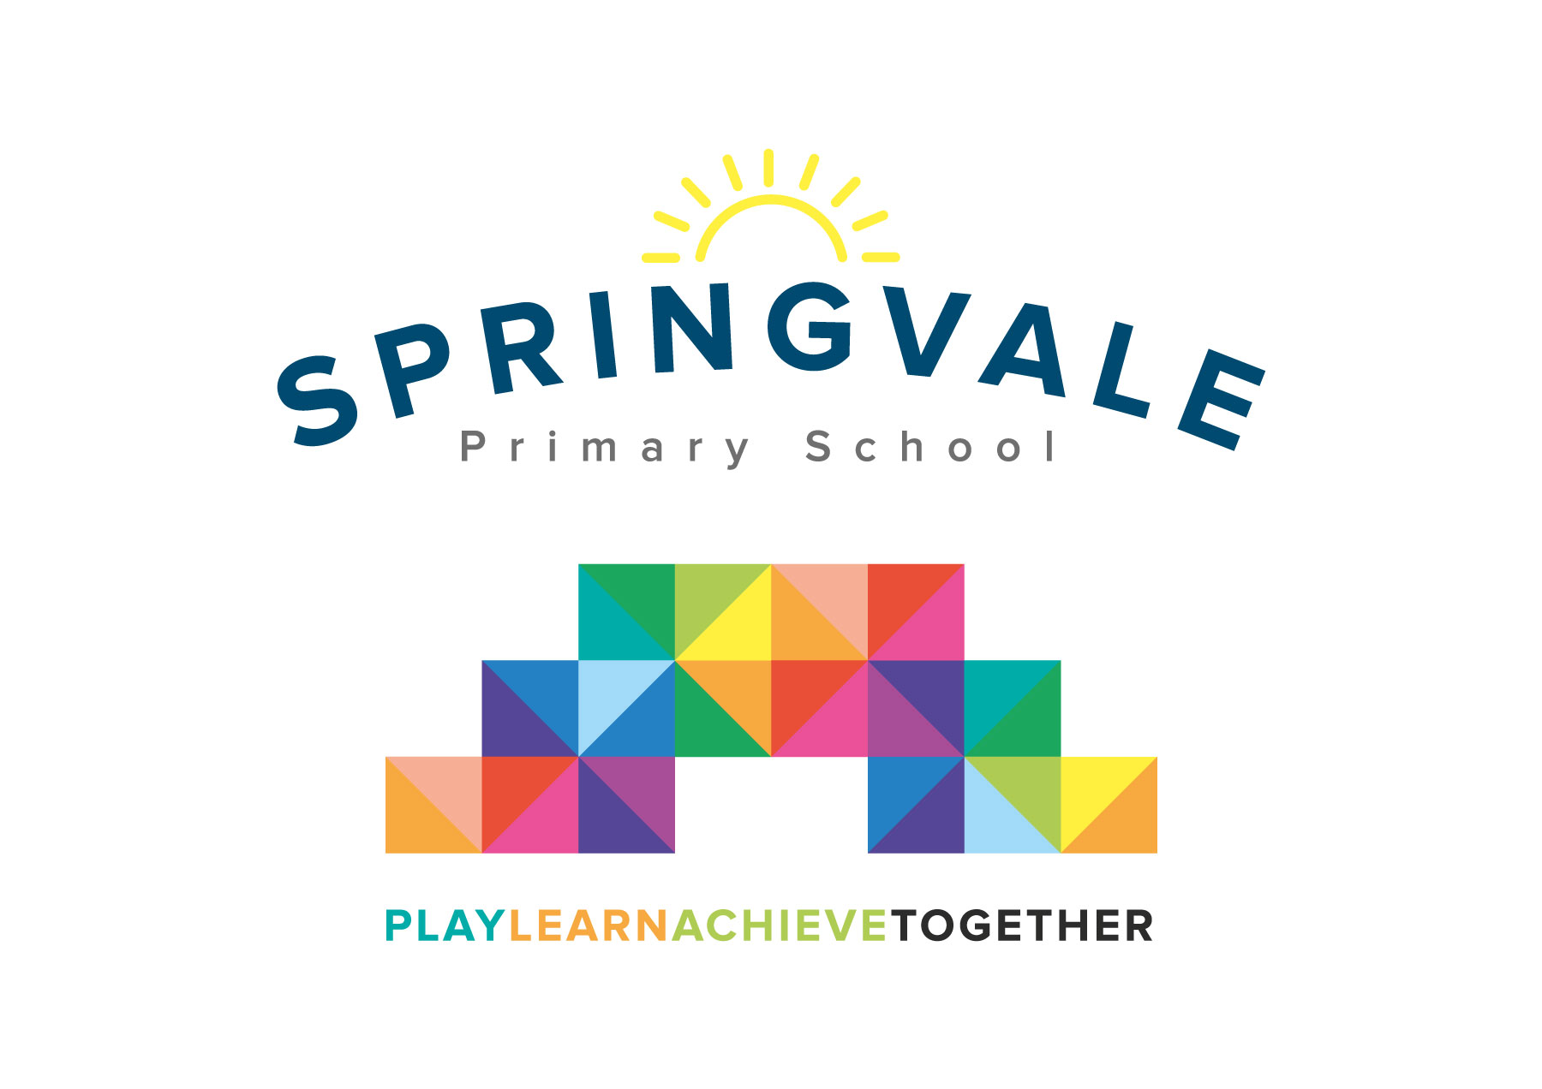
SPRINGVALE PRIMARY SCHOOL
01226 760930

Headteacher: Mr L McClure
l.mcclure@springvaleprimary.org
www.springvaleprimary.org
@SpringvalePS

Football Club Reward Visit Monday 15th January 2018

Thank you for reserving your child’s place on the SWFC reward visit! Our plans to take the children to an exciting promotion chasing fixture haven’t really worked out in the last few months but we are really excited about going along to see a relegation battle now! It promises to be a great game and a great event!

On Saturday 3rd February Sheffield Wednesday play Birmingham City at 3pm. The children have the opportunity to engage with the following activities.

- Meet at school between 9.20 and 9.30am for 9.30am for departure by private coach
- Tour of the stadium at 10.15am including the pitch, changing rooms, trophy cabinet
- Professional football coaching session 11.15am to 1.15pm
- Hot food buffet
- Match day ticket and programme, we would sit in the family stand (seats with an excellent view)
- Transfer back to school for 5.45/6.00pm

We can offer all of the above, including the transport, at a subsidised cost of £20.

Children would just require very warm clothing, a PE/football kit underneath their warm clothing (so that an extra heavy bag isn’t required), a drinks bottle and any spending money they may want for further refreshment/merchandise, etc. As we are eating at approximately 1.30pm we wouldn’t take the children for further food but they can bring a snack along for the mid-morning section of the day.

We have now opened up online payment for you to complete as soon as possible. If you paid cash at the time and we kept it (4 parents) please ignore the request for payment. Please let us know as soon as possible if your child is no longer keen to attend as we do have a waiting list for this visit.

Up the Owls!

#PlaytogetherLearntogetherAchievetogether

Kind Regards

Mr L McClure and Mr L Crossfield

Springvale FC

