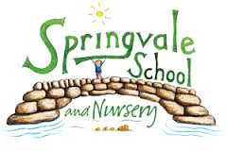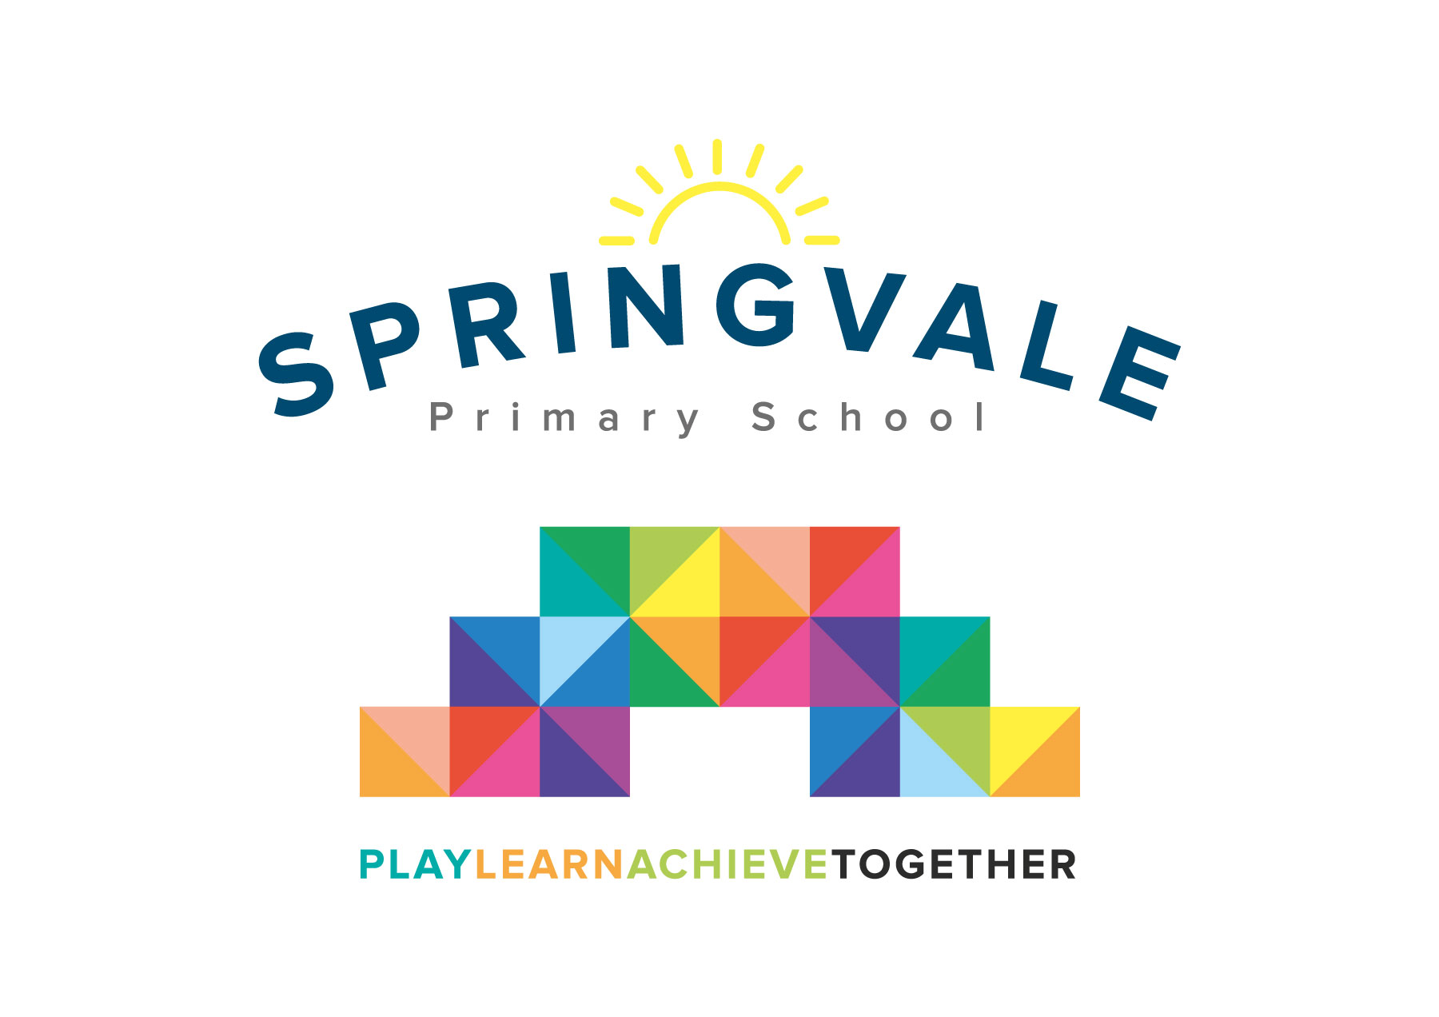
SPRINGVALE PRIMARY SCHOOL
01226 760930
Headteacher: Mr L McClure
l.mcclure@springvaleprimary.org
www.springvaleprimary.org
@SpringvalePS

Newsletter- Week 16 Tuesday 9th January 2018

Welcome Back: A very warm welcome back to everyone from the well-earned Christmas break! Autumn was an incredibly successful term and I am delighted to say that we seemed to run a fabulous Christmas programme that was enjoyed by all! On behalf of all of the staff I would like to thank families for their lovely cards, gifts and kind messages…they mean such a lot. We hope that everyone had a great break and is ready to tackle the Spring Term head on!

Spring Term Improvement Work: We have always said that we aim to be transparent our improvement work and evaluation of how the school is performing. We are adding lots of details about school outcomes and improvement work to our website but I will also add regular updates on newsletters to keep everyone suitably informed. I’m delighted with the standard of teaching, curriculum and care/guidance/support at our school and heartened to see that staff work so hard to develop and/or engage with so many exciting projects (enterprise/DT/competitions, etc) to enrich all of those qualities! Music and the arts remain very strong and sport is improving all of the time! Our big focus this year is on challenging each ability/pupil group with very precise targets and expectations. With this in mind we will be working with the Local Authority, the Governing Body and visiting Heads to ensure that we make our good provision even better, especially for those pupils who have the potential to reach greater depth in their work. We will also be working in teams of staff at some points to learn from each other and steal best practice from across the school to benefit all ability groups. We will also be inviting the parents of pupils who receive Pupil Premium funding to a special evening with Mr McClure to ensure that we are working together effectively to help your child to attend regularly, make rapid progress and achieve well against national expectations.

Clubs: All Autumn Term clubs have finished and we will be writing to parents very soon with this term’s offer. Please make a note of the original start and end dates for each club on any letters from private companies as it does get confusing for everyone towards the end of a term. All school led clubs will feature on one letter and most will start next week. Please note that some school-run clubs will all be booked/paid through the new online system as a trial this half-term (and some visits will be done using the system) and you will be able to see directly if places are available or not.

Staff Car Park: Please do not use the main staff car park as we cannot accept liability for any damages. Please use the drop off area and surrounding parking where it is safe and responsible to do so. Parking in the local area seems to have improved of late but we do still receive notification of dangerous driving/parking, especially around the school gates/nearby properties. A local school had a very serious incident involving a young child recently, let’s not wait until we have an accident to realise just how serious a matter parking and driving safely is near a school. I have recently requested extra signage near school too as I feel that the school isn’t very well signposted in some directions.

Website Update: We continue to add extra content to our fantastic new school website. Please take a look and use it as your one-stop school for school information! We are working on the diary dates section so that they appear as a calendar that can be imported straight into your phone or device! We’ll text all parents when this is in place.

Key Dates: Please see the reverse of this newsletter for our latest list of key dates. These dates are all on our school website too!

Thank you for your ongoing support and best wishes for 2018.
Kind Regards
Mr L McClure
Headteacher

Week 15 Information | 2017/18 Average  (Autumn Term) | Week 16 Diary Dates
Attendance: 95.9%  Late marks: 1  GREEN LIGHTS: 99.6% | Attendance: 97.2%  Late marks: 1  GREEN LIGHTS: 99.2% | Tuesday 9th: Creative Station Assembly (Club for F2-Y3)  Wednesday 10th: LA Visit (external monitoring)  Wednesday 10th: School Council art contest launch (Rainforest theme)  Thursday 11th: Y4-6 Enterprise Launch (Assembly)  Friday 12th: House Point Reward Afternoon (Red Oak) Disco  Congratulations to red team who won by just 8 points in the end!
Classes of the Week: 100% in Y4 Cool Columbians

Spring Term Dates

January 2018
Monday 8th: INSET (School is closed)
Wednesday 10th: Art competition launch (any form of media, any age, theme is RAINFOREST)
Friday 12th: Y5/6 Star Wars visit (AM)
Monday 15th: Y4 Visit (Eden Camp)
Wednesday 17th: Parent drop-in 3.15 to 4.45pm (come and look at your child’s work) Y1-Y6
Monday 22nd: Y6 Parents’ Meeting at 6.30pm (Robinwood, SATS, Steps to Secondary) Hall
Wednesday 24th: Pupil Premium event with Mr McClure (2-7pm) if applicable
Friday 26th: Y5 Visit to the Science and Industry Museum
Wednesday 31st: Imagination Gaming Day

February 2018
Friday 2nd: Intra-school football games (PM) all football club children involved
Saturday 3rd: Football Reward Visit to SWFC (9.30am to 6pm) confirmation letter to follow
w/c Monday 5th: Assessment Week Y1-6

Monday 12th February to Friday 16th February- School is closed for Half-Term

Monday 19th: School re-opens
Wednesday 21st: Parents’ Evening booking opens at 5pm
Thursday 22nd: 9am Y4 Class Assembly
Thursday 22nd: 3.15-4.00pm Y1 phonics screen meeting (in Y1)
Thursday 22nd: 6pm Y2 SATS meeting (in the hall)
Wednesday 28th: eSafety Day (all classes involved) and sharing assembly at 2.30pm for parents

March 2018
Thursday 1st: World Book Day- Dress-up as a book character or in a onesie
Monday 5th: Whole school questionnaire week
Tuesday 6th: Book fair arrives (open daily from Wednesday)
Wednesday 7th: Spring Term Parents’ Evening (1.30-7.00pm) Hall
Thursday 8th: 9am Y2 Class Assembly
Friday 9th: Books for Breakfast (F1 and Y4-Y6) 8.15 to 9am (Hall)
Friday 9th March: PM House Point reward afternoon

Monday 12th to Thursday 22nd March: The Big Pedal (Bikes and scooters encouraged)
*Lots of potential biking activities TBC during February and March*
Tuesday 13th: Book fair closes
Wednesday 14th to Friday 16th: Y6 at Robinwood
Thursday 15th: 9am Y5 Class Assembly
w/c Monday 19th: Penistone Art Week (potential activities)
Wednesday 21st: 9am Class Assembly
Wednesday 21st: Firefighters bag collections
Thursday 22nd: Comic Relief- Red Nose Day.Wear red dress down. Do Something Funny Assembly-9.30am
Thursday 22nd: EYFS Mothers’ Day Presentation 11am and 2.45pm
Friday 23rd: INSET Day: School Closed

Monday 26th March to Friday 6th April- School is closed for the Easter holidays

INSET Day on Monday 9th April
Return to school on Tuesday 10th April

