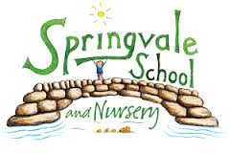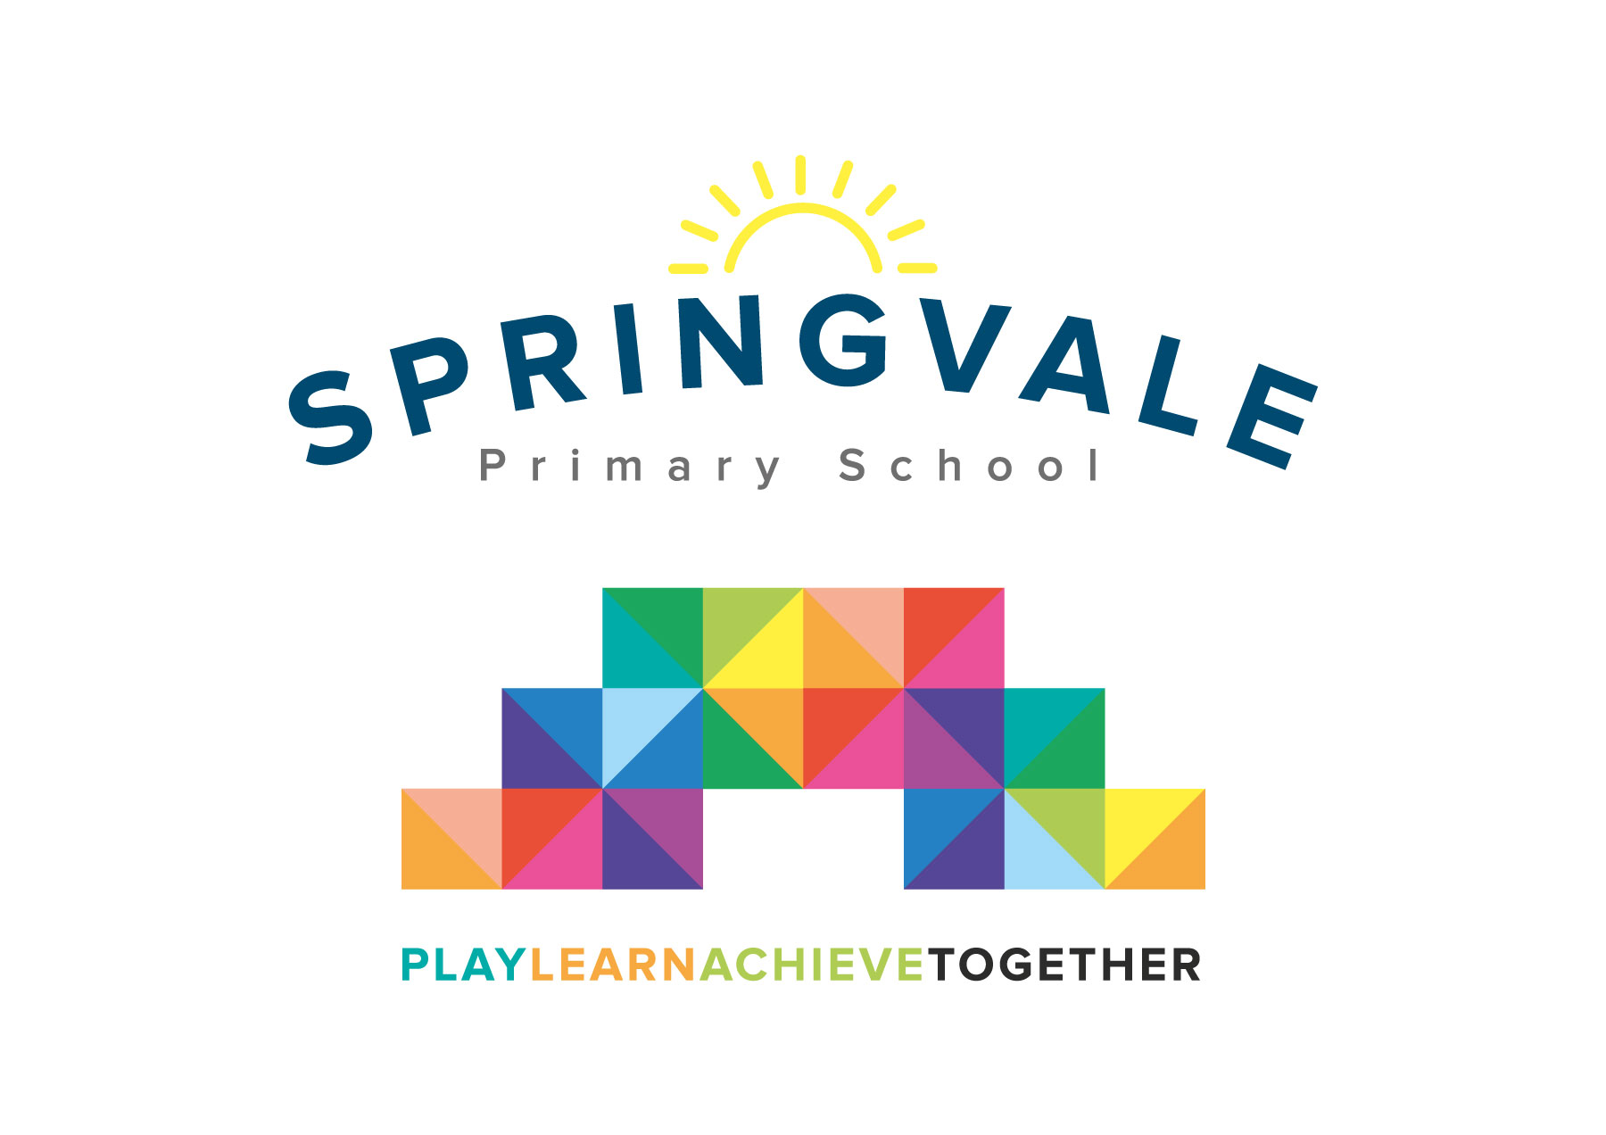
SPRINGVALE PRIMARY SCHOOL
01226 760930
Headteacher: Mr L McClure
l.mcclure@springvaleprimary.org
www.springvaleprimary.org
@SpringvalePS

Newsletter- Week 17 Monday 15th January 2018

First Week Back: It has been a pleasure to welcome everyone back after an enjoyable Christmas break. The staff and children have settled down quickly and our first week has shown that we are all set for another exciting term here at Springvale Primary.

Staffing: A warm welcome to the newest addition of the Springvale team, Mrs S Aitken. Mrs Aitken will be working with Y5 children for most of the morning and then she has a very exciting new role that has never been seen in our school before! Mrs Aitken will lead on outdoor learning and her fabulous work will supplement the exciting activities that our EYFS children experience indoors. In other updates we are delighted to welcome Miss Goodyear back, she was sorely missed by her class just before Christmas. Mrs Parr will be teaching Reception (Scottish Stars) for the rest of this year for the whole week. Her PPA time will be on a Thursday morning and this will be covered by Mrs Andrew.

Clubs: A reminder that lots of new clubs have been launched in the last few days. Some are free and some have a small charge. Some are booked by returning the letter and cash/cheque and some can be booked online as we trial our new online booking/payment system. All club information is online under ‘letters home’ and has been emailed out to all parents. Please contact the school office if you require any clarification or support with the new system. Online dinner payment will begin after half-term and all closing balances on the current system will be transferred across.

Reward Afternoon: Our RED team enjoyed a fabulous disco on Friday afternoon to celebrate their narrow victory in our intra-school competition. We now wipe the scores and start the second round of competition…good luck everybody! Keep working hard and reading at home to help your team!

Pupil Progress Feedback: This week our staff have explored and evaluated the progress that our pupils made across the Autumn Term. The profile is very positive but it was clear that the children who attend school regularly and those that read at home/complete set homework make the most rapid progress. Please keep up your vital support at home and help us to ‘learn together’ and ‘achieve together’ for the rest of this year! We will be sending out letters where we are concerned about attendance and/or lack of home reading in the coming term as we raise expectations for all pupils and aim to help them all to reach their full potential.

Purple Mash: A reminder that we have recently sent out log-in and password details to all families for Purple Mash. Purple Mash is an online system where pupils can play educational games to revise and embed key curriculum content. It is particularly useful for maths revision as the curriculum ‘moves on’ so much from theme to theme. This system costs school substantially so we hope that it is fully utilised by children. Please let us know if you require the log in details again.

Enterprise Work: Our Y4, 5 and 6 pupils may be talking about ‘enterprise’ work a lot in the coming weeks. Enterprise work is where children use their mathematics and thinking skills in a business context to encourage young, entrepreneurial skills. These sessions will take place on Thursday afternoons and they add a further exciting strand to our already super curriculum!

School Council Competition: Our School Council have set up a fabulous art competition. Children of any age can enter by placing their art work in the tray outside Y4. The theme is ‘rainforest’ and any media or materials can be used. We will announce the winners in a few weeks and give out prizes in assembly.

Thank you for your ongoing support, have a great week.
Kind Regards
Mr L McClure
Headteacher

Week 16 Information | 2017/18 Average | Week 17 Diary Dates
Attendance: 96.8%  Late marks: 1  GREEN LIGHTS: 99.6% | Attendance: 97.2%  Late marks: 1  GREEN LIGHTS: 99.3% | Monday 15th: New clubs start this week  Monday 15th: Sketching week begins  Wednesday 17th: Parent drop-in to look at Literacy/maths books (Y1-Y6)  Thursday 18th: Attendance concern letters/texts out
Classes of the Week: 100% in Y4 Cool Columbians

