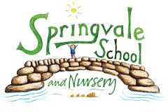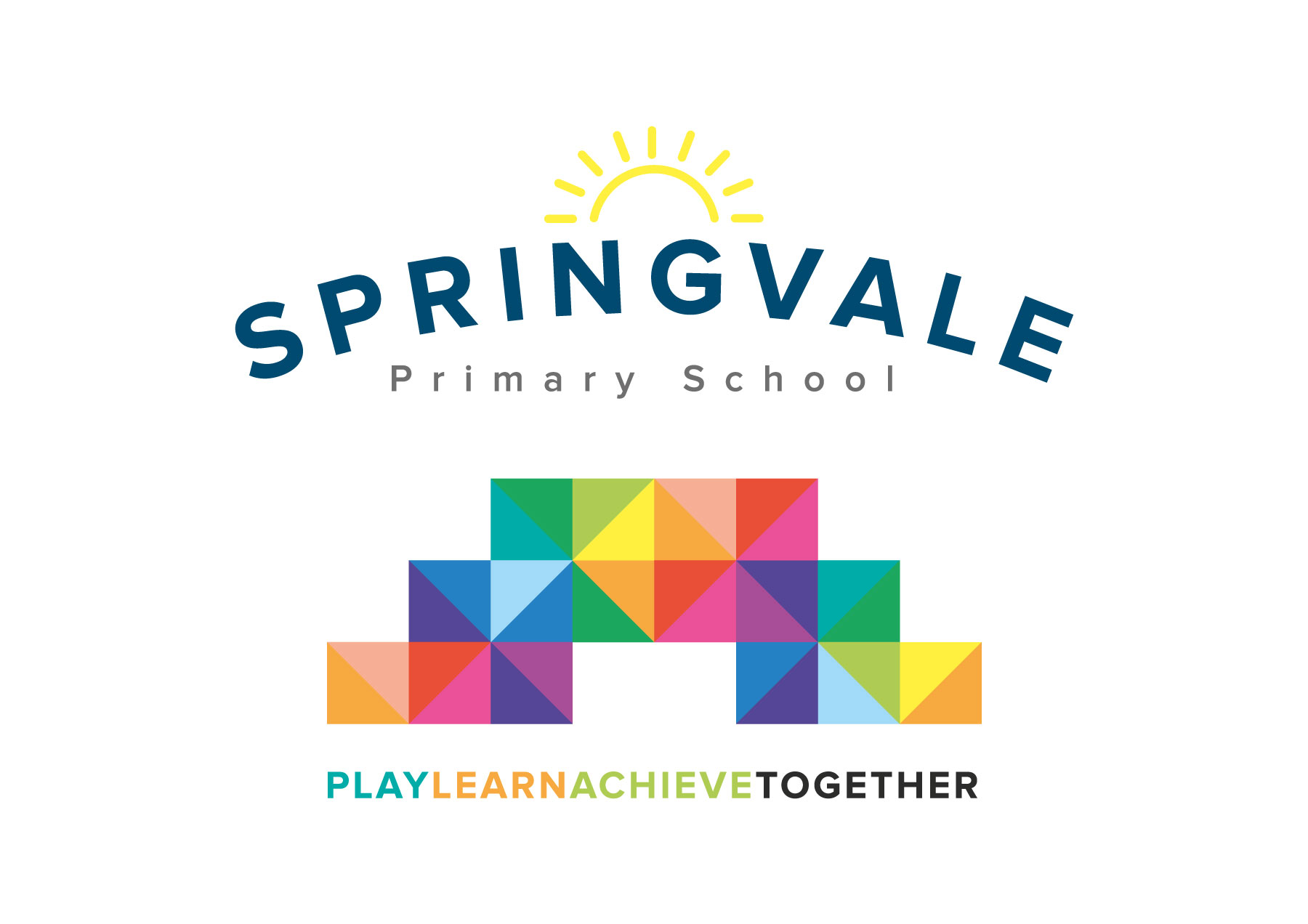
SPRINGVALE PRIMARY SCHOOL
01226 760930
Headteacher: Mr L McClure
l.mcclure@springvaleprimary.org
www.springvaleprimary.org
@SpringvalePS

Newsletter- Week 18 Monday 22nd January 2018

Let It Snow: Despite the cold, frosty and snowy weather last week we had an excellent week in school with very little disruption to learning time. The new snow system seemed to work well and we had excellent behaviour, no breaches of safety and fantastic attendance. Thank you for your positive feedback. We have tweaked the signing out system to make it quicker and are all set for the next batch of snow! We will always text and tweet at around 7am when the conditions are a concern.

Parent Drop-In: Apologies for cancelling the parent drop-in last Wednesday. It would have been great to give parents another chance to take a good look at their child’s work but we were beaten by the weather. Books will be available to see at Parents’ Evening in early March and then we will organise a chance to look at books in the Summer Term just before you receive your child’s end of year report.

Attendance and Punctuality: Our attendance and punctuality rates have improved considerably this year which is something to really celebrate. We are still keen to improve further and we do, sadly, have some families who keep children out of school for inappropriate reasons at times. Please contact us on the first morning of absence so that we are aware of the reason for absence as soon as possible and ensure that children are only absent due to illness that is significant or may affect other children. Sometimes children are kept off when they are not ill or have a minor issue like a sore throat. Our staff will always support your child in school and we would contact you if their illness started to cause concern. Once a child turns 5 years old, attendance becomes a legal requirement and not a choice. It is also the most significant factor in pupil progress and achievement so all children need to target attendance of 98 to 100% wherever possible. Lateness has really improved which is another positive factor to celebrate. We will continue to communicate any concerns about attendance and punctuality as we strive to be the best school that we can possibly be!

School Evaluation Feedback: Myself and Mrs Fearn were recently joined by our School Evaluation Officer (SEO) to explore our improvement work across the school. This was a very positive day and our SEO has recognised the hard work of everyone and what fantastic children we have at Springvale. We have received some very positive feedback and our SEO is confident that we will continue to improve rapidly over the coming terms and years from our already very positive platform. Well done everyone!

Purple Mash: A further reminder that we have recently sent out log-in and password details to all families for Purple Mash. This system costs school substantially so we hope that it is fully utilised by children. Please let us know if you require the log in details again. The system will also be very useful for INSET days, days when the snowy weather keeps families who live further afield from travelling in and for children who are not able to attend school for sickness reasons but are well enough to learn at home without risk of sharing their symptoms with the rest of their class.

School Council’s Art Competition: The closing date is this Wednesday and we have very few entries so far so please get involved if you can! We will announce the winners on our Twitter feed and give out prizes in assembly.

Hairbands: We have started to have lots of variations of hairbands or bows in school that seem to getting larger and larger each week! I think children should be able to wear things that they enjoy and that make them feel a little more individual alongside our school uniform but some of the things being worn are becoming a safety concern. Please ensure that only bands/bows that are safe and simple are worn.

Thank you for your ongoing support, have a great week.
Kind Regards
Mr L McClure
Headteacher
Week 17 Information | 2017/18 Average | Week 18 Diary Dates
Attendance: 97.4%  Late marks: 1  GREEN LIGHTS: 100% | Attendance: 97.2%  Late marks: 1  GREEN LIGHTS: 99.3% | Creation Station Clubs begin (Monday and Thursday)  Monday 22nd: Meeting for Nursery parents (5.30pm) Children welcome  Monday 22nd: Meeting for Y6 parents (6.30pm) Children welcome  Wednesday 24th: Art competition closes  Thursday 25th: Y4 enterprise session (PM)  Thursday 25th: Disability in Sports event (selected KS2 pupils) PM
Classes of the Week: 99.7% in Y4 Cool Columbians

