Springvale Primary School
Steps to Secondary Action Plan
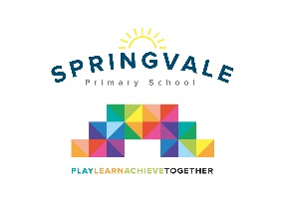
Key issues:
Pupils- worry about the size of the school, the amount/experience of travel, discipline being stricter
Y7/8 pupils had the same worries as the above when they started and said within a few weeks their concerns had settled
Parents- the new discipline system at PGS, homework systems being so different to Springvale

Positives:
Pupils- exciting curriculum, wider experiences, quality facilities, meeting new people
Y7/8 pupils said that the size and number of pupils quickly became a positive as they could meet so many new people and make friends
Parents- Greater independence for pupils

Key Actions:
- Feedback to PGS that pupils, staff and parents would benefit greatly from an extended transition or an early role over to Y7. Maybe 1 full week and then the end of Y6 isn’t too rushed? This would address their worries about uniform, travel, expectations and most importantly, make them familiar with the geography/staff of the school and stop any Summer worries about the move to PGS
- Springvale to draw up a steps to secondary plan, see below.

Springvale Y6- from February half-term (introduced to all parents at Y6 information evening for SATS/Robinwood)
- Pupils to have stricter standards around uniform, homework, organisation (having reading records, PE kits, etc)
- Pupils to receive a mock version of the PGS diary or an actual example for familiarisation purposes
- Pupils to receive more responsibility in school- leadership of activities, etc
- Parents to ask more of their children in terms of organisation and independence and avoid communicating with school unless absolutely necessary
- After SATS we will…
  - Set a programme of homework from each area of the curriculum and ask that children log the requests and prioritise when to do them and when they need to be handed in
  - Have a short lunchtime detention for children who do not have the correct kit/homework, etc- a ‘no excuses’ culture
  - Pupils to have different staff for different curriculum areas
  - Some additional clubs offered without excessive communication for parents- to see if children can sign up, organise what they need and inform parents of their involvement/what time they will be home, etc
  - Lots of additional circle time and PHSCE time for pupils to discuss their worries

