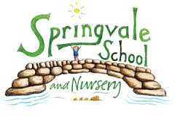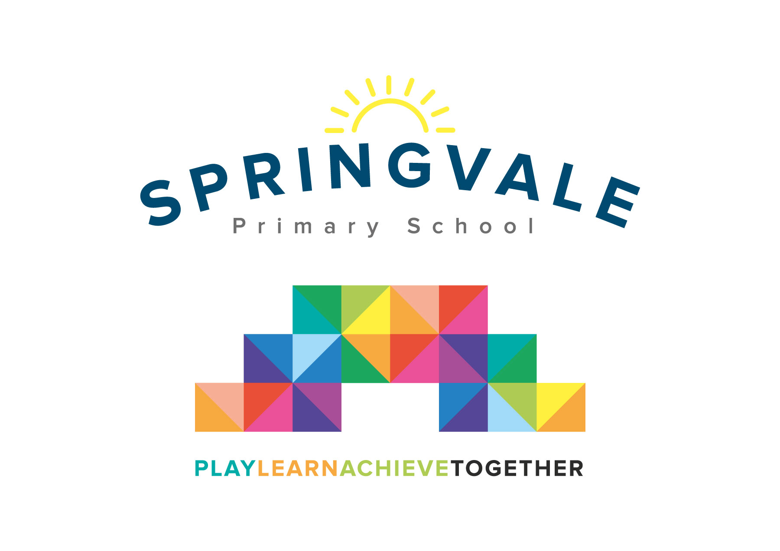
SPRINGVALE PRIMARY SCHOOL
01226 760930
Headteacher: Mr L McClure
l.mcclure@springvaleprimary.org
www.springvaleprimary.org
@SpringvalePS

Dear Parents,
Following the success of our Books for Breakfast event for F2 to Y3 pupils earlier this academic year, on Friday March 9th 2018 Springvale Primary School will be hosting a second event for the rest of school. This event will only be for children in: F1, Class 4, Class 5 and Class 6. If you have younger children from classes F2, 1, 2 or 3 then you can bring them along, and they will be supervised by a member of staff in the community room. They will need to have had their breakfast already. On the morning of the 9th March from 8.15am-9.00am you will be able to come into school, along with your child/children, have a bacon or sausage butty, or a piece of fruit, and read books. We just ask that the year 4 classroom and the circle be a food-free zone. We also suggest that F1 and Class 4 stay in the hall, while classes 5 and 6 either go to the classroom, or to the library.
This event will be entirely free, all you have to do is make a decision as to what you would like for your breakfast! Your child can bring their favourite book to this event, or read their school book. We are going to stagger the arrival times to avoid a long queue in the dinner hall. Here are the times of arrival for each class:
F1: 8.15am (Eat and read in the hall)
Class 4: 8.15am (Eat and read in the hall, please do not enter the Y4 classroom with any food)
Class 5: 8.30am (Eat and read in the library or Y5 classroom)
Class 6: 8.30 am (Eat and read in the library or Y6 classroom)
Parents must remain with their children until 8.45am when the class teacher can take over responsibility, although you are welcome to stay until 9.00am.
Please note that the event will finish at 9.00am so that the children can resume their normal lessons.
On the permission slip below please write down the name of your child/children, and who will be attending the event with them. We also need to know what you would like for breakfast, so that we can order all the food. Please return the slip below by Monday 5th March 2018. If you or your child have any food intolerances then please note this down on the permission slip.
Children who will not be attending with a parent must enter their classrooms at 8.45 through their classroom door as normal.
Thank You
Mrs Fearn
Deputy Head and Literacy Co-Ordinator

You must return the completed slip by Monday 5th March 2018 whether you are attending or not.
I give permission for my child/ren…………………………………………… Class /s __________to attend Books for Breakfast and will remain with them until 8.45am
Parent attending ________________________
Number ____ Bacon roll
Number ____ sausages
Number___Fruit Signed…………………………………………………………………………………

