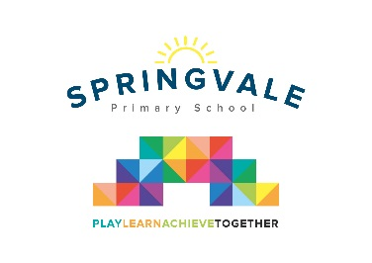
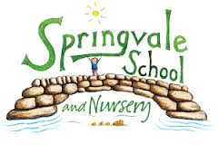
SPRINGVALE PRIMARY SCHOOL
01226 760930
Headteacher: Mr L McClure
l.mcclure@springvaleprimary.org
www.springvaleprimary.org
@SpringvalePS

Dear Parents / Carers,

To support our learning this half term we have arranged for Heeley Farm Roadshow to come into school on Thursday 15th March. It will be for children in F1, F2 and Year 1. The animals will be based on the school field and the children will have access to them throughout the day. Children will be able to get up close and learn about how to look after small farm animals and pets first hand. I am sure this will be an enjoyable and memorable learning experience. This event has been fully risk assessed but if your child has any animal aversions or allergies please let their teacher know.

On the day your child needs to wear school uniform, as usual (F2 and Y1 children), but as we are outside on the field for much of the time sensible footwear and warm, waterproof coats will be essential.

The total cost is being subsidised by school but we ask for a contribution from you of £3 per child. Please pay using the online dinner money payment system. You will be sent an e-mail containing a link to ‘School Money’ and your password within the next few days.

If you have any queries or concerns about the online payment system please contact the school office. If you have any concerns or queries about the event please arrange to speak with your child’s teacher.

Kind Regards

Mrs Evans

