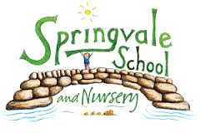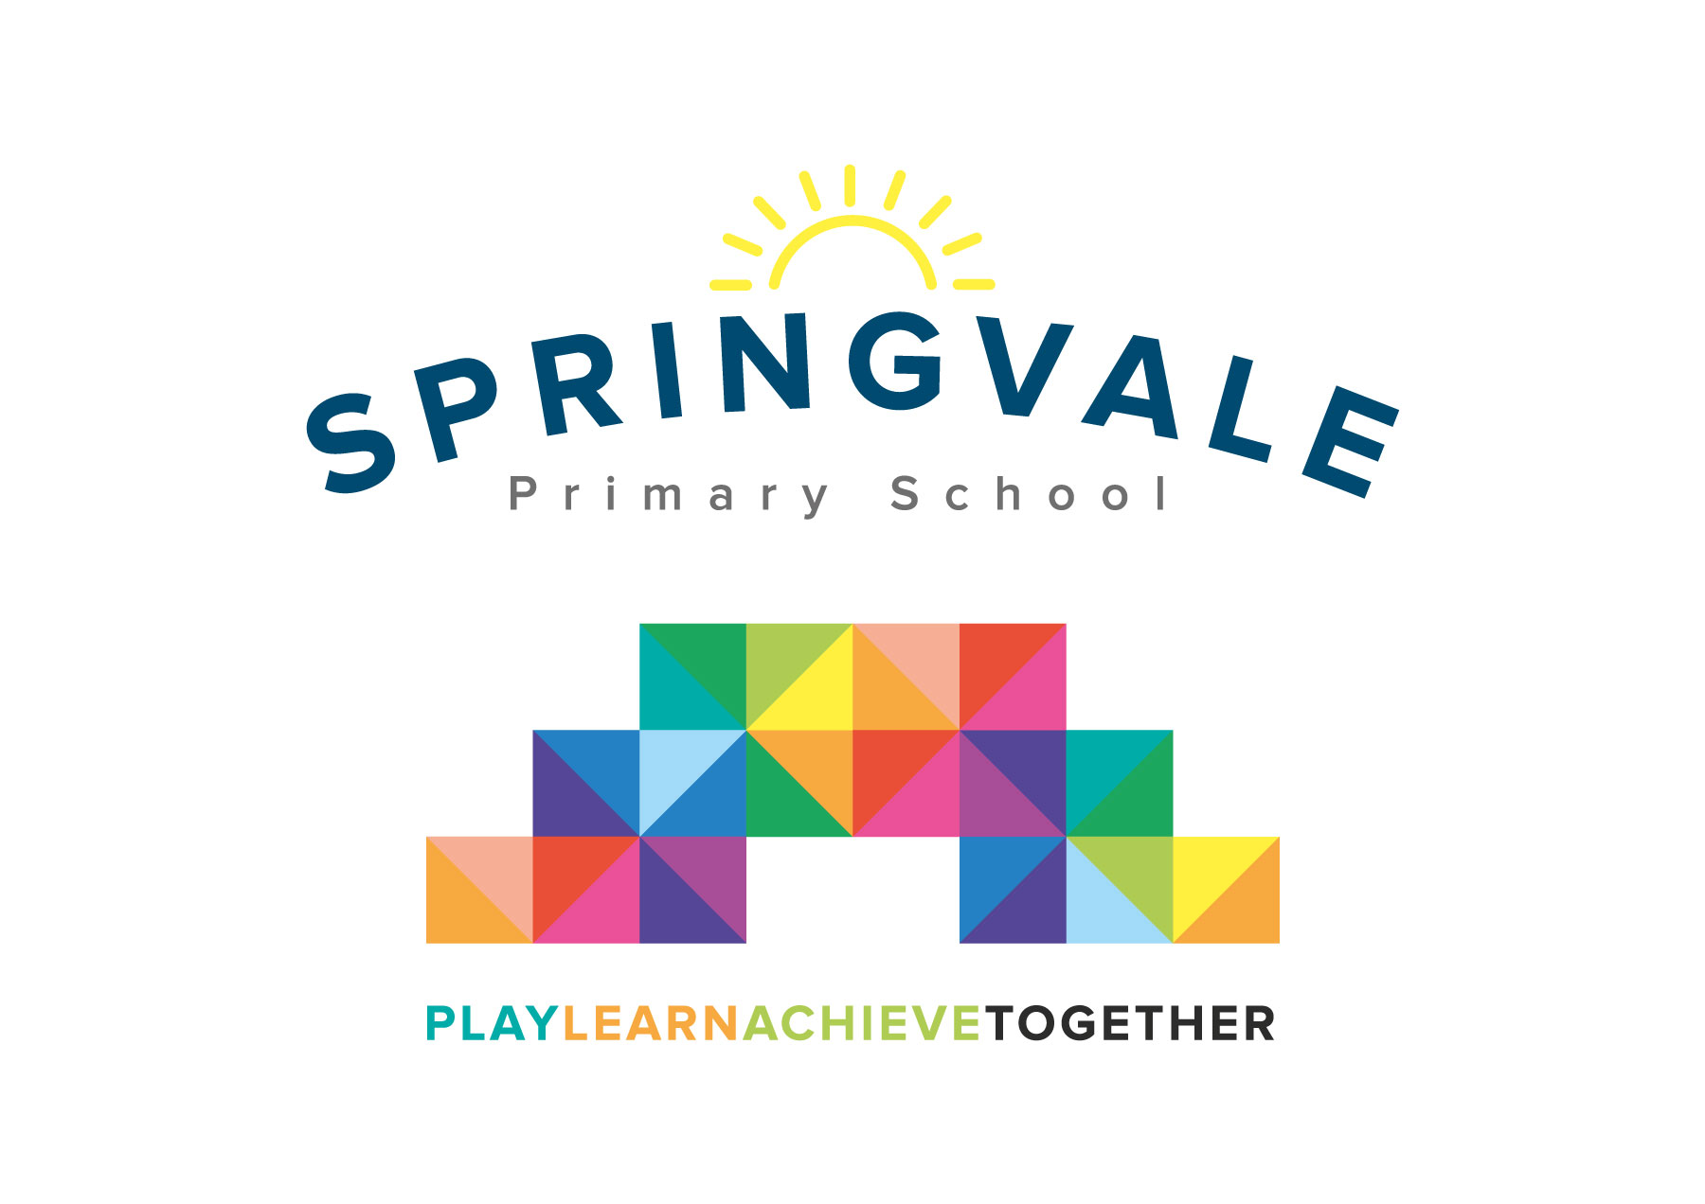
SPRINGVALE PRIMARY SCHOOL
01226 760930
Headteacher: Mr L McClure
l.mcclure@springvaleprimary.org
www.springvaleprimary.org
@SpringvalePS

Newsletter- Week 20 Monday 5th February 2018

Busy school, happy children: Welcome to our latest newsletter! It may have been a short half term but we have absolutely crammed a lot in! Last week was perhaps the busiest we have had in terms of sports, visits, special events (theatre group, gaming day, etc). This is the kind of school we want to be…quality lessons, an engaging curriculum and lots of opportunities to take part in new and exciting activities! Our EYFS were loving life last week as they tried to find out who had eaten the chocolate (I have an alibi)! Take a look at Twitter for all of the news and pictures!

Improvement Update: It has been another fabulous half term where we continue to play, learn and achieve together to make the school the best that it can be! We have particularly worked hard on the wider curriculum, the pitch and challenge for children with the potential to reach greater depth (the highest grades), continued to plan for a bigger and better EYFS environment, achieved a grant for a new and improved library that will engage and enthuse children from 3 to 11 years old (to be completed by the end of the school year), started to work in teams of staff to develop our engaging teaching methods further and continued to push the importance of high standards of uniform, behaviour, attendance, punctuality and reading at home. Basically, we’ve all been very busy! Keep it up everyone…doing the right things day in, day out and working hard will always yield the highest results for our school, our children and our community.

Half-term: A final reminder that we break up on Friday (9th February) for the half term and that we return on Monday 19th February for another 5 week half term taking us up to Easter. There are no INSET days linked to this school holiday.

eSafety: Thank you for your support with our eSafety work. The children in upper school have responded really well to the special assembly last week and many have reported that they have spoken at home about safety online and the expectations that families have on safe and appropriate use of phones and tablets.

Sports Update: Well done to our Y3/4 children who attended the relay event at PGS last week (you worked really well as a team!) and to our Y4/5 futsal players who were excellent in qualifying from a tough group before, sadly, losing their quarter final at the event at Shoot 5, Silkstone. It was a pleasure, despite the result, to take 30 children to Hillsborough on Saturday. The group were inspired by the coaching, tours of a professional group and the match itself. I am sure they, like us, will never forget playing on the pitch in front of so many people. Thank you to Mr Crossfield for giving up his Saturday to watch his bitter rivals play too! Always appreciated.

Club Updates: Football club is starting again after half-term and we are now fully booked with 40 children on our register. A Thursday morning tennis club starts after half-term that is available to children from Y1 to Y6. The coach is from Barnsley Tennis Club, an excellent, family orientated club based just 10-15 minutes from school. If any families would like information about lessons or coaching please let me know.

School Council’s Art Competition: Congratulations to everyone who entered the art competition and thank you to the School Council, Mrs Tomlinson and Danny from design company ‘We Are Awesome’ who organised the competition, the prizes and the judging. The standard was incredibly high and we saw a wide range of different styles/methods used. Well done to Brilliant Brazilian Freya (Y3) for winning the overall competition and congratulations to each class winner who also received exciting prizes.

Thank you for your ongoing support, have a great week.
Kind Regards, Mr L McClure, Headteacher
Week 19 Information | 2017/18 Average | Week 20 Diary Dates
Attendance: 98%  Late marks: 1  GREEN LIGHTS: 99% | Attendance: 97.4%  Late marks: 2  GREEN LIGHTS: 99.2% | Monday 5th: Y1/2 Relays event at PGS (4-5.30pm)  Tuesday 6th: Y3/4 Boys South Yorkshire Cross Country event  Wednesday 7th: Pupil Premium event (F2-Y5) 2-7pm  Thursday 8th: Y6 enterprise session (PM) and Y4 WWII café event  Friday 9th: Inclusive sports event  Friday 9th: Break-up for half term
Classes of the Week: 100% in 3 different classes…wow! Well done to Y1, Y4 and Y5 Spanish Superstars, Cool Columbians and Wonderful Welsh!

