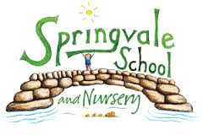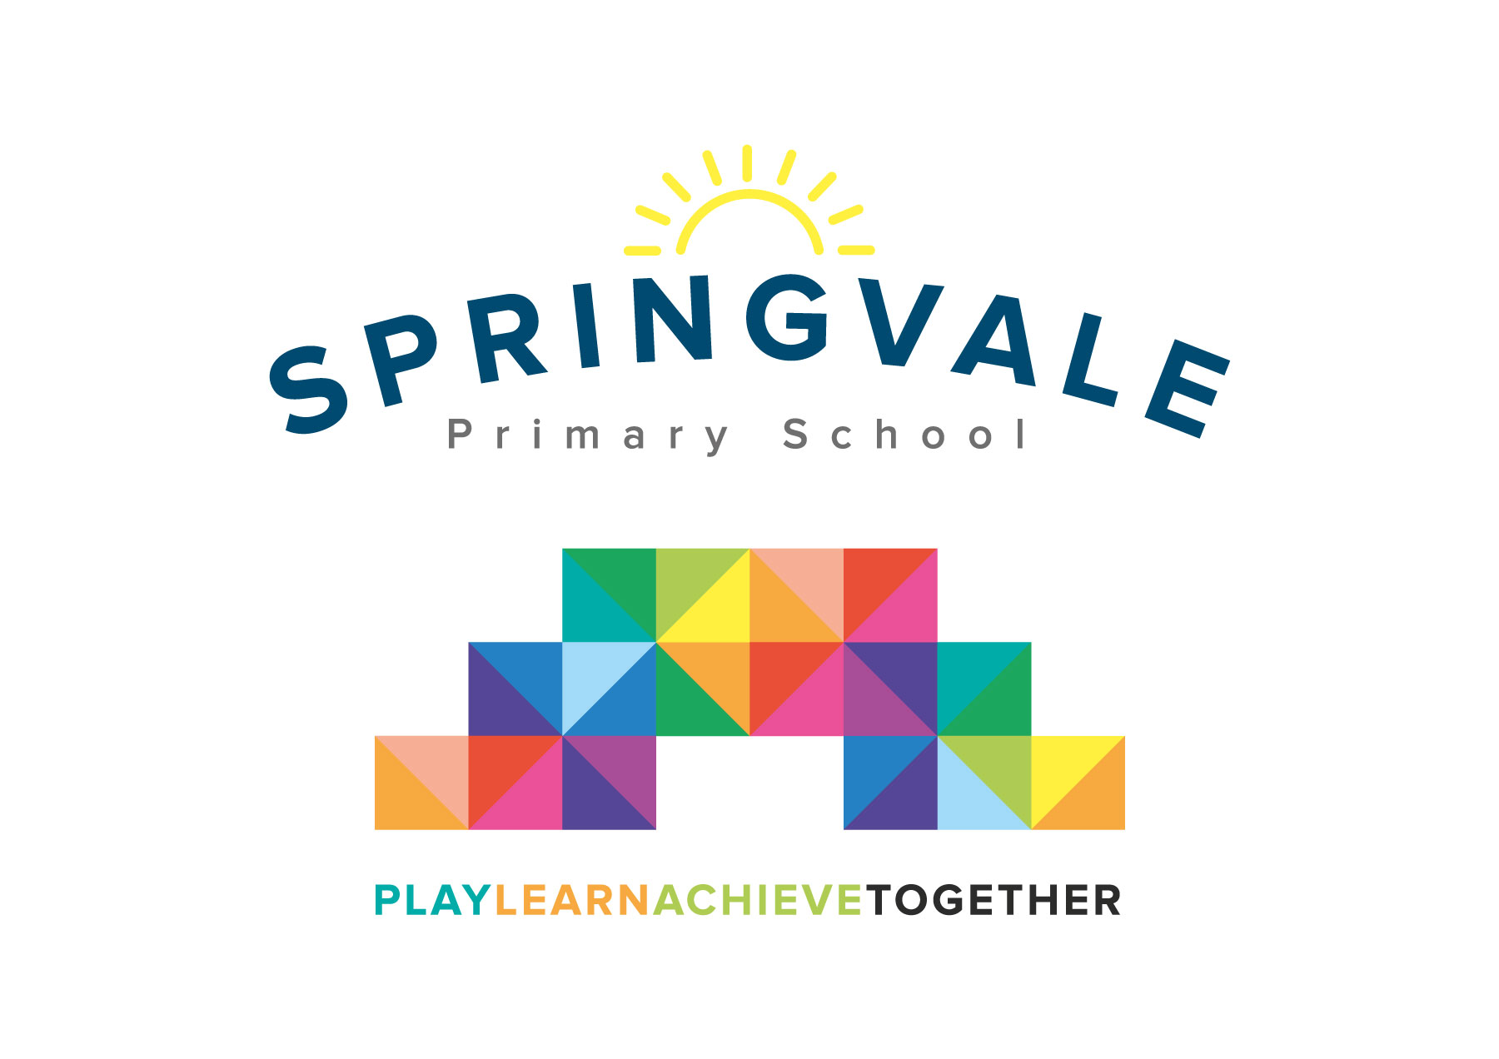
SPRINGVALE PRIMARY SCHOOL
01226 760930
Headteacher: Mr L McClure
l.mcclure@springvaleprimary.org
www.springvaleprimary.org
@SpringvalePS

Dear Parents / Carers,
We are planning to hold a special event for our Foundation Stage children on Tuesday 20th March 2018. We would like children to join in a sponsored ‘wheel-a-thon’ to raise money for new bikes.
Our outdoor area is a very important learning space for all children and we have been working towards improving it over recent months. We have exciting plans to increase resources and the storage for outdoors very soon, but also would like to be able to buy more bikes and helmets too. Many of our bikes the children use are Rabo bikes, which are specially designed for young children, but also very expensive!
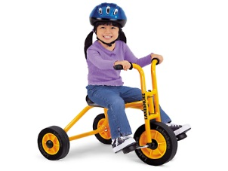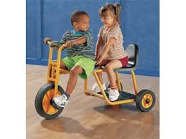
On Tuesday 20th March we would like children to either bring their own bikes/scooters to school or use ours and participate in riding along ‘roads’ and ‘pathways’ around our playground. Please send bike helmets if your child has one.
We also plan on setting up a bike wash and a bicycle repair centre as part of the children’s play outdoors.
Please find attached a sponsor form which can be returned to school after the event.
Thank you,
Foundation Stage team

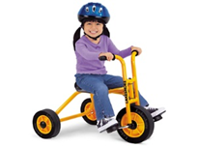
‘Wheel-a-thon’ sponsor sheet
Name of child sponsored is:

Name of sponsor | Amount pledged | Paid

Please return after Tuesday 20th March 2018. Thank you.

