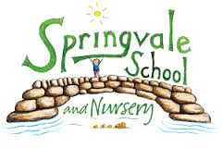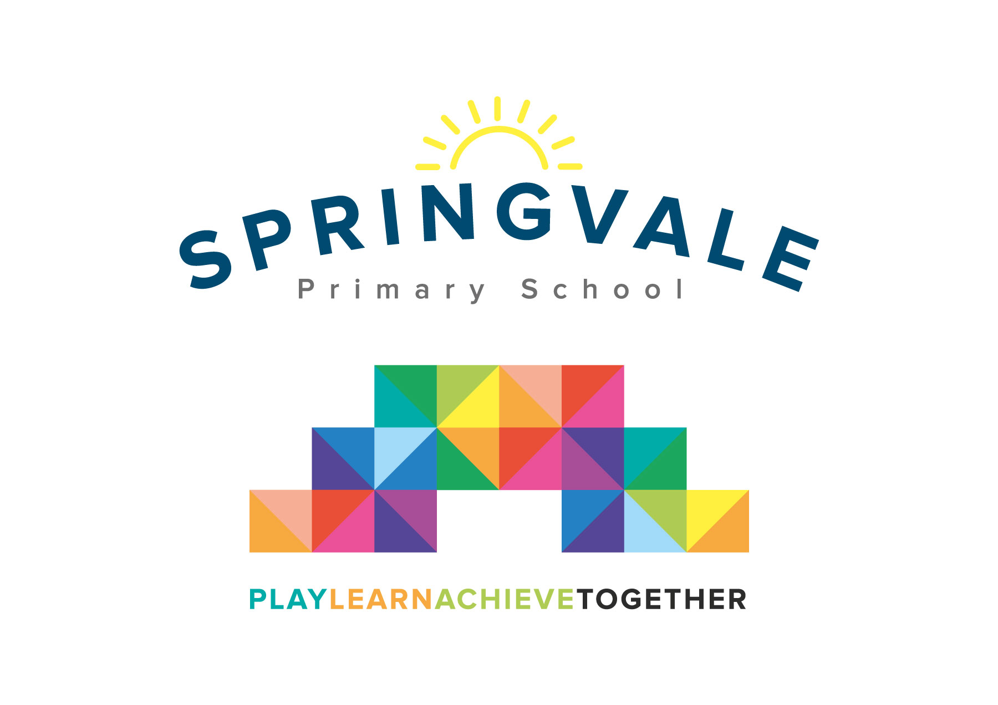
SPRINGVALE PRIMARY SCHOOL
01226 760930
Headteacher: Mr L McClure
l.mcclure@springvaleprimary.org
www.springvaleprimary.org
@SpringvalePS

WW2 Café 02/02/2018

Dear Parent/Carer,
On Thursday 8th February, we will be holding a café to show some of the work we have done on the topic of WW2. The children will be cooking and preparing all of the food and drink that will be served and will be filling all of the job roles you would find in a café. The food will be based on the types of things you would have been able to make during the war.
In order to help cover the cost of all the ingredients, there will be a small charge for the food on the night, which you will be able to choose from a menu (as you would at a real café)!
It will take place in the hall from 3:25 to 5:25 and I will need as much of the class as possible to stay for the event, so that there are plenty of waiters, waitresses, cooks, till staff and front of house staff.
The children will have put in a lot of work in the build-up to the event and I feel that they will get a great deal from taking part in the event. Therefore, I would ask that you return the slip below to tell me if your child will be able to stay for the event and if you are able to attend.
Finally, I recognise that some people have specific dietary needs and allergies and will work with Mr Punshon to ensure that the food the children cook is suitable for as many of these needs as possible.

Kind regards,

Mr Venus

____________________ (child’s name) WILL WILL NOT
be attending the WW2 café on 09/02/18.

Please write the number of adults that will be attending the event below (if you cannot come, just put 0).

_______________________

