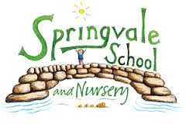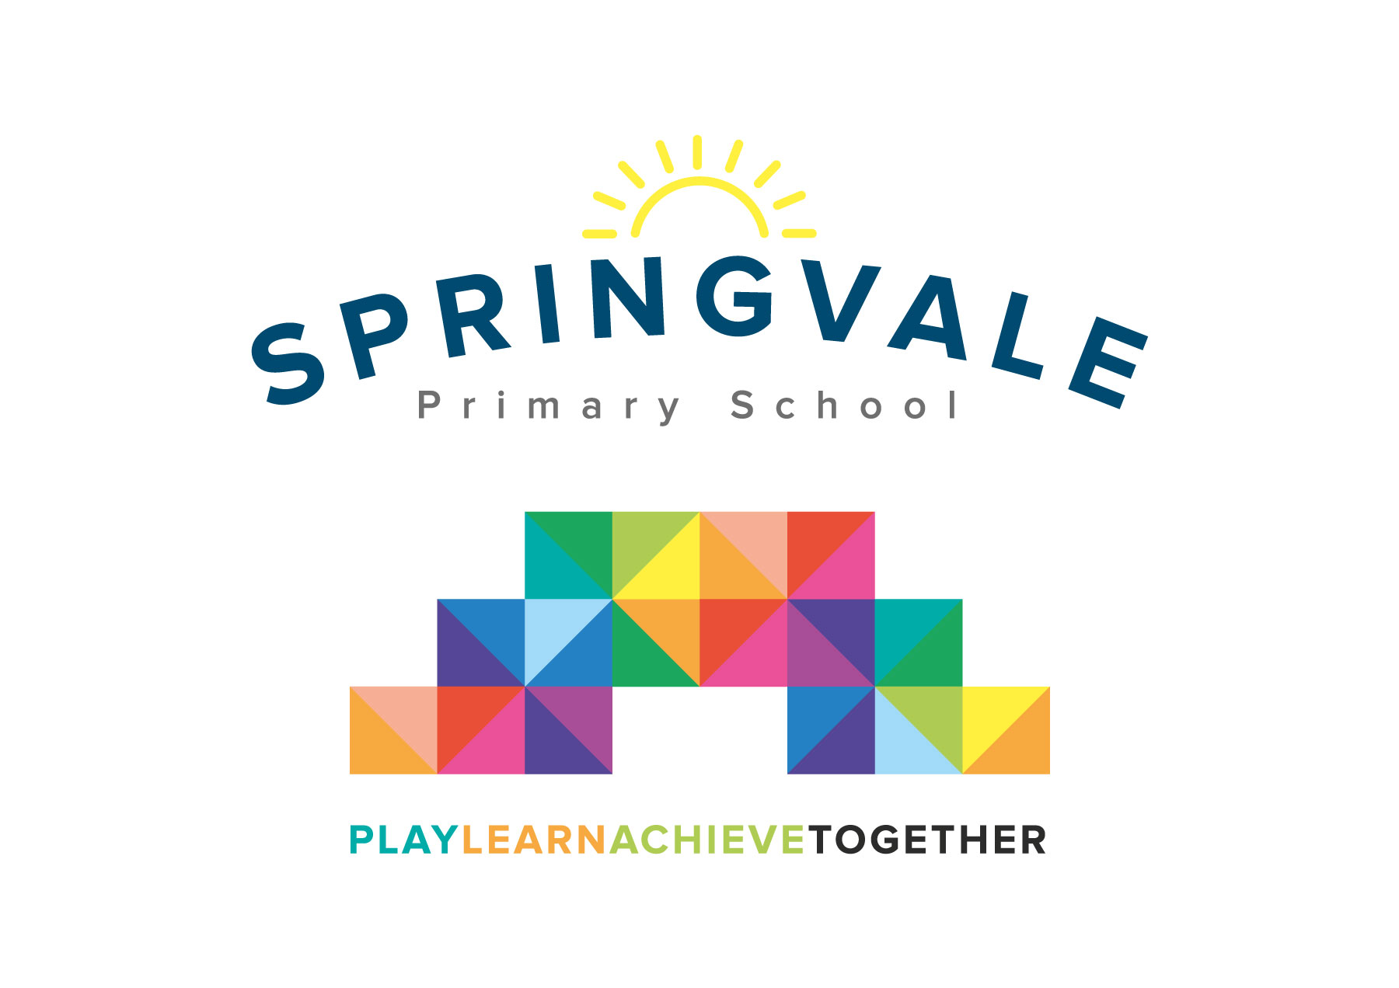
SPRINGVALE PRIMARY SCHOOL
01226 760930
Headteacher: Mr L McClure
l.mcclure@springvaleprimary.org
www.springvaleprimary.org
@SpringvalePS

Book Fair Monday 5th March 2018

Dear Parents,
I am writing to let you know that our Book Fair will be arriving in school on Tuesday 6th March and will be available to buy books from until Tuesday 13th March. This year we shall be holding an art competition, if your child/children wish to enter then they need to draw a picture of their favourite book character. They need to make sure that they put their name and their class number on the back of their art work. Mr McClure and Mrs Fearn will choose three winners, who will each receive a book of their choice from the book fair. There will also be a certificate given to the best illustration from each class. The children can use any form of art/craft to create their pictures.
The closing date for the competition will be Friday 9th March. Please can children put their entrees into the tray outside classes 3 and 4.
I shall look forward to seeing all of the masterpieces- have fun with it and good luck!

Thank You

Rhia Fearn
Deputy Head and Literacy Co-ordinator

