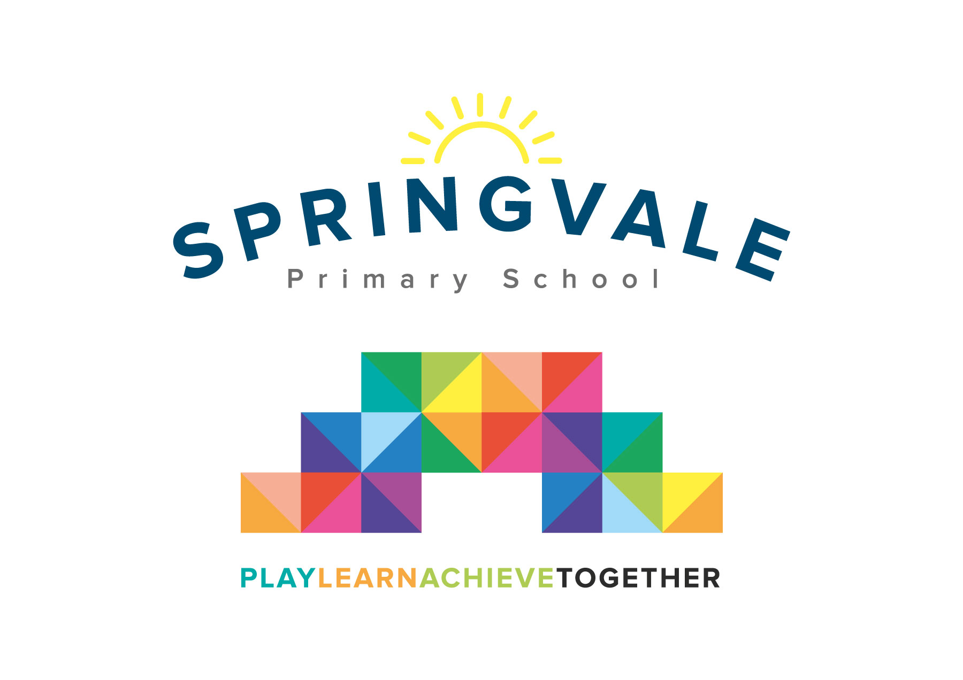
SPRINGVALE PRIMARY SCHOOL
01226 760930

Headteacher: Mr L McClure
l.mcclure@springvaleprimary.org
www.springvaleschool.org.uk
@SpringvalePS

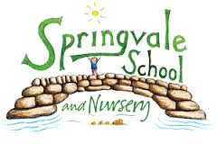

Viking Visit 21/03/2018

Dear Parent/Guardian,

On 12/04/18, we are going to be visited by a real, live Viking! The day will consist of workshops about Viking weapons and ways of life and will also involve dressing up as a Viking (information about what Vikings looked like will be sent home with the children). This visit will kick start our fantastic Viking topic.

There will be a cost for the school to have this special day, so it would be greatly appreciated if you could make a voluntary contribution. Mr McClure has kindly subsidised the cost of the day so that the contribution we need from you will be £5. Please note, if we do not receive enough contributions, the visit will not be able to go ahead.

Please log into school money to give consent for your child to take part in the day and pay the contribution, once you have received the link via text and email.

Kind regards,

Mr. Venus

