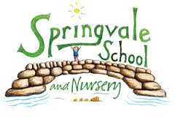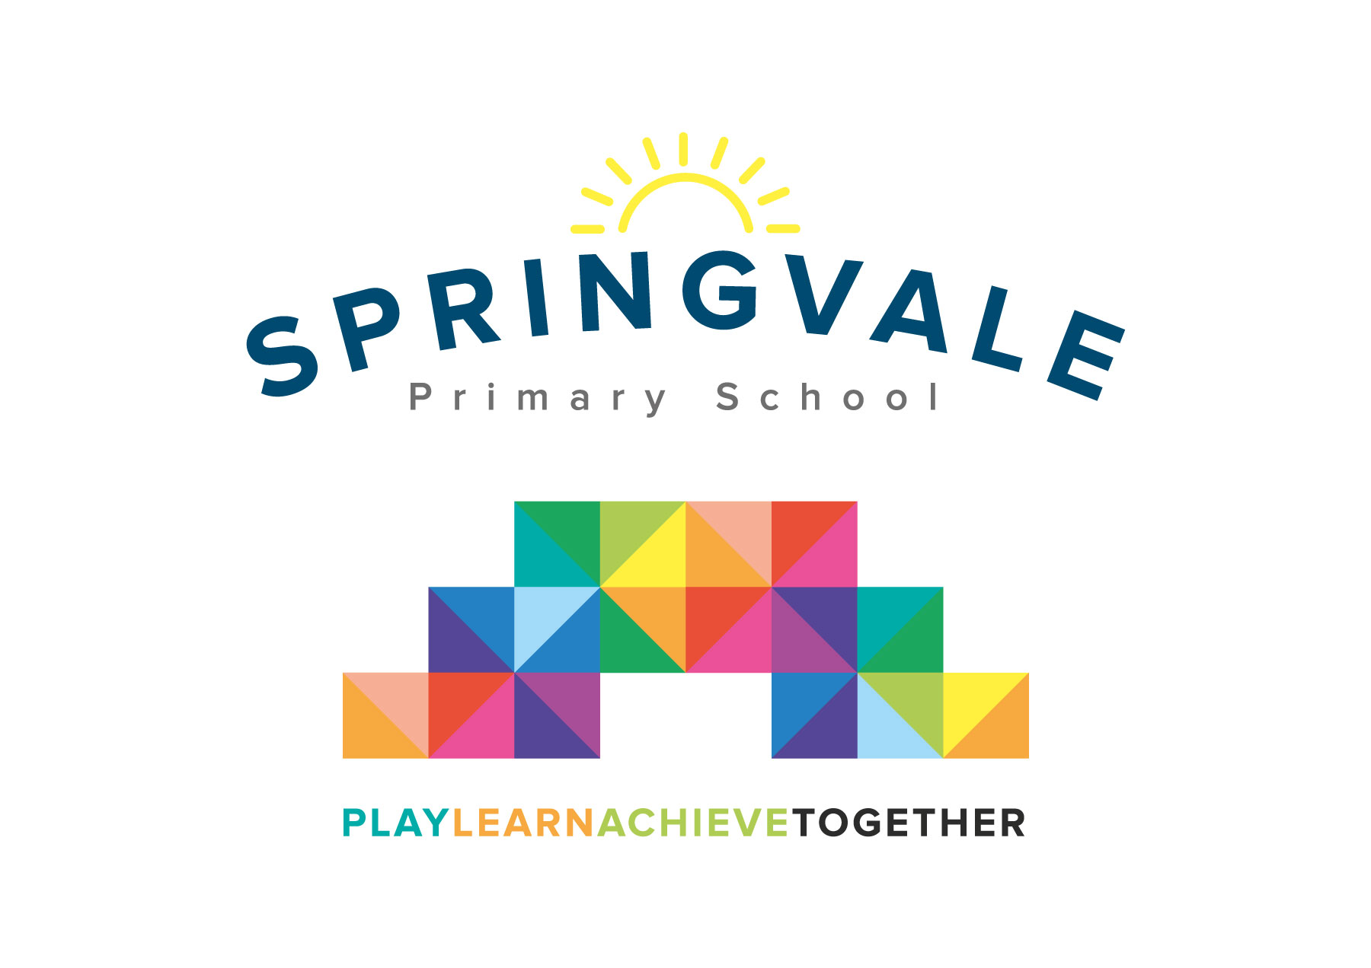
SPRINGVALE PRIMARY SCHOOL
01226 760930
Headteacher: Mr L McClure
l.mcclure@springvaleprimary.org
www.springvaleprimary.org
@SpringvalePS

Ofsted Report Wednesday 7th March 2018

Please find attached our latest Ofsted report. As you will be aware, we were inspected on Tuesday 20th February, for just one day by one inspector. Schools in strong positions with data that suggests that standards are positive now only receive a ‘short’ inspection. While this is positive for school leaders as it allows us to succinctly summarise our strengths it does mean that many of things that we believe in, and work hard for, don’t get seen or evaluated. For this reason I wanted to write a covering letter to ensure that we encapsulate all of the positive things about Springvale!

As you will see, the report is very short too so I thought it be useful to also add more context to the areas that aren’t yet as strong as we would like them to be. Some areas of the report make sense to the school leadership team as we were part of the evaluation work that took place but, in my opinion, they aren’t clear enough for all staff, Governors or parents to understand.

To begin with I want to highlight what a positive inspection this was and what a good report it is. Ofsted will also balance key strengths with areas to develop as this is their role but the report reflects the hard work of everyone in the school community for the last 4+ years since the last inspection in November 2013. The inspector felt, as we do, that the school had maintained the good judgement but that vast improvements were evident since the last inspection. Credit for this must go to staff, families, Governors and, of course, our wonderful children! Not just those in the building now but anyone who has been part of the last four years. With that in mind I must also say a big thank you to Mr Platt as he led the school for 80% of the time since the last inspection and much of the groundwork had been laid on key documents like policies and self-evaluation reports. I also adopted a school with a very strong curriculum and positive teaching team which means that we can move forward swiftly with our plans to improve further.

From the first day I visited the school I knew it was the perfect match for my values and vision of education and I was excited to take, what is clearly a good school where the children get a very well rounded education and lots of vital experiences, even further. The plan was always to be seen as ‘great’ by our children and parents (as soon as possible) and ‘outstanding’ by Ofsted and the Local Authority in the longer term. Our leadership team put a 3 year plan in place in September/October, a plan that is detailed and linked to all areas of our provision and performance.

Naturally, an Ofsted phone call only 6 months into that 3 year plan might not be seen as a helpful thing but I disagree. The inspection has proved that we have high standards, especially in teaching, safety, safeguarding and leadership. It also proves that we are well placed as a good school but still improving, a crucial judgement that means that school is heading towards an even more positive future. The key word that came out of our day of inspection was ‘consistency’. All key subjects and all classes were evaluated as good or better in their standards and this means that our staff can work together as an effective team to give every child the provision and support that they need and deserve.

The inspection proves that we are accurate in our judgements of teaching and overall school standards and, most importantly, that we have identified the right elements to improve further over the coming years. Our leadership team identified 3 areas to develop at the start of this year and we are delighted to see that, with information about every aspect of school available to our inspector, they have judged the exact same areas to be the key areas to work on. Crucially, the inspector saw our plans for these areas and can see that they are going to address the areas but she felt, rightly in my opinion, that it would take some time to carry out the plans, embed them and then see the fruits of the hard work in outcomes for pupils. For this reason we were always likely to be a good school with the potential to be outstanding in the near future- a judgement that we 100% agree with and are very proud of. We are now likely to have 3 to 4 years to embed our plans to move to an even stronger position.

There are many people to thank and celebrate after a positive Ofsted inspection.

Our staff are incredible. They are hardworking, skilled and experienced. They work together well and share their strengths. Teachers and teaching assistants are well deployed and they have excellent subject knowledge. They have supported me 100% since I arrived and have taken feedback, positive or developmental, in their stride and implemented change where needed. Their relationships with pupils and parents are warm and positive and they are regularly observed to go the extra mile. Thank you to them for their hard work!

Our parents are right behind us. Your support has been unwavering and so positive. It means the world to us all. The general feedback that we receive is always so warm and thoughtful, it keeps the staff going to know that our efforts are appreciated. The support that you give your pupils is also a key factor in our outcome- all of the homework, reading, multiplication tables…it all adds up!

A special thank you to Governors and external agents (SEND professionals, Gareth our ICT technician, welfare, finance, our amazing catering staff, attendance officers and Linda Singleton from the Local Authority) for your constant support and input. We have seen many changes to our Governing Body recently but anyone who takes the time to support and challenge us and take on a role that has so much accountability on a voluntary basis has my full respect.

Lastly, but most importantly, the children themselves. We are proud of our children and their talents. We are most proud of their attitudes to learning, their manners and their well-rounded skills and abilities. These short reports often don’t capture just how marvellous the children are but I assure you the inspector was aware just how wonderful our young people are.

The report also doesn’t reflect how effective our new school ethos has been has binding all of the groups mentioned above to one shared goal. Just a few months into our new ethos statement there is much evidence that we are all working collaboratively to play together, learn together and achieve together. The questionnaire responses (100% positive from staff, 98% positive from children and parents) are amongst the most positive experienced and suggest that the school is harmonious, safe and that leaders are willing to listen to feedback and give everyone a voice, this is so important to our future development.

To explain a few points about what we must do next to improve:
- The report mentions that we have measurable targets in our plans but not for subject leadership or pupils’ personal development. This means that we have some good plans for subject leadership and personal development (like improving assessment and directed leadership time for the foundation subjects like art, for example, and we have done lots on Y6 leadership and transition to secondary, for example) but that we need to plan those into the longer term future like we have other aspects of school performance. Core subjects (Literacy and maths) and phases (like the EYFS) are very well led. The standards in EYFS have risen over the last 4 years and we have exciting plans to develop the indoor and outdoor environments and provision over the next 18 months. SEND is well managed in school and pupils who have additional needs have personalised learning experiences and excellent support, helping them to make personal and academic progress at a pleasing rate.
- The report mentions bullying in a positive light, we explained that we are working on the definition of bullying with our parents and pupils and that we have evidence to show that when bullying is reported, it is taken very seriously and addressed with great tenacity by school leaders. Please help us by reporting any concerns directly to as soon as possible.
- Our KS1 outcomes last year were slightly below national averages. This is because the current Y3 cohort have more additional needs than our other classes. The group made positive progress in Y2 last year and, when moderated externally, their levels of progress were highlighted positively and judged to be extremely accurate. Our current KS1 pupils are making at least expected progress with many making more rapid progress. This year’s KS1 results are on track to at least match national averages with children targeted to make rapid progress throughout KS2 and, ultimately, achieve very well.
- We have made significant strides in supporting our most able pupils. We are now identifying children with the potential to achieve above expected standards much earlier and we are working together in research teams to develop how we can challenge our greater depth pupils more effectively. Ongoing observations show that more able pupils across the school are challenged well and that, when the start of a lesson suggests a child can tackle the given work, it is quickly adapted to stretch the child further. This is an area we have made good progress with but need more time to get right for everyone.
- We have a clear plan for developing how we meet the needs of our Pupil Premium children. Again, some positive elements have already been put in place, not least by bringing parents and carers into the discussions about how we support the children and meet their needs. Again, the inspection came too early into a long term plan to see the impact on the progress that this group of children makes.

Overall, our report shows that we are very well placed and working, with great enthusiasm and rigour, on the correct and necessary areas to make us even stronger. Thank you, once again, for your fabulous support. We are delighted that so many parents already recognise our school as a ‘great school’ and we look forward to your view on this week’s family questionnaire to help us to develop our plans for the future even further. We will, of course, keep you updated of our progress every step of the way!

Kind Regards
Mr L McClure
Headteacher

