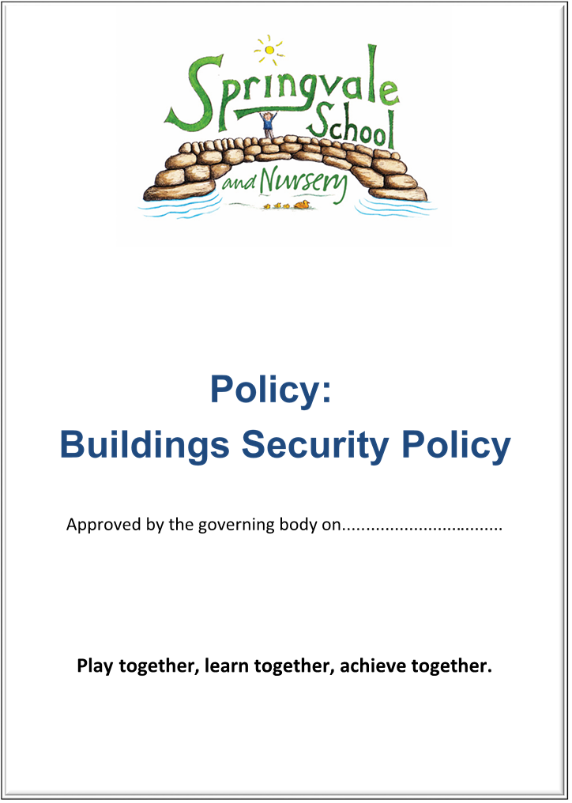
Allegations of abuse against Staff and Whistleblowing
SPRINGVALE PRIMARY SCHOOL Revised Spring 2018
Policy for Allegations of Abuse Against Staff and Whistleblowing Introduction

This policy has been formally adopted by the governors of Springvale Primary School. It was initially presented as a model policy by BMBC and has been accepted or adapted to reflect our practice.

Aims and Principles

The policy is underpinned by the central aims of Springvale Primary and values held by school community:
Aims of the school
- Springvale Primary is committed to promoting high standards of academic achievement for all learners in all subjects.
- As a school we will continue to develop and instil key life skills and values in our pupils.
- We will encourage positive relationships and communications between home, our community and the wider world.

In particular, Springvale School has an inclusive approach to our provision. Our aim is always to involve all our children and stakeholders in all areas of the curriculum and school life. In accordance with our Disability Equality Scheme we recognise that this may mean making special adaptations or arrangements from time to time for children with specific disabilities. We welcome the involvement of disabled adults in all areas of school life.

Springvale Primary School understands that an allegation could be made against any member of staff.
Allegations could refer to verbal, physical, emotional or sexual abuse.
If such an allegation is made, the member of staff receiving the allegation will immediately inform the headteacher. The Headteacher should then inform the Chair of Governors.
The headteacher on all such occasions will discuss the content of the allegation with the BMBC LADO within 1 working day.
If the allegation made to a member of staff concerns the Headteacher; the designated teacher will immediately inform the Chair of Governors who will consult with the LADO directly.
The school will follow the LA procedures for managing allegations against staff, which forms part of this policy. Reference should be made to the document ‘Working together to Safeguard Children’.
All members of staff and other regular volunteers within the school will be asked to read this policy and sign to indicate their understanding and acceptance of the procedures indicated.
This policy will be reviewed on a three yearly basis or following any notification from Barnsley LA that their procedures have changed.

Other relevant government publications:
‘What to do if you are worried a child is being abused’ DFE 2006
‘Working together to Safeguard Children‘ March 2015
‘Keeping Children Safe in Education’ Sept 2016

What follows is the BMBC policy for Whistleblowing as it affects all members of the Council. It has been slightly modified to bring clarity to staff at Springvale Primary School.

Barnsley Metropolitan Borough Council
CORPORATE WHISTLEBLOWING POLICY

1. Introduction

1.1 The Council is committed to the highest possible standards of openness, probity and accountability. In line with that commitment, employees and others with concerns about any aspect of the Council’s work have a duty to come forward and voice those concerns. This policy intends to support that duty and seeks to encourage and enable employees to raise concerns so that the Council can take prompt action.

1.2 Employees and others who work with the Council are often the first to realise that there may be something wrong within the Council. However, they may not express their concerns because they feel that speaking up would be disloyal to their colleagues or to the Council. Indeed it may also be the case that someone with a concern is not aware how best to raise it. It is important to stress that any concern raised through this Policy will be treated confidentially and with the utmost seriousness.

1.3 This Policy also makes it clear that legitimate concerns can be raised without fear of reprisals. It is human nature to be apprehensive about raising a concern and consequently someone may also fear harassment or victimisation for doing so. In these circumstances, despite their concern, someone may find it easier to ignore it rather than report what may be just a suspicion of wrongdoing. The Council is committed, as part of its overall ethical framework, to provide a process and procedure that encourages freedom of speech so that this does not happen.

1.4 To ensure an effective framework for receiving and dealing with concerns, this policy aims to:-
- show who the policy applies to;
- describe what kind of activity should be reported through this mechanism;
- explain how an employee should raise a concern within the Council;
- provide safeguards to protect and support individuals raising concerns and those who are the subject of concerns;
- describe how the Council will respond to concerns brought to its attention;
- describe how employees will receive feedback on the action the Council has taken;
- describe how an employee can take the matter further if they are dissatisfied with the Council’s response.

1.5 Guidance has been prepared to assist in the use and application of this Policy and should be read in conjunction with the Policy.

2. Who this Policy applies to

2.1 The policy applies to all employees and elected and co-opted members of the Council including those employees employed in locally managed schools. Employees of Council-owned companies, contractors employed by the Council, partner organisations and organisations receiving grant aid from the Council may also make use of the Council’s arrangements where they wish to raise concerns relating to the Council, its elected members or officers.

2.2 This Policy should be read in conjunction with the Council’s Code of Conduct for Employees. The Council’s Code of Conduct for Employees states that there is a duty on individuals to report any suspicion or concern they may have that Council employees, elected members or other individuals described in 2.1 above are involved in actual or potential fraudulent or corrupt activities (see Section 3). Once a concern has been raised the procedure within this policy must be followed. Failure to report a concern may also lead to further action being taken in exceptional circumstances.

2.3 The provisions of this Policy are for those individuals referred to above. These arrangements are not directly available to members of the public. The Authority’s complaints procedure should be used where a member of the public wishes to raise a concern.

2.4 For the benefit of brevity, the terms ‘employee’ and/or ‘elected member’ are subsequently used to include anyone defined in paragraph 2.1 above.

3. What sort of activity should be reported?

3.1 It is impossible and inappropriate to try to provide an exhaustive list of activities that would constitute misconduct or malpractice, but broadly speaking, the Council would expect to receive concerns surrounding:-

- abuse of children or staff
- a criminal offence, actual or potential;
- a failure to comply with a legal obligation;
- a miscarriage of justice;
- a misuse or theft of Council money, physical assets or the abuse of working arrangements, time recording or other human resources policies, e.g. recruitment procedures;
- a misuse or abuse of the Council’s computers, its systems, data or information;
- an act that breaches the Council’s financial regulations, contract standing orders or policies;
- the malpractice in dealing with or mistreatment of a client of the Council;
- actions which endanger the health and safety of staff or the public;
- an abuse of power or position;
- actions which cause damage to the environment;
- suspicions of bribery i.e. an inducement or reward offered, promised or provided to gain personal, commercial, regulatory or contractual advantage;
- improper conduct by an officer or elected member; or
- any action intended to conceal any of the above.

3.2 The Enterprise and Regulatory Reform Act 2013 introduces a public interest test in relation to whistleblowing. This ensures that, in order to benefit from protection, whistleblowing claims must satisfy a public interest test and disclosures which can be characterised as being of a personal rather than a public interest will not be protected. For example, if an employee does not receive the correct amount of holiday pay (which may be a breach of contract of employment), this is a matter of personal rather than wider interest. The whistleblower must also show that the belief that the disclosure was in the public interest was reasonable in the circumstances.

3.3 In the event of a dispute concerning an individual’s own employment, employees should use the provisions of other Council policies covering disciplinary, grievance, harassment and recruitment and selection procedures. Where the matter does not relate to your own employment position, it may be appropriate to use the provisions of the Whistleblowing Policy. Equally, where the actions of one employee is impacting on a number of others and directly or indirectly affecting the service being provided, it may be appropriate to address the concern adopting the Whistleblowing procedures.

3.4 This Policy is not intended for disagreements with Council policy. However if you reasonably believe that in following a Council policy an action, as listed in paragraph 3.1 above, is likely to occur, you should of course report it.

3.5 Although it is likely and often appropriate to start a formal investigation into matters raised, it is also possible that a more informal approach is recommended subject to the nature of the allegations made.

3.6 It is important to note that all concerns raised are considered on an individual basis and it is therefore not appropriate to set out any firm or suggested rules for how a particular type of concern is best dealt with.

4. Whistleblowing Officers

4.1 In order to provide employees with a recognised and consistent contact point, two Whistleblowing Officers have been designated. These are:

- Rob Winter, Head of Internal Audit and Risk Management, Telephone No. 775788
- Andrew Frosdick, Director of Legal and Governance, Telephone No. 775799

4.2 These officers will, as described in subsequent sections of this Policy, be the initial points of contact for employees who wish to use the Whistleblowing procedures. The Whistleblowing Officers will seek to assist an employee to raise a concern effectively.
4.3 Subsequent changes in officers will be communicated accordingly.

5. How to Raise a Concern

5.1 The Council through the provisions of this Policy encourages employees to raise concerns as early as possible to make it easier to take effective action. Normally and preferably, employees at Springvale should raise concerns within the Headteacher. In the event that the concern surrounds the Headteacher, it should be raised with the Chair of Governors.

5.2 Where an employee feels it is appropriate to raise a concern outside their normal management arrangements, one of the Whistleblowing Officers (see paragraph 4.1 above) should be contacted. Should an employee wish to speak to a female officer in detail, this can be arranged through the Whistleblowing Officers (if both Whistleblowing Officers are male).

5.3 Notwithstanding the provisions of this Policy, the Council’s Financial Regulations require actual or potential breaches to be reported to the Head of Internal Audit and Risk Management. However this requirement should not prevent or deter employees from raising concerns through the whistleblowing procedures.

5.4 When raising a concern employees are also encouraged to set out the background and history of the concern, giving names, dates, places and amounts where possible, and the reason for their concern. Absolute proof is not required as long as you can demonstrate reasonable grounds for the allegation. It is more important that concerns are raised than seeking to provide all the available evidence at the outset. If further information is needed this can be obtained by further investigation through the Council’s normal procedures. Specialist officers will be appointed to undertake the investigation to ensure objectivity, independence and that the proper processes are followed.

5.5 Employees and elected members who are raising a concern are therefore not permitted to undertake their own investigations, surveillance or to interview or visit any ‘witnesses’ as this could jeopardise a formal investigation.

5.6 There are a number of ways and facilities through which employees can raise a concern if they feel it is not appropriate to inform a manager within their section or department:

- contacting one of the Whistleblowing Officers by telephone (there is a voicemail facility if unanswered):
  - Rob Winter, Head of Internal Audit and Risk Management - Telephone (01226) 775788
  - Andrew Frosdick, Director of Legal and Governance - Telephone (01226) 775799

- using the dedicated 24 hour Whistleblowing hotline - 0800 138 2939

- writing in to the Whistleblowing Officers using a dedicated P.O. Box :-
Barnsley Metropolitan Borough Council
P.O. Box 320,
Barnsley,
S70 2YL

- e-mailing one of the Whistleblowing Officers :-
- WBO1RWinter (internal)
- WBO1RWinter@barnsley.gov.uk (external)

- WBO2AFrosdick (internal)
- WBO2AFrosdick@barnsley.gov.uk (external)

5.7 The Council recognises that employees may wish to seek advice from their trade union and indeed may invite their trade union (or professional association) to raise a matter on their behalf.

5.8 Employees are encouraged to give their name when raising a concern. If an employee chooses to raise a concern anonymously it will be taken further at the discretion of the designated Whistleblowing Officers in liaison with the appropriate senior officers and the Director, Finance, Property and Information Services as necessary. In exercising this discretion, certain factors will be taken into account. These are:-
- the seriousness of the issues raised;
- the credibility of the concern;
- the likelihood of confirming the allegation from attributable sources.
6. Safeguards

6.1 Harassment or Victimisation
The Council recognises that the decision to report a concern can be a difficult one to make, not least because of the fear of reprisal. The Council will not tolerate any form of harassment or victimisation, and will take the appropriate action to attempt to protect employees who raise a concern. However, this does not mean that if an employee raising a concern is already the subject of other employment procedures e.g. disciplinary or redundancy, that those procedures will be halted or suspended.

6.2 The Council will take steps to minimise any difficulties that the employee(s) may experience as a result of raising a concern. An employee might, as a last resort, be required to give evidence in Court or in disciplinary hearings. The Council will advise and support the employee about this, if necessary, to reduce any anxiety they may have.

6.3 Confidentiality
The Council will do its best to protect the identity of an employee who raises a concern and does not want his or her name to be disclosed to colleagues and / or the person(s) under investigation. Where an investigation takes place, the investigating officers will not disclose the whistleblower’s identity unless they are required to do so by law. This might happen if a formal, written statement is needed as evidence for example or where the matter is referred to a third party such as the Police for investigation. In no circumstances will the employee’s identity be revealed before he or she is consulted.

6.4 Untrue or Malicious Allegations
The Council’s intention in having a Whistleblowing Policy is to encourage employees to raise legitimate concerns. Consequently if an employee makes an allegation with a reasonable belief that the disclosure was in the public interest, but it is not confirmed by the investigation, no action will be taken against them. Where, however, an employee is shown to have made malicious, frivolous or vexatious allegations, or indeed undertaken their own investigations, surveillance or interviewed or visited witnesses or for their own personal gain, disciplinary action may be taken.

7. How the Council will Respond

7.1 The action taken by the Council will depend on the nature of the concern. In order to protect individuals and the Council, initial enquiries will be made to decide whether an investigation is appropriate and, if so, what form it should take. Concerns or allegations that fall within the scope of specific procedures (for example, child protection, disciplinary or discrimination issues) will normally be referred for consideration under those procedures. The matters raised will be investigated internally to establish basic facts. At that stage a decision will be made on whether:

- to complete the investigation internally;
- to refer the matter to the Authority's External Auditor;
- to refer the matter directly to the Police;
- to refer the matter to Social Care
- to organise an independent inquiry;
- take no action.

7.2 Some concerns may be resolved by agreed action without the need for a formal investigation.

7.3 Feedback to Employees raising a concern
The Council will inform the employee who raised the concern where possible, practical and appropriate within ten working days of a concern being received, and as appropriate:-
- acknowledging that the concern has been received;
- indicating how it proposes to deal with the matter;
- stating whether any initial enquiries have been made;
- stating if further investigations will take place, and if not, giving reasons.

7.4 The amount of contact between the officers considering the issues and the employee(s) who raised the concern will depend on the nature of the matters raised, the potential difficulties involved and the clarity of the information provided. Initial contact with the employee(s) may be outside of the work place to protect their identity and, if necessary and mutually acceptable, subsequent meetings may be held away from work and / or outside normal working hours. At Springvale School, we will maintain clear written records of any communication.

7.5 When any meeting is arranged, the employee(s) who raised the concern may be accompanied by a Trade Union or professional association representative, willing colleague or other representative of their choice as long as that person is not involved in the concern being discussed.

7.6 The Council accepts an employee who raised a concern may need to be assured that the matter has been properly addressed. Thus, subject to legal constraints, he / she will receive information about the outcomes of any investigations.

7.7 It is recognised that instances may arise where a concern has been raised but not proven, that results in the whistleblower and accused resuming a working relationship together. This in turn may give rise to concerns of potential victimisation or harassment. Where this is the case, reference should be made to the Council’s existing personnel procedures.

8. The Public Interest Disclosure Act 1998 (PIDA) and Enterprise and Regulatory Reform Act 2013 (ERRA)

8.1 The PIDA became Law on 2nd July 1999. Its purpose is to protect employees from victimisation as a result of raising a concern ‘in good faith’. However, the ERRA has now removed the requirement that a disclosure be made ‘in good faith’ in order to be a protected disclosure and benefit from whistleblowing protections.

8.2 Both Acts afford protection to employees who raise concerns in accordance with certain criteria and describe where protection will not be available when a disclosure is made in certain ways.
8.3 Protected Disclosures
Protection will be afforded to an employee where the concern is made in the public interest and has been raised in the first instance within the Council or to a Solicitor in the process of obtaining legal advice.
Any concern raised in the public interest to one of the Whistleblowing Officers or to an employee’s own management will, all things being equal, qualify as a protected disclosure.
Other circumstances where protection through the Act is applicable are where a disclosure is made:

- to a prescribed Regulatory Body (i.e. Health and Safety Executive);
- to a wider audience (press, MP etc.) if made internally first or to a prescribed Regulatory Body.

Protection would also be afforded albeit in exceptional circumstances, where the employee raised a concern outside the Authority where they have a real and reasonable fear that they would suffer victimisation or that the information would be concealed or indeed the matter is exceptionally serious.
Section 19 of the ERRA introduces a vicarious liability provision so that where the employee making the protected disclosure is subjected to a detriment by a co-worker and the detriment is done in the course of the co-worker’s employment with the Authority then the detriment is a legal wrong and is actionable against both the Council and the co-worker. However, the Council will not be liable for the actions of a co-worker if they have taken all reasonable steps to prevent the co-worker from subjecting the Whistleblower to a detriment. In these circumstances the co-worker will still be liable and the Whistleblower could bring a claim against the co-worker.
In the event of an employee being dismissed or victimised, the Act allows that employee the right to compensation at an employment tribunal although the ERRA provides employment tribunals with the power to reduce an award of compensation by up to 25% where a protected disclosure has not been made ‘in good faith’.

8.4 Unprotected Disclosures
Simply speaking, any disclosure not meeting the criteria for protection will be unprotected. This means for example that an employee making a malicious disclosure or one made hastily to the media will not be protected.

8.5 Both Acts are complicated pieces of legislation. General advice is available from the Authority’s Legal and Governance Section of the Corporate Services Department. Employees are however encouraged to seek specific advice from their Trade Union or own solicitor.

8.6 The provisions of the Acts address the implications that an employee may otherwise face under their contract of employment from making a disclosure. Employees should also be aware that any person about whom a disclosure is made may have rights under the common law of defamation if that disclosure contains anything that it not accurate. However the common law defence of defamation will normally apply where any person in making a disclosure that is not accurate acts with reasonable belief that the disclosure is in the public interest and without malice. Again, any specific legal advice as to an employees own position should be obtained independently.

9. How The Matter Can Be Taken Further

9.1 This policy is intended to provide employees with an avenue to raise concerns within the Council and be satisfied with the Council’s response. However, should an employee feel dissatisfied with the Council's response, and feels it is right to take the matter outside the Council, they can do so. Contact can be made through one of the following contact points:

- the Authority’s External Auditors, KPMG:

  - Leeds Office: - 1 The Embankment, Neville Street, Leeds, LS1 4DW Telephone 0113 231 3000 or

  - John Cornett (KPMG Director), St Nicholas House, Park Row, Nottingham, NG16FQ - Telephone 0115 935 3535;

- The relevant professional bodies or regulatory organisation ;
- Public Concern at Work (who can be contacted on 020 7404 6609)
- Trade Union
- a Solicitor
- the Police

Note – Public Concern at Work can also be contacted should someone wish to seek independent advice about how best to raise a concern. Seeking this independent advice would not constitute legal notification to the Council.

9.2 It should be remembered that failing to raise the matter within the Council first may result in the disclosure being unprotected within the provisions of the Public Interest Disclosure Act 1998.

9.3 Employees who are in any doubt regarding the provisions of the Policy should contact Human Resources. Advice as to whether or how a matter should be raised should be sought by contacting one of the Whistleblowing Officers.

10. Trade Unions

10.1 This Policy has been endorsed by the Trade Unions.

11. The Responsible Officer

11.1 The Chief Executive has overall responsibility for the maintenance and operation of this policy.

12. The Audit Committee

12.1 In accordance with its Terms of Reference for the oversight of the internal control and governance framework of the Authority, the Audit Committee will review this Policy and consider its effectiveness through a process of annual review.

