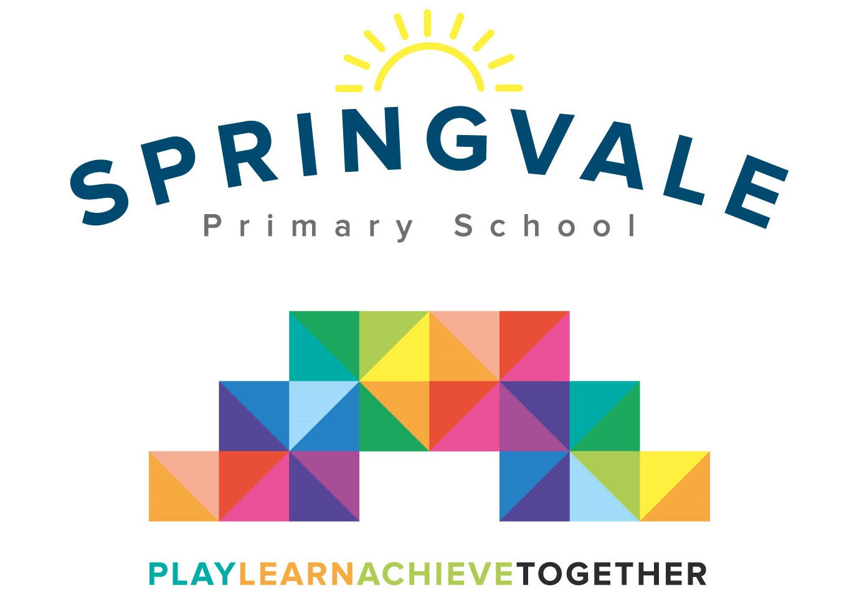
SPRINGVALE PRIMARY SCHOOL
01226 760930

Headteacher: Mr L McClure
l.mcclure@springvaleprimary.org
www.springvaleprimary.org
@SpringvalePS

‘Bike It Breakfast’ Monday 23rd April 2018

Dear families,

We have organised a special breakfast event to encourage more children to cycle and scoot to school, when it is safe to do so. As part of our two-week ‘Big Pedal’ (which started today) we are encouraging as many children as possible to travel to school in active ways to stay safe, fit and healthy and to help to protect our environment.

On Monday 30th April, from 8.15 to 9am we are offering a free breakfast to children who travel by bike or scooter. The breakfast will be healthy including breads, fruits and juices. There will also be some bike related prizes up for grabs! Children can attend without supervision from Y1 to Y6 and they should be left at main reception and checked off the list at the hall doors. Children in F2 or AM F1 can also attend but they must be supervised by an adult throughout and then taken to their classroom before 9am. Please note that we are only offering breakfast to children on this occasion due to the limited budget available.

To secure your place please email l.mcclure@springvaleprimary.org before 5pm on Thursday 26th April and please inform me of any dietary needs or allergies.

Children from Y1 to Y6 will be supervised throughout and taken down to classrooms at 9am. Children who attend running club, but would still like to take part, should still email to reserve a place but they will have their breakfast at 8.45am after running!

Kind Regards

Mr L McClure

Headteacher

