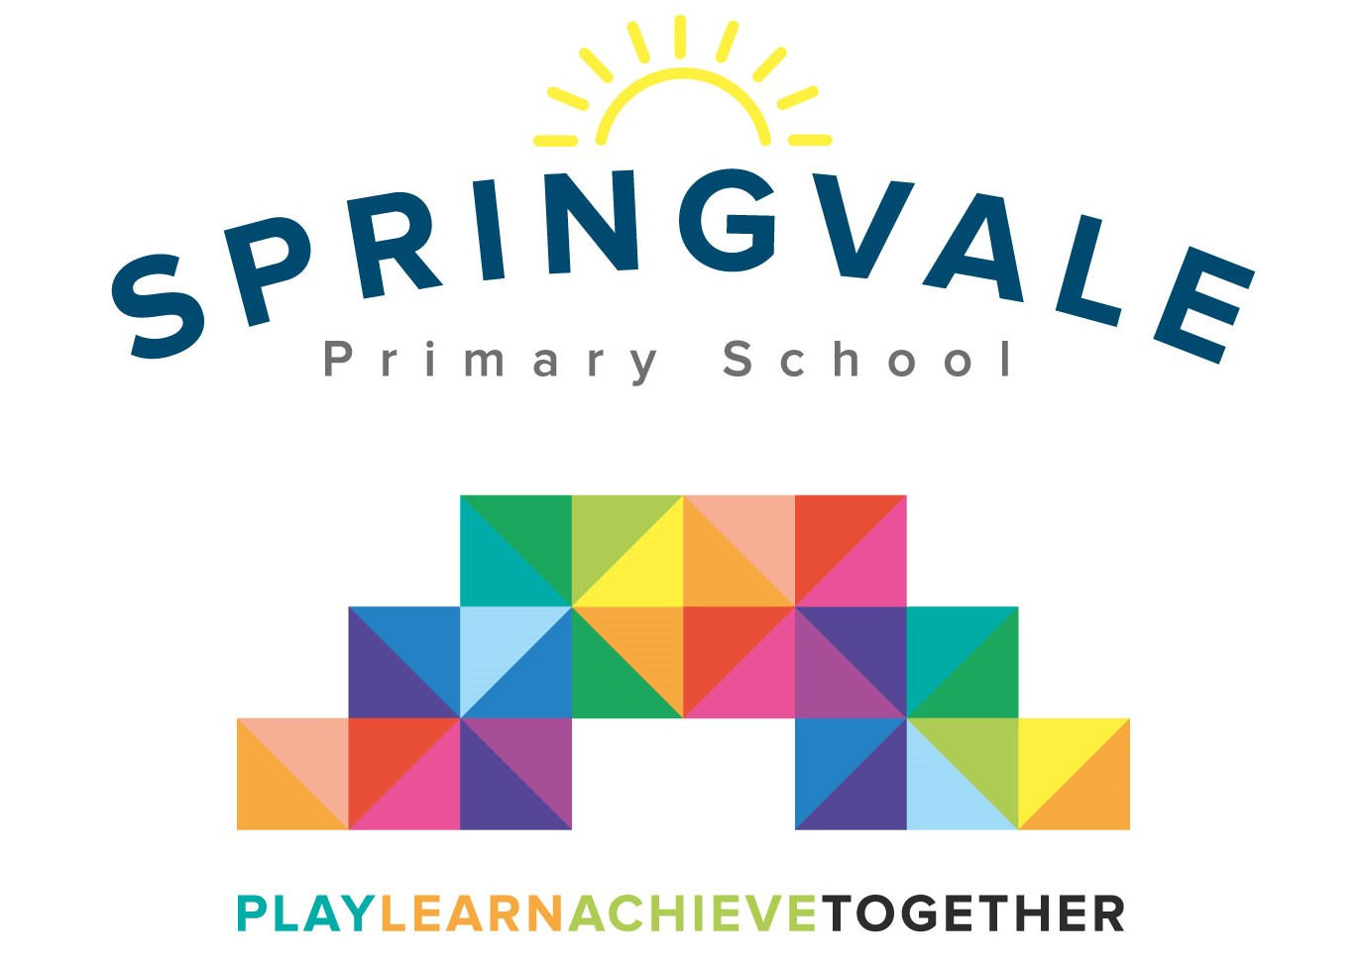
SPRINGVALE PRIMARY SCHOOL
01226 760930

Headteacher: Mr L McClure
l.mcclure@springvaleprimary.org
www.springvaleprimary.org
@SpringvalePS

KS2 Football - Bruce Dyer Wednesday 18th April 2018

I am delighted to confirm that we have been invited to take part in Bruce Dyer’s annual football tournament. The event is next Friday after school, on Friday 27th April. The event will take place at Barnsley Football Club’s academy and it will start at 3.30pm and finish at approximately 5.30pm. The permission slip below must be completed and returned for children to take part. Children will need to be transported to and from the event by parents. Bruce has invited the children who attend his club. The winning team could actually play on the Oakwell pitch on the Saturday!

Children require white or black shorts/socks, appropriate footwear (boots ideally due to the wet/muddy pitch), a t-shirt, a warm jacket and a water bottle. We strongly recommend shin pads are also worn but parents can give permission to play without (see below). We will give the children a school shirt which must be handed back at the end of the game. We ask for players to bring their own shorts and socks as they get lost easily and are costly to replace.

We hope that the children are Bruce’s club and are looking forward to the tournament! Please note that children will only represent their school in sporting fixtures if they attending school regularly, working hard and following our ‘Steps to Success’. I am sure the children will represent their school fantastically well!

#PlaytogetherLearntogetherAchievetogether

Kind Regards

Mr L McClure

Headteacher

My child can take part in the football tournament. I will collect them from school at 3pm and transport them to the event at Barnsley FC Academy. (Siblings can also be collected early)

Please select either…
My child will wear shin-pads _______________

Or…
I give my child permission to play without shin-pads _____________

Name _______________________________ Class ___________________________

Signed by parent _____________________________________

