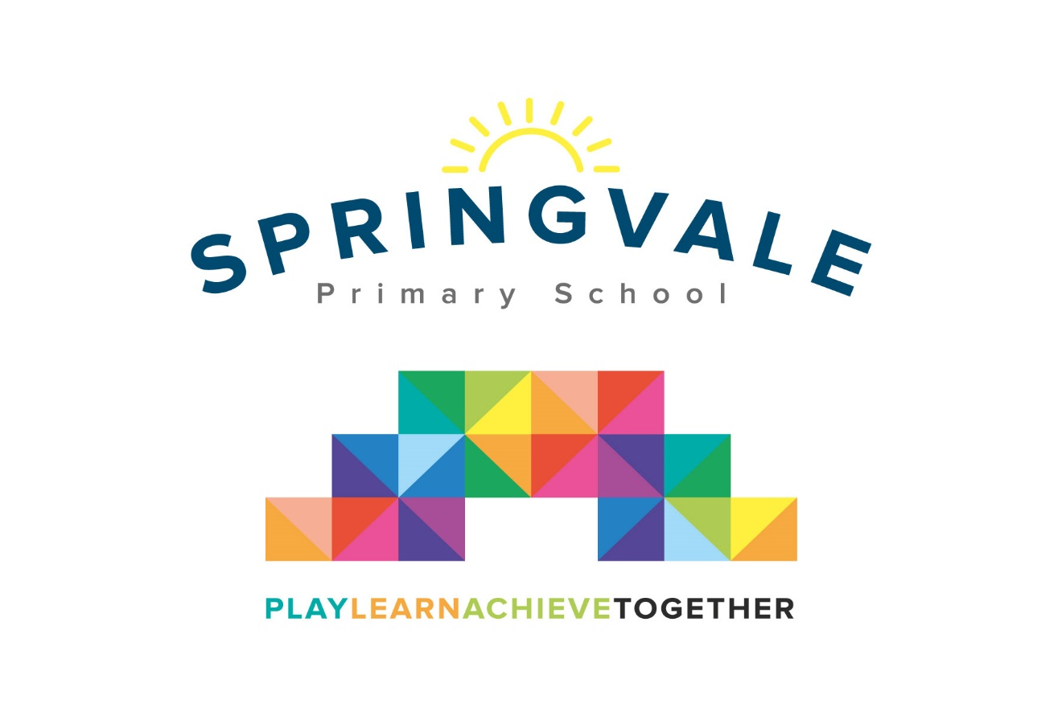
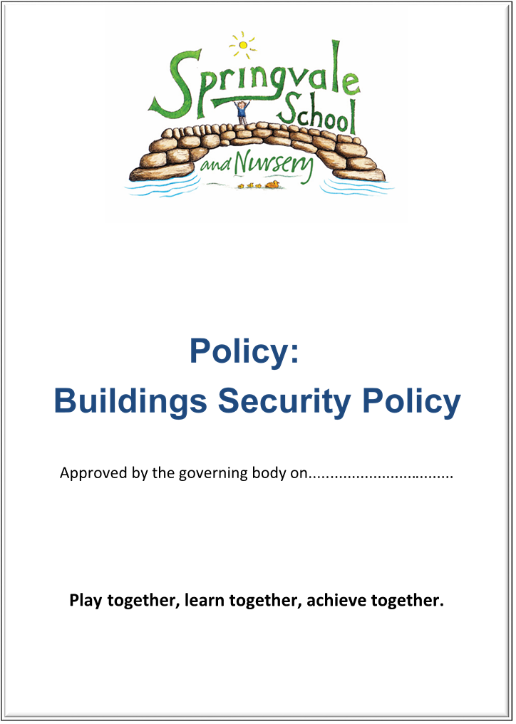
SPRINGVALE PRIMARY SCHOOL Revised Autumn 2014
Healthy Eating Statement
Healthy Eating Statement
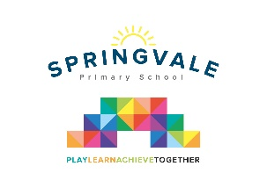
Introduction

This policy was created after a period of consultation with relevant stakeholders within school. It has been formally adopted by governors and reflects our approach at Springvale Primary School.

Aims and Principles
The policy is underpinned by the central aims of the Springvale Primary and values held by the school community:
Aims of the school
- Springvale is committed to promoting high standards of academic achievement for all learners in all subjects.
- As a school we will continue to develop and instil key life skills and values in our pupils.
- We will encourage positive relationships and communications between home, our community and the wider world.

In particular, Springvale School has an inclusive approach to our provision. Our aim is always to involve all our children and stakeholders in all areas of the curriculum and school life. In accordance with our Disability Equality Scheme we recognise that this may mean making special adaptations or arrangements from time to time for children with specific disabilities. We welcome the involvement of disabled adults in all areas of school life.

Purpose of the policy
This policy is a statement of current practice in Springvale School. It offers a positive framework for all members of our school community to enable us to: -

- Learn about foods that are good for us
- Have more foods that are good for us in school
- Manage foods that are not good for us

It was drafted with reference to the policies set out in Barnsley Food and Health Policy, after scrutiny and development of Healthy Food Practices in Springvale School. It is important for all those involved in providing food to our children to help them make suitable choices.

Barnsley Policy Recommendation
- ‘Every Barnsley School should be encouraged to adopt and implement a nutritional policy which covers both teaching about nutrition and the provision of food within and around the school environment. Governing bodies should consider nominating an individual governor with responsibility for monitoring implementation of the nutrition policy.’

Our Response
- Teaching about healthy eating has been identified across all of the Key Stages in school.
- The Governor for safeguarding takes responsibility for monitoring this policy.

A Healthy Eating Programme of study has been developed and is adhered to in school.

- Drinking water is available for all children and staff throughout the day.
- Healthy, nutritionally balanced meals appear daily on our school menu and meet the required nutritional standards set out by the government.
- Fresh fruit and salad are available every day at lunchtime for children who take up the offer of a school meal.
- Our spending of the Sports Premium ensures that physical exercise has a high profile, with all classes enjoying two full hours of sport each week. This supports our teaching of healthy eating for fitness and well-being.
- Children begin to understand the benefits of growing their own food and the origins of fruit and vegetables.
- We aim to give healthy options such as fruit and smoothies at events such as Sports Day and the Macmillan Coffee morning
- School takes up opportunities to work with other agencies which promote healthy eating to children such as the Health4life programme of family learning.
- All phases teach children about a balanced diet and, more specifically, a healthy lunchbox.
- Foundation Stage and Key Stage One pupils have a range of fruit daily as a snack during the school day.
- Teachers take feedback from the SMSA team about the contents of lunch boxes and speak to parents where they have concerns. Staff will always model and encourage healthy alternatives. Sweets and nuts are not accepted in lunchboxes. Unbalanced lunchboxes are also not allowed and parents may be contacted to discuss the contents of a child’s lunchbox.

Barnsley Policy Recommendation

“Updating Barnsley teachers on current food and health issues could be programmed into the inset training programme/joint/BASIS courses.”

Our Response
- As appropriate, members of staff attend courses related to staying healthy and and disseminate ideas and information at staff meetings
- Our PE provision and extended range of clubs and competitions, coupled with our more active break-times led by Y6 Play Leaders will ensure that children are healthier and more active
- All staff are aware of the obesity problems among school children, and discuss nutrition and exercise both within the curriculum and informally
- We are supported by a food professional from our school caterers who works alongside the Senior Leadership Team/teaching team to deliver messages about healthy eating.
- We encourage children to celebrate their birthday by not sharing baked goods with the class or sweets but to consider healthy and dietary friendly options. Where children do choose to share a birthday treat with their class, they are given out at the end of the day so that parents can decide if/when the treat will be taken.
- We will hold a bake sale for local/national charities at 3 points of the year, generally once per term. Alternatives will be offered for children with dietary needs that meet hygiene standards of a working kitchen.
- At two discos during the year we will sell juice and healthy snacks as part of the event.
- These opportunities do not promote unhealthy eating but they do celebrate a balanced diet against a healthy and active lifestyle.

Barnsley Policy Recommendation
“… The guidelines recommend a whole school approach to food and nutrition”

Our Response

The development of this policy, and our shared awareness as a staff, ensures that Springvale School has a whole school approach to healthy eating.

