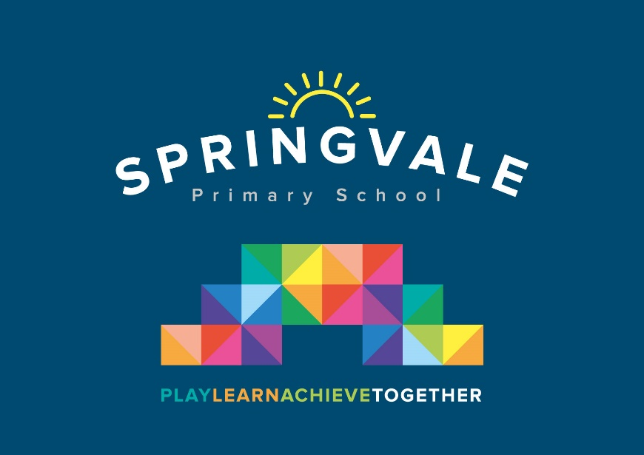

Springvale Primary Data Protection
Privacy notice for pupils and their families

Schools are currently required to inform pupils and their families about how their personal data may be collected and used. This requirement will remain once the General Data Protection Regulation (GDPR) comes into effect on 25 May 2018.

Who processes your information?

Springvale Primary is the data controller of the personal information you provide to us. This means the school determines the purposes for which, and the manner in which, any personal data relating to pupils and their families is to be processed. Mr L McClure acts as a representative for the school with regard to its data controller responsibilities; they can be contacted on 01226760930 or l.mcclure@springvaleprimary.org.

In some cases, your data will be outsourced to a third party processor; however, this will only be done with your consent, unless the law requires the school to share your data. Where the school outsources data to a third party processor, the same data protection standards that Springvale Primary upholds are imposed on the processor.

Mr L McClure is the data protection officer. Their role is to oversee and monitor the school’s data protection procedures, and to ensure they are compliant with the GDPR.

Why do we collect and use your information?

Springvale Primary holds the legal right to collect and use personal data relating to pupils and their families, and we may also receive information regarding them from their previous school, LA and/or the DfE. We collect and use personal data in order to meet legal requirements and legitimate interests set out in the GDPR and UK law, including those in relation to the following:

- Article 6 and Article 9 of the GDPR
- Education Act 1996
- Section 3 of The Education (Information About Individual Pupils) (England) Regulations 2013

In accordance with the above, the personal data of pupils and their families is collected and used for the following reasons:

- To support pupil learning
- To monitor and report on pupil progress
- To provide appropriate pastoral care
- To assess the quality of our service
- To comply with the law regarding data sharing
- To support families and their wellbeing
Which data is collected?

The categories of pupil information that the school collects, holds and shares include the following:

- Personal information – e.g. names, pupil numbers and addresses
- Characteristics – e.g. ethnicity, language, nationality, country of birth and free school meal eligibility
- Attendance information – e.g. number of absences and absence reasons
- Assessment information – e.g. national curriculum assessment results
- Relevant medical information
- Information relating to SEND
- Behavioural information – e.g. number of temporary exclusions

Whilst the majority of the personal data you provide to the school is mandatory, some is provided on a voluntary basis. When collecting data, the school will inform you whether you are required to provide this data or if your consent is needed. Where consent is required, the school will provide you with specific and explicit information with regards to the reasons the data is being collected and how the data will be used.

How long is your data stored for?

Personal data relating to pupils at Springvale Primary School and their families is stored in line with the school’s GDPR Data Protection Policy.

In accordance with the GDPR, the school does not store personal data indefinitely; data is only stored for as long as is necessary to complete the task for which it was originally collected.

Will my information be shared?

The school is required to share pupils’ data with the DfE on a statutory basis, this includes the following:

- Dates of birth
- Curriculum year group
- Pupil attendance data
- Pupil performance data
- Exclusion data
The National Pupil Database (NPD) is managed by the DfE and contains information about pupils in schools in England. Springvale Primary is required by law to provide information about our pupils to the DfE as part of statutory data collections, such as the school census; some of this information is then stored in the NPD. The DfE may share information about our pupils from the NDP with third parties who promote the education or wellbeing of children in England by:

- Conducting research or analysis.
- Producing statistics.
- Providing information, advice or guidance.
The DfE has robust processes in place to ensure the confidentiality of any data shared from the NDP is maintained.

Springvale Primary will not share your personal information with any third parties without your consent, unless the law allows us to do so. The school routinely shares pupils’ information with:

- DfE
- Pupils’ destinations upon leaving the school
- The LA
- The NHS

What are your rights?

Parents and pupils have the following rights in relation to the processing of their personal data.

You have the right to:

- Be informed about how Springvale Primary uses your personal data.
- Request access to the personal data that Springvale Primary holds.
- Request that your personal data is amended if it is inaccurate or incomplete.
- Request that your personal data is erased where there is no compelling reason for its continued processing.
- Request that the processing of your data is restricted.
- Object to your personal data being processed.
Where the processing of your data is based on your consent, you have the right to withdraw this consent at any time.

If you have a concern about the way Springvale Primary and/or the DfE is collecting or using your personal data, you can raise a concern with the Information Commissioner’s Office (ICO). The ICO can be contacted on 0303 123 1113, Monday-Friday 9am-5pm.

Where can you find out more information?

If you would like to find out more information about how we and/or the DfE collect, use and store your personal data, please visit our website at www.springvaleprimary.org where you can download our full GDPR Data Protection Policy.

Declaration

I, Mr L McClure, declare that I understand:

- Springvale Primary has a legal and legitimate interest to collect and process my personal data in order to meet statutory requirements.
- How my data is used.
- Springvale Primary may share my data with the DfE, and subsequently the LA.
- Springvale Primary will not share my data to any other third parties without my consent, unless the law requires the school to do so.
- Springvale Primary will always ask for explicit consent where this is required, and I must provide this consent if I agree to the data being processed.
- My data is retained in line with the school’s GDPR Data Protection Policy.
- My rights to the processing of my personal data.
- Where I can find out more information about the processing of my personal data.
Name: | –––––––––––––––––––––––––––––
Signature: | –––––––––––––––––––––––––––––
Date: | –––––––––––––––––––––––––––––

