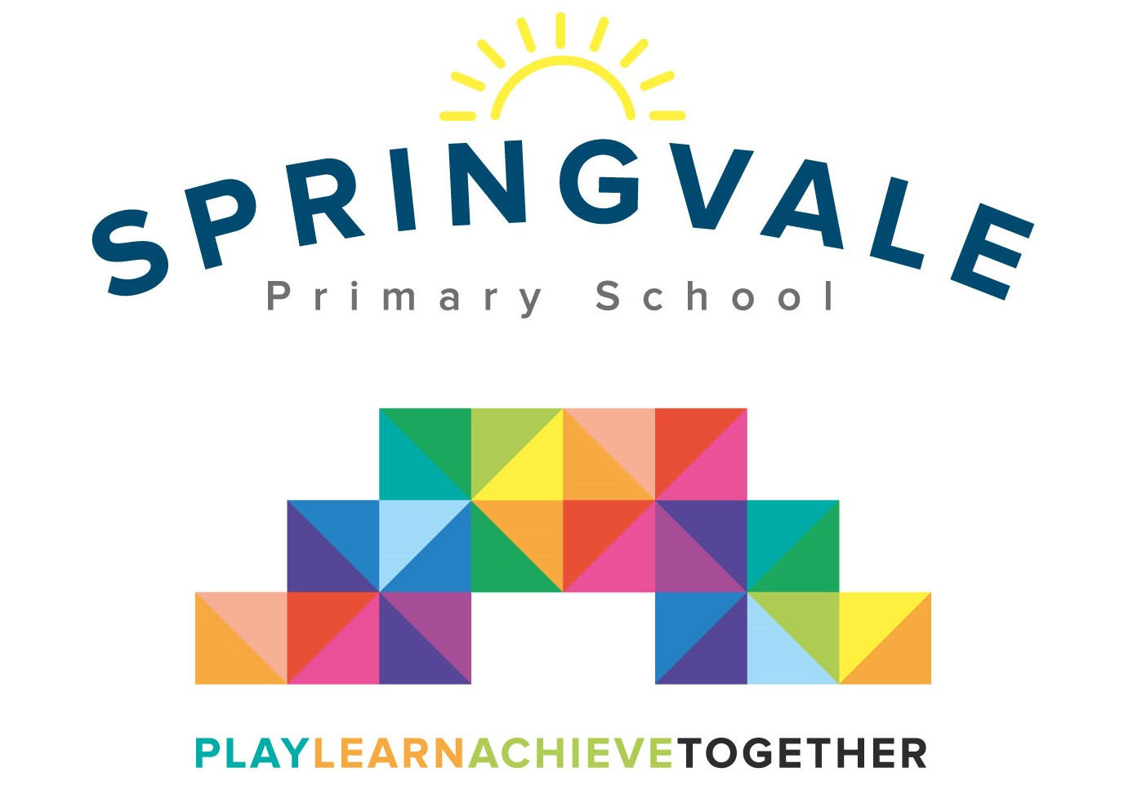
SPRINGVALE PRIMARY SCHOOL
01226 760930

Headteacher: Mr L McClure
l.mcclure@springvaleprimary.org
www.springvaleprimary.org
@SpringvalePS

Pop Shop! Wednesday 11th April 2018

Dear parents,

As our children’s choir never took off we wanted to explore other opportunities for children to learn to sign and perform with confidence. We now offer a free choir to the children on a Friday lunchtime but the opportunity has arisen for an excellent additional offer.

Mrs Audrey Parsons, who comes highly recommended and is a former parent at the school, would like to lead a club where children learn theatre and performance skills to increase their ability and confidence. The club will run on Tuesday afternoons and it is initially open to pupils in Y2-Y6.

The club will run for 6 weeks starting on Tuesday 17th April with the first session being a free trial. The club will end on Tuesday 15th May but we will look to keep it going if we have enough interest. We can only offer up to 20 places for the full block so if you want to secure your place please book/pay online ASAP. If you are unsure but your child wants to try the club first, please email me (details above) but please be aware that the club may book up in the meantime.

The cost is £25 for the block, £5 per session after the free trial.

We need a minimum of 15 children to run the club and we will contact everyone who has booked if the club does not have enough bookings to run sessions.

The club will run from 3.15 to 4.30pm and children should be collected from the Community Room.

What an exciting new club! We hope that you can get involved!

Kind Regards

Mr L McClure

Headteacher

