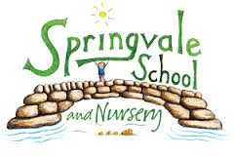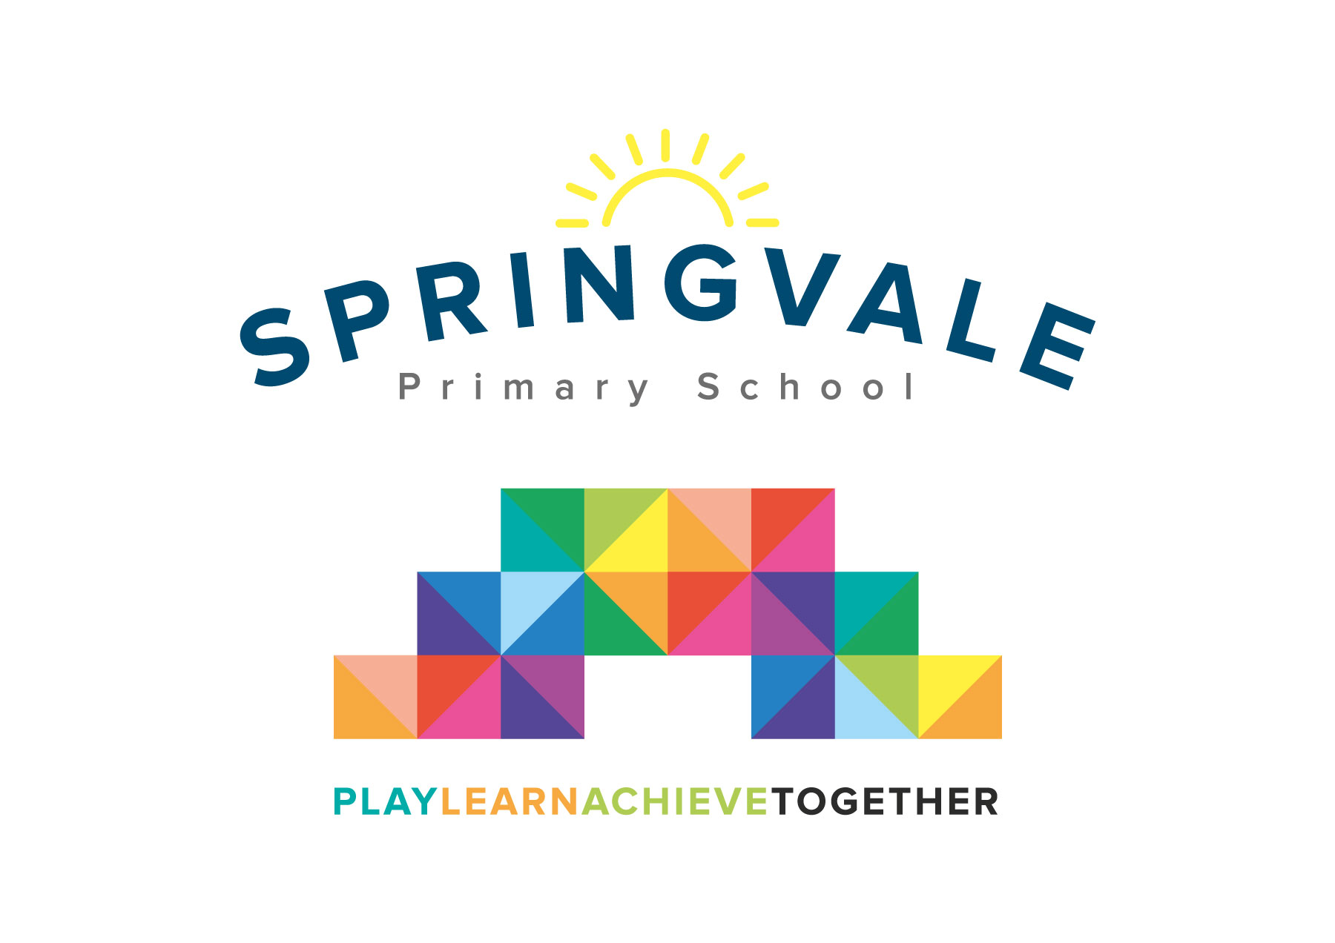
SPRINGVALE PRIMARY SCHOOL
01226 760930
Headteacher: Mr L McClure
l.mcclure@springvaleprimary.org
www.springvaleprimary.org
@SpringvalePS

Newsletter- Week 29 Monday 30th April 2018

Dear families,
The busy start to term has gone into fifth gear with lots of events recently and even more to come! Remember, whilst it is great that so many people now follow us on Twitter and use our new and developing website, this weekly newsletter is the place to go for all of the key information about what is going on in school! If you can catch up with the newsletter every Monday you won’t miss out on anything!

Music Concert: Last Wednesday we had an amazing music concert for all of our instrumentalists. They were so confident and clear, we were all incredibly proud. Well done to everyone involved and keep up the excellent progress…I’m already looking forward to next year! If your child would like to take up an instrument, please ask at the office for prices and details. A big thank you to our visiting music teachers for their hard work and support, as ever. Congratulations to our amazing award winners…Lucie Roberts (guitar) and Lucinda Dyson (piano/keyboard) from Y6 who won our ‘Hilary Smith Award’ for achievement and Isabel Curran (violin) from Y4 who won our ‘Jack Sykes Award’ for determination and progress in music.

Attendance: Our attendance is absolutely fantastic at the moment and we want to keep it high! We currently have the best attendance of all Barnsley Schools (to the best of our knowledge!) and we want to keep it that way. Well done everyone! Our next focus will be to reduce persistent absence; this is when a child has attendance below 90% for the whole school year. Look out for a letter about how we plan to address this in the near future, if it applies (or almost applies) to your child.

PE Kit: We are working with our uniform supplier, Vortex, to deliver a new PE kit for September 2018. We would like the children to wear a coloured shirt to match their house point team for all PE lessons and sporting events. Sample shirts have appeared on Twitter in the last few days and all views are welcomed. The shirts will raise standards of uniform/appearance and they will ensure that kit is performance material that lasts longer and stays fresh for longer. In the meantime could we ask that all children have an indoor PE kit available every day for the rest of the school year. As the weather improves we hope to have more outdoor PE so please also include sensible outdoor kit to keep children warm and safe. We will clarify the outdoor kit expectations in the new policy but for the time being anything sensible and warm is allowed.

Uniform/Shoes: Standards of uniform remain incredibly high, thank you for your amazing/ongoing support. The only slight issue we have is footwear. The new, relaxed guidelines were well received but we are now starting to see a few styles and colours creeping in. The one guideline is that they must be plain and black. Some children also wear trainers very regularly and say they cannot find their shoes; this must be addressed as soon as possible to ensure that standards remain very high. We will start to send out texts and/or letters where uniform is not appropriate. We still, occasionally, have issues with jewellery and nail polish; again these items are not permitted. Thank you for your understanding. A full, detailed uniform policy will be sent out priory to the Summer Holidays to help to prepare for next year.

Medicines: Just a reminder that school can only administer medicines with express permission from a parent/carer (please ask for a form at reception) and the medication must be appropriately labelled having been prescribed by a doctor. If you have any worries or concerns about your child’s medication please speak to reception.

Thank you, always, for your wonderful support. Have a good week!

Kind Regards,
Mr L McClure,
Headteacher

Week 28 Information | 2017/18 Average | Week 29 Diary Dates
Attendance: 97.6%  Late marks: 1  GREEN LIGHTS: 99.3% | Attendance: 97.6%  Late marks: 1  GREEN LIGHTS: 99.3% | Monday 30th: Bike It Breakfast (8.15am), Y4/5 Cycle Skills  Monday 30th: Theatre Visit (F1-Y2) AM Barnsley Civic  Thursday 2nd: Toddler group music session (9-11am)  Friday 4th: Tour De Yorkshire, no Y5 swimming, no cello lessons
Classes of the Week: Y3 Brilliant Brazilians with 99.3%!

The following items are key reminders from previous newsletters:
Y2 and Y6 SATS: Just a reminder that we have KS1 SATS running throughout May and KS2 SATS from Monday 14th May to Thursday 17th May this year. All pupils need to be in school on assessment days, especially in Y6 as absence means a ‘not classified’ score.

May Day Bank Holiday: I just wanted to point out the encroaching May Day Bank Holiday. We will be closed on Monday 7th May and we re-open on Tuesday 8th May at the usual time. All of our clubs were planned and costed with the extra day off in mind. Clubs resume as normal on the Tuesday.

Sun safety: Please ensure that all children have access to a hat and a water bottle (both named please) at all times in school. We sent out our Sunscreen letter recently which needs to be completed and returned by the end of the week please (4th May). Please read the letter carefully as we have to follow the policy to ensure that children are protected from the sun when they learn/play outside.

Tour de Yorkshire: Please find below a more detailed plan for our themed Tour de Yorkshire day on Friday 4th May:
- It is the last day of ‘The Big Pedal’ so please ‘scoot’ or cycle to school if you can (‘The Big Pedal’ is a competition that started last week (and we’re pushing even more this week) where we count the number of bikes and scooters each day to compete against other schools locally and nationally- parents also count- there are excellent prizes up for grabs for the school!)
- Children can ‘bling their bike’ with a theme of Star Wars and they can dress in Star Wars themed clothes. This is totally optional. Any costumes/blinged bikes will be paraded on the playground at 10.30am weather permitting! Any yellow clothing (even socks or a head band, please don’t buy something!) is the other dress code option. We will be having an additional dress down/charity day on June 22nd for Cystic Fibrosis, a condition close to the hearts of our school and many of our families, with a theme of wear something yellow too.
- A fairly normal morning/lunch is planned but we will go out and watch the race at 2.00pm (approx.) until 3.00pm. Please either collect children as normal at 3.15pm or before the race starts. Children can be signed out from the office at 1.30pm if you would like to watch it with them. If you live in an area where you will not be able to collect in the middle of the day then please contact us rather than miss the whole day as we don’t want to affect your child’s, or the school’s, attendance record.
- Please plan your journeys to and from school/work carefully on this day and if you are running late to collect at 3.15pm, due to the roads, please let us know via telephone so that we supervise your child appropriately.

