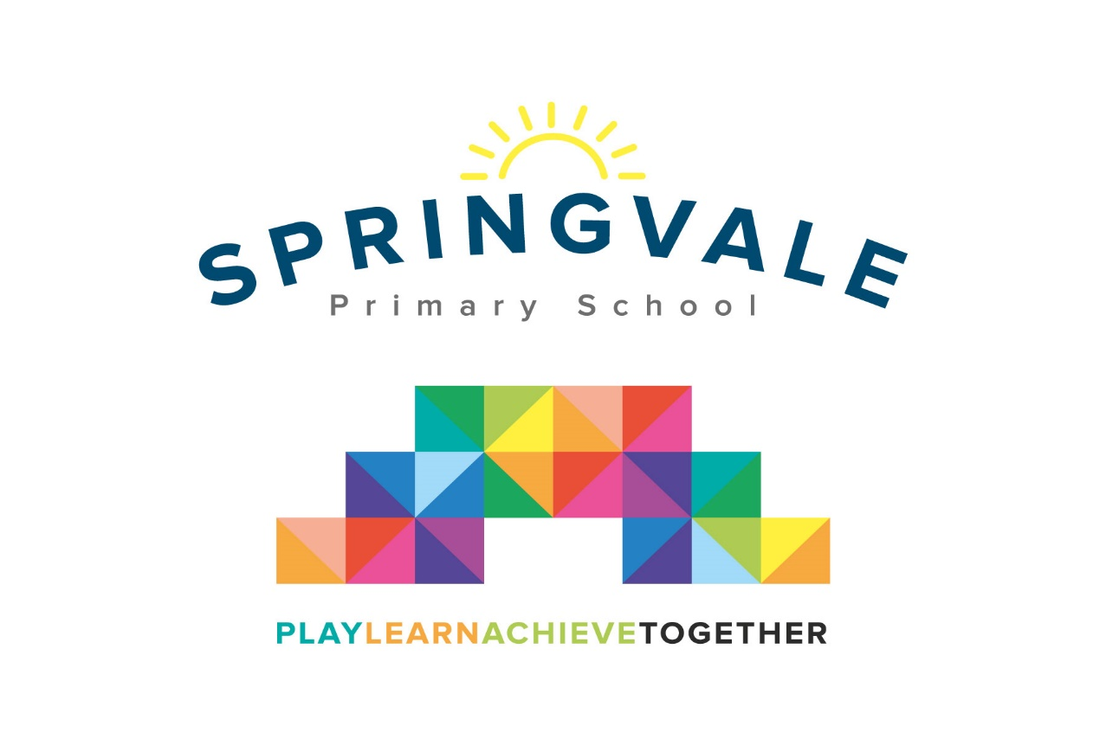
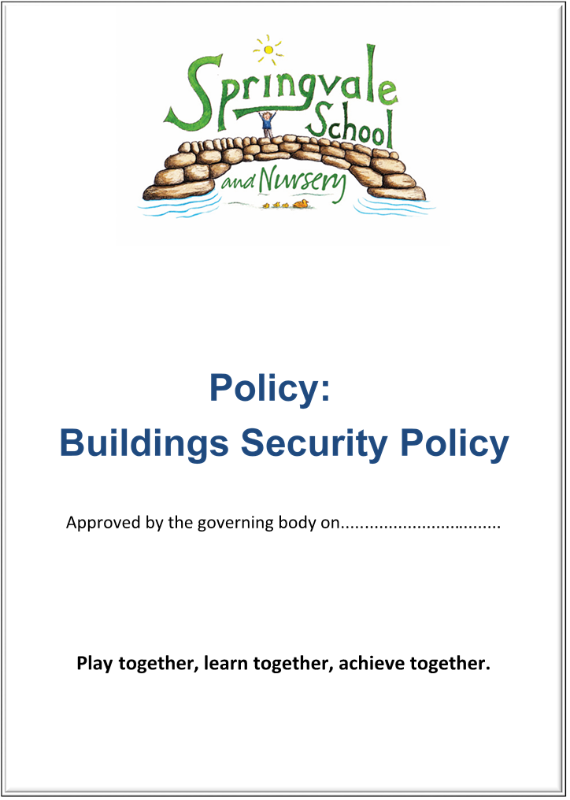
Staff Code of Conduct
SPRINGVALE PRIMARY SCHOOL
Staff code of conduct
Spring 2018
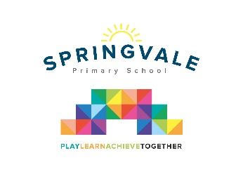
Introduction

This policy was created after a period of consultation with relevant stakeholders within school. It has been formally adopted by governors and reflects our approach at Springvale Primary School.

Aims and Principles

The policy is underpinned by the central aims of Springvale Primary and values held by the school community:
Aims of the school
- Springvale is committed to promoting high standards of academic achievement for all learners in all subjects.
- As a school we will continue to develop and instil key life skills and values in our pupils.
- We will encourage positive relationships and communications between home, our community and the wider world.

In particular, Springvale School has an inclusive approach to our provision. Our aim is always to involve all our children and stakeholders in all areas of the curriculum and school life. In accordance with our Disability Equality Scheme we recognise that this may mean making special adaptations or arrangements from time to time for children with specific disabilities. We welcome the involvement of disabled adults in all areas of school life.

Code of Conduct
At Springvale Primary School, we are committed to creating a safe school culture that promotes equality, excellence and an environment where children, young people and adults feel safe and valued.

Within school we promote the core principles of respect, fairness, justice, tolerance and understanding. We recognise that everybody within the school has the right to be treated in this way but is also responsible for promoting these values in the way they work within the school.
The objectives of the code of conduct are to:
- Safeguard pupils
- Give staff a safe environment in which to work
- Minimise opportunities for abuse within the school environment
- Enable all staff to feel confident to report concerns in a safe environment with appropriate levels of confidentiality
- Respond promptly to concerns, which have been fully documented and will be investigated and addressed
- Exercise appropriate sanctions
- Create an ethos of mutual respect, openness and fairness

- All staff are required and expected to follow the school’s policies and procedures: Safeguarding and Child Protection, Anti- bullying and Behaviour.

Pupils and staff are expected to work together to build a school where relationships are characterised by mutual and appropriate respect. The recognition of positive behaviour should be a priority and any sanctions/disciplinary issues should be dealt with in an appropriate manner and in the appropriate environment e.g. not in an area in full view of visitors to the school.
All interactions should take place in a calm manner and staff should not excessively raise their voice at pupils wherever this is avoidable unless there is a health and safety risk.
In accordance with Keeping Children Safe in Education and Teachers’ Standards 2012 we all must ensure that we safeguard children's wellbeing and maintain public trust in the teaching profession as part of our professional duties.
The school’s Behaviour Policy and associated documents establish in more detail the expectations within school and the approved sanctions to be used. If there are occasions when a member of staff is having difficulties managing a child’s behaviour this should be discussed with their mentor and/or line manager at the earliest opportunity. Any actions to be taken should be recorded, monitored and reviewed.

- All staff should work within an environment where physical contact with children / young people is managed appropriately.

Staff should only use physical restraint as a last resort and should use techniques from the school’s training relating to managing difficult behaviour (Team Teach). Please refer to the school’s Restraint Policy. All staff must undertake this training every three years. Physical restraint should only be used where there is a need to prevent injury to a child or a member of staff. In certain circumstances a Personal Handling Plan is prepared between the school and parents for each appropriate child. This plan will indicate an agreed method for handling children to ensure their safety.
Staff should only initiate physical contact with a child which is appropriate to the situation i.e. comfort to a child who is hurt or distressed. Very rarely should physical contact be initiated for children in Year 1 or beyond. When children initiate physical contact, like a hug, the staff member should acknowledge the contact (assuming it is appropriate) and then move away.
Any physical contact should be within clear boundaries and should not leave the member of staff open to any allegations of inappropriate touching. Contact to build esteem like ‘high fives’ is appropriate where staff deem it to be necessary.
A level of physical contact may be necessary for a child / young person with medical/specific learning needs. This contact will be agreed within a health plan, be subject to the required risk assessments, manual handling plans, and in an appropriate private space with two adults if possible.
If adults are required to be in a one to one setting with a child/young person the adult should consider how this can be managed effectively i.e. leaving a door open, using a room that has a window in the door, position yourself within sight of the door and consider if this is really necessary. Consideration may also be given to informing a colleague who may then monitor/join the member of staff.
Staff should not act in a way that is considered as exploiting young people e.g. identify pupils / young people as their “favourite” or act in any way that can be seen as an abuse of trust.
Staff should have professional boundaries if their own children attend the school. They should not be treated differently to other pupils or access areas of school where children would not normally be granted access (e.g. staff areas). Staff should not deal with behavioural/friendship issues for their own child.

- All staff are expected to treat each other with respect.

Relationships between staff should be characterised by fairness, openness and respect. This means valuing all contributions, acknowledging difference and working together to build an environment where continuous improvement is the foundation.
Politeness and respect towards one another are essential requirements and where differences occur they should be dealt with fairly, calmly and professionally. Children and/or visitors must not be present whilst differences of opinion are discussed.
Bullying, discrimination or racism from one member of staff to another will not be tolerated.
- All staff should treat resources responsibly and exercise due financial care.

All staff should have a responsibility to look after the resources of the school.
This includes not wasting resources e.g. heat, electricity and school materials. The principles of “reduce, re-use, recycle” should be adopted whereever this is appropriate. Any materials taken home for lesson preparation should be signed for.
All money received in the classroom should be sent to the school office as soon as practicable clearly labelled and the full amount recorded.
Staff who handle money on a frequent or regular basis should familiarise themselves with the Council’s Financial Procedures and follow them at all times. All items purchased for school use should have a receipt which identifies the VAT element or has a separate VAT receipt.
- All staff are expected to behave professionally.

All staff are expected to behave thoughtfully and responsibly. Staff should be punctual at all times and be well prepared to carry out the tasks required of them to the best of their ability. Staff must take breaks at appropriate times and ensure that they are available to supervise pupils in lesson times (including being prompt to meet children after break times).

Staff are expected to dress appropriately for the activities they are involved in. Teachers and teaching assistants should set a good example in what they wear led by the school management team. Clothing should not be overly casual or inappropriately provocative. Excessive jewellery or make up should not be worn.

- All absences relating to ill health will be reported to the Head and the relevant absence monitoring procedures will be followed.

Any concerns relating to absences will be managed in accordance with the BMBC Managing Illness Policy.

- Confidentiality
Staff are privy to personal information relating to children and young people and their families. This information should be recorded appropriately, kept securely and only shared on a need to know basis.
- Staff should seek to establish a good and open relationship with parents.
Staff should aim to create a welcoming and open relationship with parents and/or carers/extended family. All concerns raised by parents should be taken seriously and dealt with promptly and feedback given to the parents. When parents or visitors report any safeguarding or welfare concerns they must be logged, stored securely and treated with the strictest confidence by all staff. Information needs to be shared by school safeguarding leads from time to time so that staff at classroom level or on the playground can monitor their wellbeing and happiness. This may be in the form of bulletin meetings or emails or in discrete conversation with safeguarding leads. Staff must make every effort to read and action the safeguarding points raised and they must always treat the information as private and confidential.
Concerns relating to parents’ behaviour will be reported to the Designated Safeguarding Lead/Headteacher for further consideration.
Relationships with parents should remain on a professional basis at all times and should not be the catalyst for “friendships” outside school to develop.
- All staff need to be aware of the school and Local Authority Child Protection Procedures.
All staff need to take a proactive approach towards the school and Local Authority Child Protection Policies.
All staff should, on induction, familiarise themselves with the procedures, attend the required training and additional courses as agreed.
Staff will also need to familiarise themselves with and follow the procedures for reporting and dealing with concerns, including those relating to fellow professionals and/or the headteacher.
Staff should also be familiar with the procedure for reporting concerns relating to a professional and the headeacher.
Child Protection, the reporting of concerns etc, is the responsibility of every member of the staff team.
All staff need to take a proactive approach towards child protection and behaviour policies through the creation of a positive classroom environment where all children are respected and encouraged to respect one another.
- All staff need to be aware of how to record/report concerns relating to colleagues.

Where staff have any concerns about a colleague in school or other settings, these should be reported immediately or as soon as is practicable to the headteacher or Deputy. If the concern relates to the headteacher the concern should be passed to the Chair of the Governing Body. Concerns may be reported through the Whistleblowing Policy or through the Local Authority Designated Officer where the concerns are of a child protection / safeguarding matter.

11. All staff should take care of their physical and mental well-being.
All staff are encouraged to look after their own physical and mental well-being. This can be supported by a healthy work/life balance. If a member of staff needs additional support for issues relating to stress / anxiety, support services are available. A staff well-being week will be planned each year.
- All staff need to be prudent in the use of the internet, particularly in terms of social networking
Many staff will use aspects of internet technology as part of their daily life.
Use of the internet in school should be for professional reasons only. Websites and content accessed should be entirely appropriate.
The use of mobile phones for personal reasons (e.g. calls/texts) in schools should not take place in view of children.
Staff should not use personal devices to take or store images of children for their own use at any time.
Any use of social networking sites should be with privacy settings in place and staff are encouraged to be selective with who follows their account. If someone only known to you in a professional sense attempts to follow/’friend’ your account then please do not accept it and ask the headteacher to remind parents of our policy through a newsletter.
Social networking sites should not be used to bring the school, the local community or the Local Authority into disrepute. All staff should also ensure that no activities they are personally involved in can be accessed so that their professional integrity is maintained at all times.
- All staff will carry out their duties relating to safeguarding diligently. All staff will ensure high standards of personal and professional behaviour.
All staff should be aware of the dangers inherent in:
- working alone with a child
- physical interventions
- dealing with sensitive information
- disclosing personal details inappropriately
- using discriminatory vocabulary
- contacting children through social media, personal communication devices, etc

Conclusion
The code of conduct is a framework for ensuring that all staff understand the requirements needed to ensure that the school is a safe, secure and stable environment for all pupils and staff. The code should be read in conjunction with other policies and procedures.
All staff will read and acknowledge receipt of the Staff Code of Conduct as part of their induction. This policy will be displayed at all times in the staff room.

