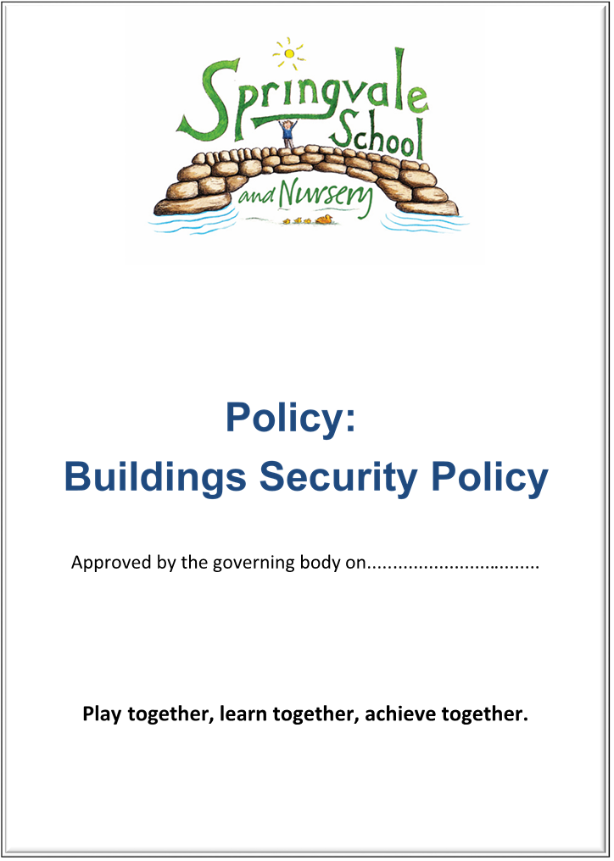
Volunteer Policy
SPRINGVALE PRIMARY SCHOOL
Policy for Working with Volunteers
Introduction

This policy was created after a period of consultation with relevant stakeholders within school. It has been formally adopted by governors and reflects our approach at Springvale Primary School.

Aims and Principles
The policy is underpinned by the central aims of Springvale Primary and values held
by the whole school community:

Aims of the school
- Springvale is committed to promoting high standards of academic achievement for all learners in all subjects.
- As a school we will continue to develop and instil key life skills and values in our pupils.
- We will encourage positive relationships and communications between home, our community and the wider world.

In particular, Springvale School has an inclusive approach to our provision. Our aim is always to involve all our children and stakeholders in all areas of the curriculum and school life. In accordance with our Disability Equality Scheme we recognise that this may mean making special adaptations or arrangements from time to time for children with specific disabilities. We welcome the involvement of disabled adults in all areas of school life.

Background
The Governing Body recognises the valuable contribution that volunteers make to enhance and support the work of the School.
There are many reasons why people volunteer, including and a willingness to help young people develop, the opportunity to form new friendships, to build confidence and skills, to stay active and healthy and to help find new employment.
The school is aware of and appreciative of the contribution made by volunteers and will seek to facilitate their involvement in a broad range of school activities.
This policy sets out the procedure to be followed to ensure the safe, fair treatment of volunteers and to preserve the integrity and security of the school, ensuring that school standards are maintained.
For the purpose of this policy, volunteers are defined as individuals who freely offer to take part in tasks for the school without pay.
Conditions of enrolment of volunteers
Volunteers will be appointed in line with the principles of the TUC Charter on Volunteering:-
- Volunteers will not be asked to perform any duties / tasks formerly undertaken by staff whose posts have been made redundant or hours reduced.
- Volunteers will not be utilised in times of industrial action to do the work of paid staff.
- The School will ensure that staff are clear about the roles of volunteers, maintaining good relationships and treating volunteers with respect.
Springvale is committed to safeguarding and promoting the welfare of children, young
people and adults and expects all staff and volunteers to share this commitment. There
is also a high standard of conduct expected of all adults within school. Volunteers will
be made aware of the school’s Health and Safety policy and must adhere to expected
levels/standards. This is all detailed in the induction booklet provided for volunteers.

Identification and approval of volunteering placements
New volunteering opportunities must be approved by the headteacher.

To ensure the work undertaken is within the capabilities of the volunteer, the head
teacher or class teacher will agree the set tasks. The volunteer will work under the
supervision of the class teacher.

Enrolment of volunteers
An Enhanced Disclosure and Barring Service check (DBS) should be in place before
the volunteer starts work in School. This will confirm their entitlement to work/volunteer in the UK. A copy will be taken and the details kept on the single central record. If possible, references should also be provided to confirm previous employment. In the case of recent school leavers seeking experience of work in a school environment, character references should be sought from their former school and qualifications will be checked.

The school has assessed the risks involved and ensured control measures are implemented. Due to Health and Safety implications, volunteering opportunities are not available to those aged 15 and under.
School leaders will consider any voluntary placements carefully where there may be a conflict of interests for confidentiality reasons.

Induction of volunteers
In order to enable them to fulfil their roles effectively, on appointment all volunteers will benefit from the school’s induction procedure which is set out more fully in the Staff Induction Policy.
Volunteers are required to read and sign the induction booklet (which is explained in more detail in the Staff Induction Policy) before the placement begins.
The Health and Safety Officer, (currently Helen Kelly) is responsible for providing the volunteer induction, providing a copy of the induction booklet and the induction checklist. This will include an overview of the appropriate Health and Safety procedures and the school’s Code of Conduct. Support and training will be discussed and reviewed to ensure the volunteer is provided with the skills and knowledge to safely and effectively contribute within school. All volunteers will be expected to adhere to the schools policies, procedures and code of conduct. Volunteering arrangements should be monitored and reviewed every term to ensure standards are being met and maintained.
There is no formal set working pattern for volunteering in school. An agreement would be made between the volunteer and the member of staff they are working with. Volunteers are requested to give adequate notice if they wish to conclude their services. Teachers plan work for volunteers and therefore require advance notice if the volunteer’s services are no longer available.
For ‘one off’ volunteers (who are usually parents offering to assist with school visits or events such as the school float or Sports Day), the following arrangements must be followed:
- Parents must read the trip information cards available in every class before the trip begins. If possible, a meeting should be held for all parent volunteers detailing the learning objectives, itinerary and expectations beforehand.
- Volunteers must not be left alone and unsupervised in charge of children.
- They should not take pictures of children on their mobile devices.
- They should not take children, other than their own, into toilets.
Volunteers who visit the school on occasional basis and are closely supervised by a member of staff will not require DBS clearance.
Dealing with problems
- Where the supervisor / class teacher identifies a problem with the volunteer’s capability:
- Any minor concern should be dealt with informally by the class teacher and a reasonable timeframe agreed for improvements to be made
- If the required improvement has not been achieved the volunteer will be informed that their services are no longer required
- A note of the concerns and any actions would be compiled by the headteacher and stored securely in school

- Where the supervisor / class teacher identifies a problem with the volunteers conduct:
All volunteers are expected to adhere to the schools code of conduct. Where conduct falls short of the expected standards, the following procedure should apply:
- Any minor concern should be dealt with informally by the class teacher
- Where the problem is of a more serious nature, the headteacher will notify the volunteer of the conduct causing concern, stating that the volunteer is in violation of the school’s Code of Conduct and the volunteer must leave with immediate effect. Copies of all notes and correspondence should be placed in the volunteer file.

- Where a problem is identified relating to the volunteer which has potential implications under Child and Adult Safeguarding Procedures:

- If a concern is identified that the volunteer has:
- behaved in a way that has or may have harmed a child
- possibly committed a criminal offence against or related to a child
- behaved towards a child in a way that indicates she/he is unsuitable to work with children

- If a concern has arisen outside of the volunteer’s role, e.g. if someone is alleged to be abusing their children at home.

The appropriate safeguarding procedures should be followed, including
referrals to the Local Authority Designated Officer (LADO).

- Where the volunteer identifies a problem with the School or another member of staff:
The problem should be discussed immediately with the volunteer and the supervisor in an attempt to resolve the matter informally. If the matter cannot be resolved in this manner the volunteer is advised to take the matter to the headteacher.
A volunteer may also make reference, if appropriate, to the Whistleblowing Policy. Any complaints of this nature should be discussed immediately with the headteacher.

Insurance
The Authority’s insurance arrangements will extend to cover volunteers or persons co-opted to assist the School whilst they are undertaking tasks directly for the School.
There is no reason to notify the Insurance Section when volunteers are enrolled by the School. However, if there is any doubt as to whether the volunteer meets the required criteria, the insurance company should be contacted for guidance.
Volunteers MUST NOT use their own vehicle to transport pupils in place of qualified staff.
Any use of the volunteer’s own vehicle whilst involved in school activities, must be covered by the volunteer’s own private insurance.

