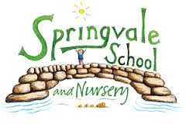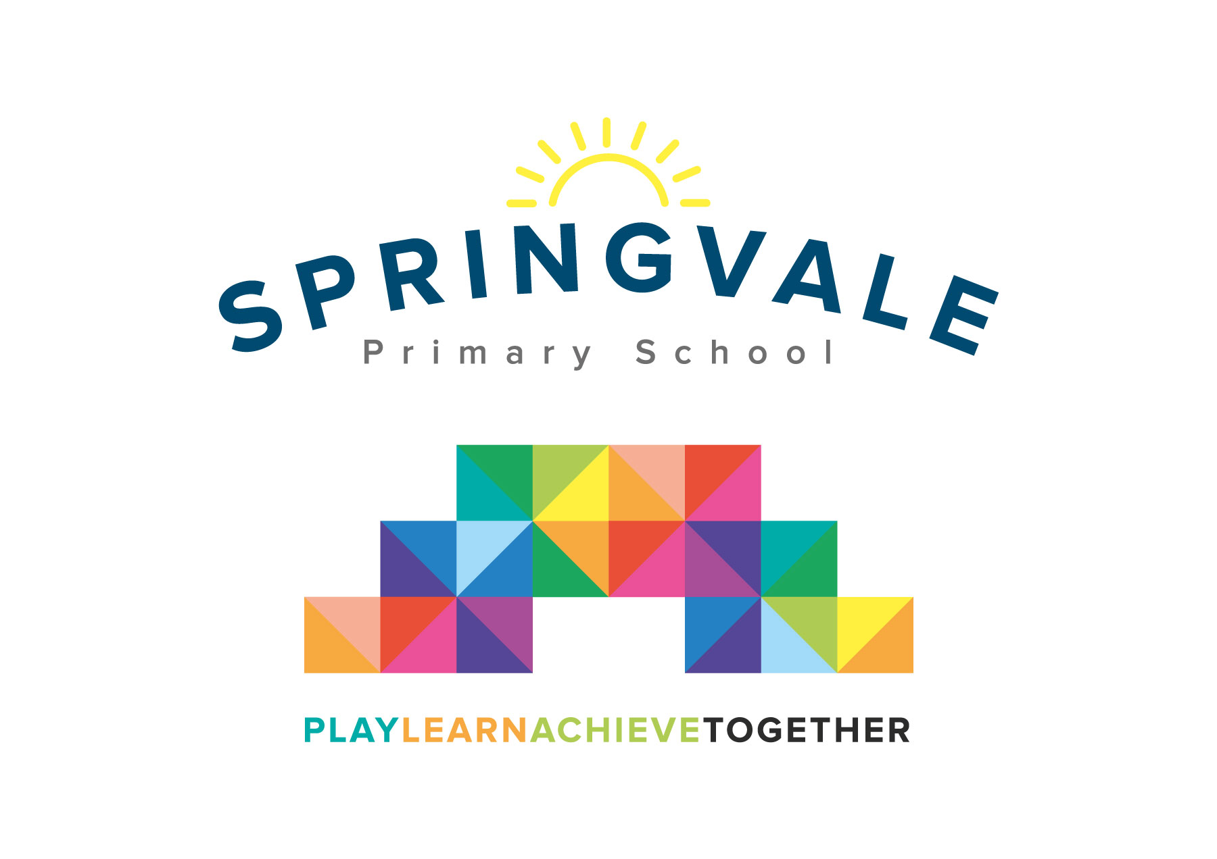
SPRINGVALE PRIMARY SCHOOL
01226 760930
Headteacher: Mr L McClure
l.mcclure@springvaleprimary.org
www.springvaleprimary.org
@SpringvalePS

School based counselling Wednesday 25th April 2018

Dear Parents/Carers

As you may be aware from our recent newsletter and social media output we have employed a school based counsellor on a fortnightly basis. This is a really exciting additional support tool that many of our children will benefit from. No matter how large or small, all children from time to time require some extra support to make them feel happy and safe. We will feedback to parents regularly on how your child is responding to the support and would always appreciate your feedback from home too.

Miss Sonia Prescott will visit our school every other Tuesday and she will support children, and their families where requested, from 1pm to 4pm. The appointments will be in my office to ensure a quality, calm environment and privacy from the rest of school. I have worked with Sonia before with excellent results. She allows children to talk to an impartial person, about a wide range of matters, and she helps them and their families to understand how they are feeling. She is not here to address the issues, just to listen, to understand and (where appropriate) signpost to relevant services who may be able to help.

Naturally, Miss Prescott has to follow the school’s key policies when she visits the school so it is important that we have written permission for your child to take part in the sessions. Most importantly, she will follow our protocols around data protection, confidentiality and safeguarding. If a child disclosed any information to us that we feel should be shared with the family, or wider services, to ensure their safety for example, we would have to do so. We would always contact the family in the first instance about any such issues, as detailed in our Safeguarding Policy.

Please return this slip to the school office, or email Mr McClure, as soon as possible.

Thank you for your co-operation in this matter.

Yours sincerely
Mr L W McClure
Headteacher
___________________________________________________________________________

Permission for my child to work with Mrs Sonia Prescott (School based counsellor)

I give permission

I do not give permission

……………………………………………………..(Child’s name)

Signature…………………………………….. (Parent/Guardian) Date…………………….

I would prefer: Child only session (usually in school time) ____
Parent only session (first session) (usually between 3 and 4pm) _____
Parent and child session (first session only) (to be negotiated) ____

