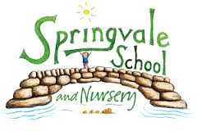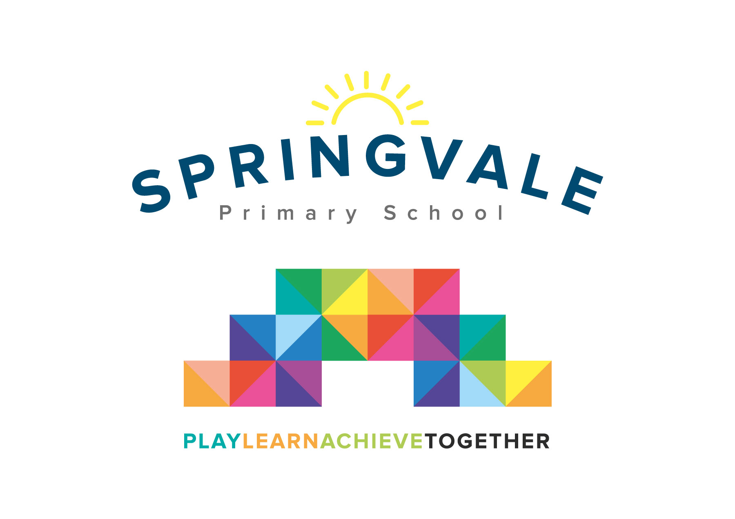
SPRINGVALE PRIMARY SCHOOL
01226 760930
Headteacher: Mr L McClure
l.mcclure@springvaleprimary.org
www.springvaleprimary.org
@SpringvalePS

Newsletter- Week 30 Tuesday 8th May 2018

Dear families,
We hope you all enjoyed the three-day weekend and the excellent Tour De Yorkshire! We had a great day in school and the children were a credit to us all, as always! I’ve had good feedback on the way that we have communicated, what was a very complicated event, on Friday. We have shared details of the date and plans throughout the month of April via newsletters, diary dates, the website, texts and tweets. Sadly, some parents said that they still didn’t know about our plans and many made or changed plans for collection after the deadline (Thursday 3.30pm). Please note that we are not trying to be awkward with deadlines on key days like this. We have to plan extensively for safety and safeguarding and ensure that all staff are aware of their class lists/groupings. Last minute changes risk children’s safety and raise the possibility of us making a mistake, which we have to avoid. Please ensure that future deadlines are adhered to; this will help us to ensure the safety and enjoyment of everyone on days like these. Thank you for your amazing support and we hope you all had a great time too!

Sports Day: Our Sports Day for Y1-Y6 will be throughout the day on Friday 25th May. The events will run throughout the full day and we will invite parents in, as is traditional to enjoy the day and have lunch on the school field. Look out for a separate letter later this week! Please note that the reserve date is Friday 8th June. Teams will compete in their coloured groups as always!

Sports Update: Our pupils continue to express themselves through a range of sports and competitions. Well done to all of the many children signed up for new clubs and opportunities. It is great to see and hear so many stories about children joining clubs and pursuing their new interests in clubs outside of school! Please tweet us your own club news and achievements so that we can share them! Well done to Y4 who recently took part in a fantastic mixed-ability archery competition so admirably! Well done also to the Bruce Dyer club children who took part in Bruce’s cup at Oakwell with great enthusiasm and passion!

Counselling Services and Speech and Language Support: Last week our counselling services started and they were very well received. It is a significant strength of our school that we can offer such services to our young people. Our plans for a speech clinic are still making good progress and we hope to offer support for pupils and parents with any speech needs after half-term.

Wheelathon and Outdoor Update: Our outdoor learning areas continue to develop at pace, especially in the EYFS where children access outdoor learning opportunities daily. The staff have received additional resources and training and are working hard to make our outdoor learning a key strength of the school! Our sponsored Wheelathon event raised a massive £920 and this will significantly improve the bike and scooter resources that we have- what an amazing effort by everyone! Thank you!

Parent Governor: We currently have a vacancy for a Parent Governor. Our Governing Body do vital work and form a key partnership with the leadership team and staff to monitor our finances, evaluate standards and to support improvement work. We have recently said goodbye to several Governors and we wanted to say a big thank you to Mr Hood, Mrs Hughes and Mrs Weldon for their excellent work. We wish them all well for the future. We have co-opted Mr Perry (children in Y2/Y6) and Mr Cliffe to add key skills to our Governing Body in recent months and we now require a parent representative and we will be sending out information regarding this post as soon as possible.

Thank you, always, for your wonderful support. Have a good week!

Kind Regards,
Mr L McClure,
Headteacher

Week 29 Information | 2017/18 Average | Week 30 Diary Dates
Attendance: 97.7%  Late marks: 0  GREEN LIGHTS: 99.7% | Attendance: 97.6%  Late marks: 1  GREEN LIGHTS: 99.3% | Monday 7th: May Day Bank Holiday  Wednesday 9th: Y5 to Scarborough (9am)  Friday 11th: Y5 return from Scarborough (approx. 4pm)
Classes of the Week: Y3 Brilliant Brazilians with 99%!

