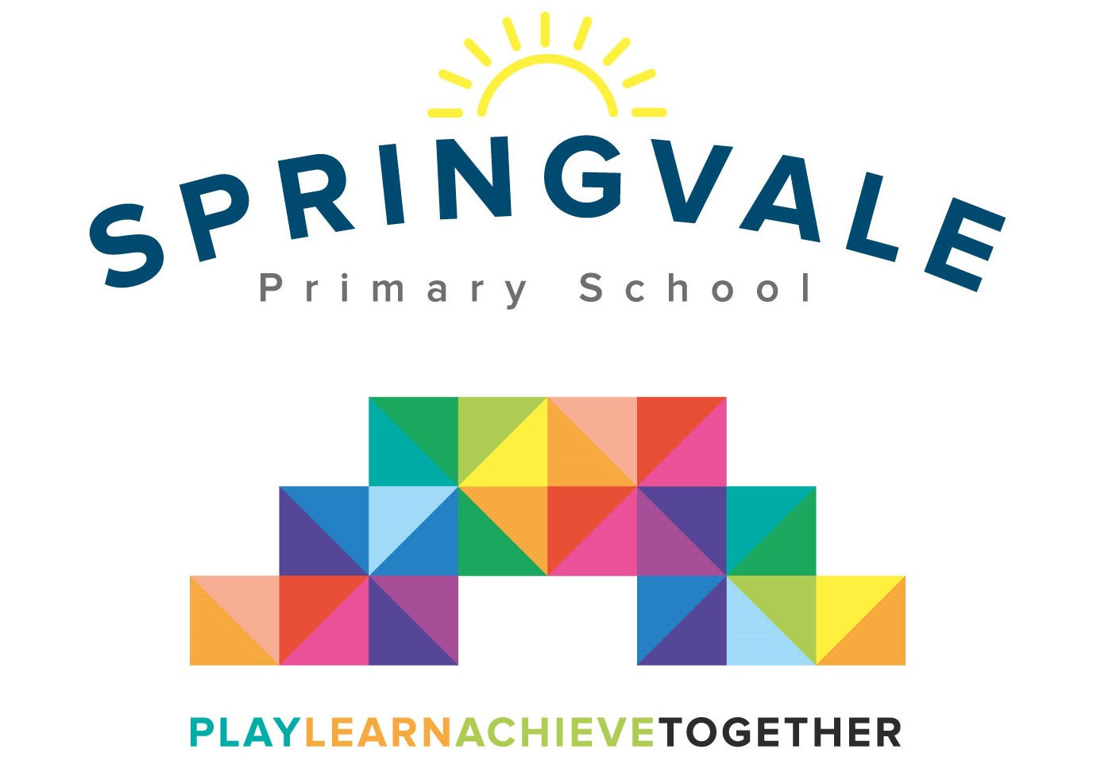
SPRINGVALE PRIMARY SCHOOL
01226 760930

Headteacher: Mr L McClure
l.mcclure@springvaleprimary.org
www.springvaleprimary.org
@SpringvalePS

Athletics Competition- Y4 Friday 29th June 2018

Dear parent/carer,

I am delighted to confirm that we have entered an athletics competition against 7 other Barnsley schools. The event will take place at Dorothy Hyman Sports Centre (Cudworth, Barnsley… the postcode is S72 8LH) on Wednesday 4th July 2018. The event begins at 1pm and it will run until 3pm. We will be back for 3.50pm approximately. The permission slip below must be completed and returned for children to take part. Children will be transported by coach at no cost to parents.

We will have lunch at 12.15pm so that we can leave at 12.30pm to arrive at 1pm.

Children require an outdoor PE kit, a warm jacket and a water bottle. Parents are quite welcome to attend the event and you may take your child from the event at 3pm if you prefer.

#PlaytogetherLearntogetherAchievetogether

Kind Regards

Mr L McClure

Headteacher

My child can take part in the athletics competition.

I will collect my child from the event by 3pm ___________________

Or

I will collect my child from school at 3.50pm ___________________

Or

My child will join their Wednesday club and I will collect them at 4.15pm ____________

Name _______________________________ Class ___________________________

Signed by parent _____________________________________

