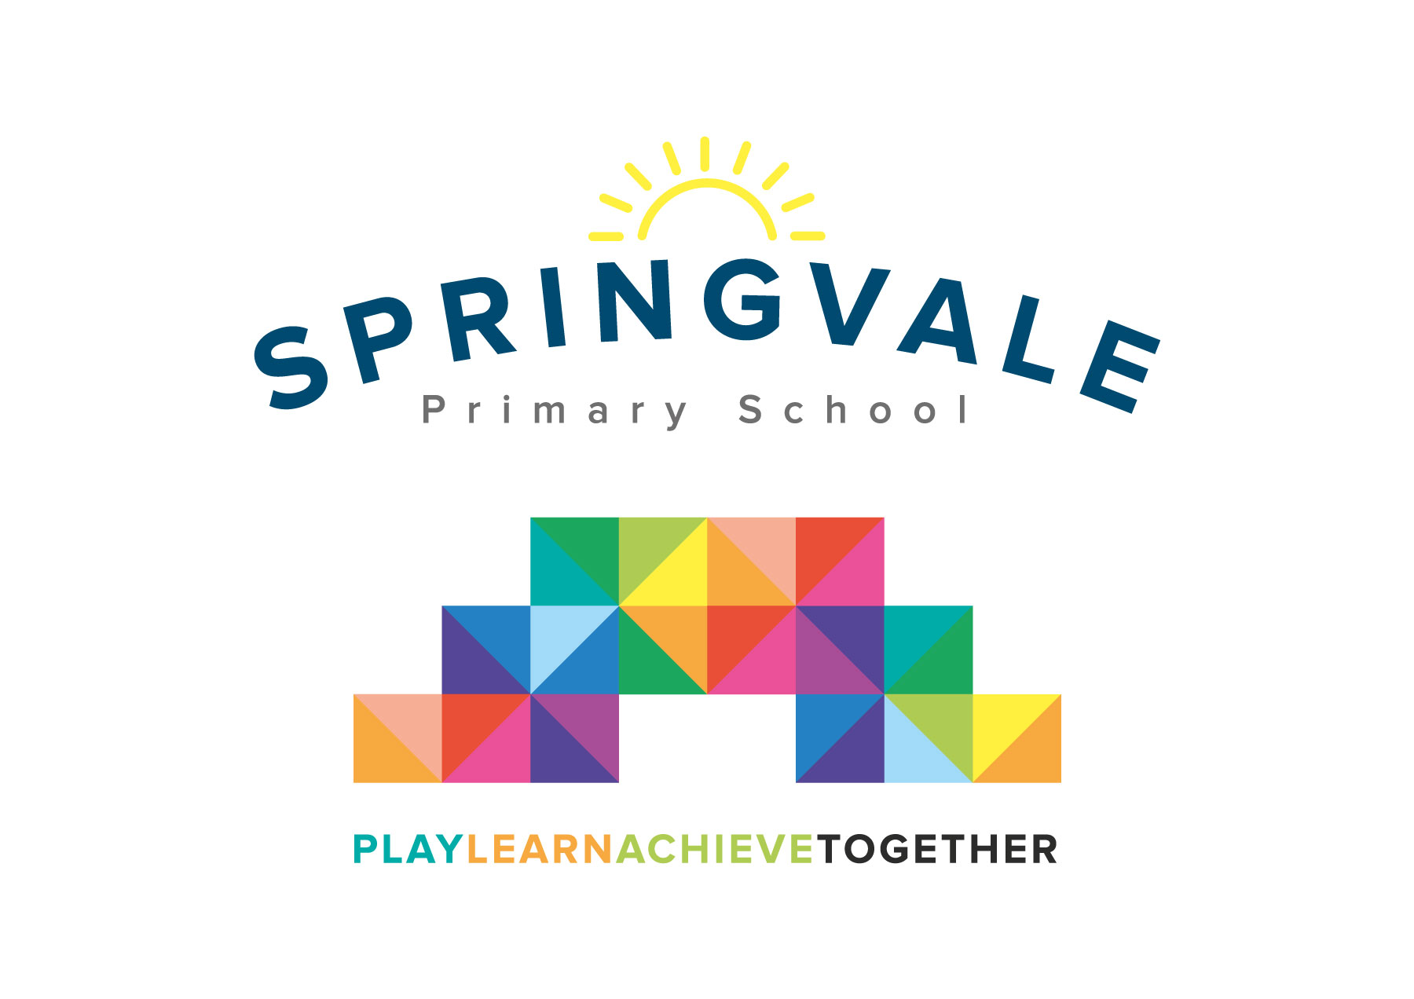
SPRINGVALE PRIMARY SCHOOL
01226 760930
Headteacher: Mr L McClure
office@springvaleprimary.org
www.springvaleprimary.org
@SpringvalePS

08/06/2018

Dear Parents/Carers

We would like to inform you of two exciting events that we have planned for the children across Foundation Stage.

On Monday 18th June ‘Meet a Creature’ will be visiting school and the children will be involved in an animal handling workshop. This will involve the showing and handling of live animals and all the children will be invited to handle the animals themselves. The aim is to educate and inspire children about the natural world.

We also plan to take the children to Cawthorne Park on Monday 16th July. We will be feeding the ducks, looking for signs of summer, hunting for minibeasts and playing games. The visit will take place in the morning, so afternoon nursery children will need to attend in the morning on that day. We will be leaving school promptly at 9.00am and returning at 12.30pm. We will provide a snack and a drink for the children

The cost of the both events will be £11.00. We are required to inform you that the trip has to be paid for by voluntary contributions, but if insufficient funds are available then the trip will not go ahead. You will receive an email & text notification shortly with information about how to pay for this trip on the ‘Schoolmoney’ system. Please follow the link on this message to login to your account. If you have any account login or payment queries, please do not hesitate to contact the school office. You will also be asked to give your parental consent online as well.

Please complete the slip below and return to F2/nursery as soon as possible.

Thank you

The Foundation Stage Team
__________________________________________________________________

I would like my child ________________________________ to go to Cawthorne Park

on Monday 16th July and enclose £11.00.

Signed _________________________________Parent/Carer

