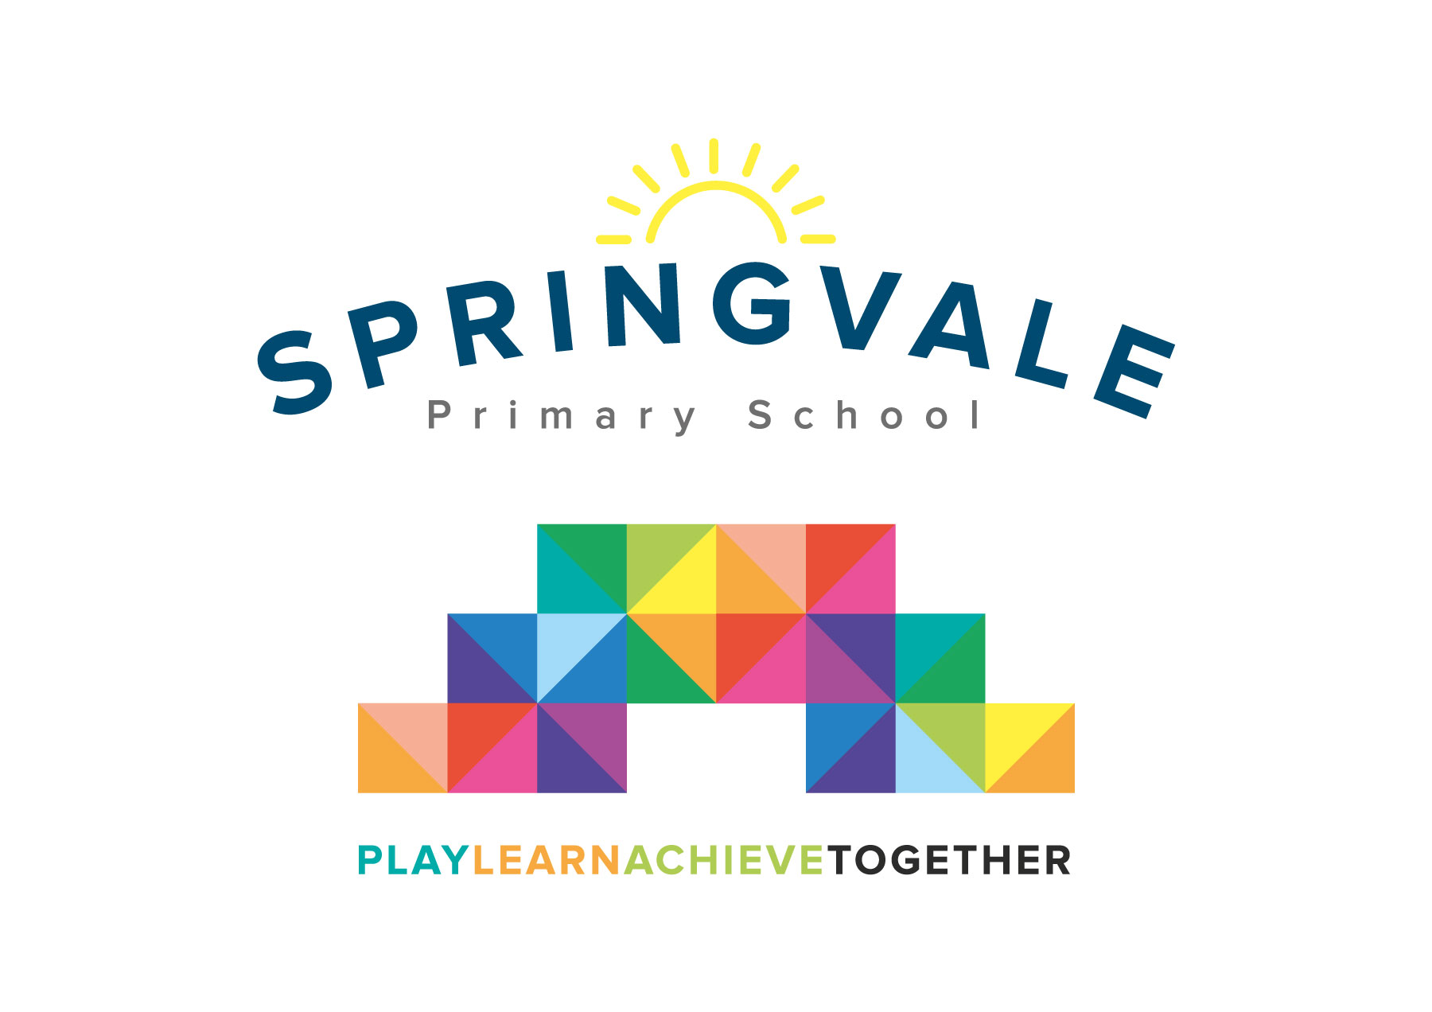
SPRINGVALE PRIMARY SCHOOL
01226 760930
Headteacher: Mr L McClure
l.mcclure@springvaleprimary.org
www.springvaleprimary.org
@SpringvalePS

Media Release Consent Monday 2nd July 2018

Dear Families
Photography/media publication permission and information sharing via pupils

As you may be aware we are using social media (e.g. Twitter), our website and internal/external school displays to celebrate our pupils many achievements and to keep parents and carers up to date with what is going on in school. Springvale Primary School and Barnsley Metropolitan Borough Council (BMBC) require your permission before publishing material which may include images of your child. The photographs, or videos, selected could appear in school/council literature, in the local press and on the BMBC/school (or other appropriate) websites for publicity/promotional purposes.

I am writing to request your approval to release any material that might include your child during their time at Springvale (e.g. from now until they leave, we will not send this letter out annually as children move class so parents must let us know if their circumstances or preferences change as soon as possible, please). You may have previously received a letter regarding this subject but at that point we were asking you to return the slip only if you did not give your permission. Due to new legislation under the Data Protection Act (DPA) and General Data Protection Regulations (GDPR) 2018 we now require you to return the slip below giving us your permission to make sure all parents and guardians have been contacted and their preferences noted.

Please return this slip to your child’s teacher, or to the school office as soon as possible and by Monday 16th July. Please note that we also, from time to time, need to send home information (like your child’s annual report or attendance updates, via school bags. Again, please grant your permission below if you are happy for us to continue to send information home in this way.

Thank you for your co-operation in this matter.

Yours sincerely
Mr L W McClure
Headteacher
___________________________________________________________________________

To be returned to school by Monday 16th July 2018
Permission for photography/media publication and information sharing via pupils by Springvale Primary School/ Barnsley Metropolitan Borough Council

I give permission for images to be published and information to be sent home via children

I don’t give permission for images to be published and information to be sent home via children

for any information/material including ……………………………………..(Child’s name)

to be taken and published by Springvale Primary School / BMBC / any third party suppliers approved by the school.

Signature…………………………………….. (Parent) Date…………………….

