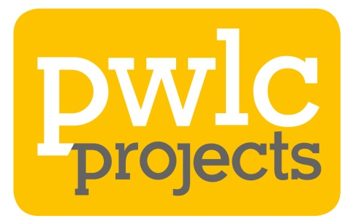
PWLC Projects LLP
Photo Consent Form

From time to time we want to take photographs of our projects, schemes, activities and events. This form outlines how we will use, store and process images that you have provided consent for. You are under no obligation to give photo consent in order to participate in any of our events, activities or engagements.

Why do we want your photo consent?
We would like permission to use the images for promotional, marketing and reporting purposes throughout our channels to raise the profile of PWLC Projects LLP and the projects that we are delivering on behalf of our clients.
You can withdraw your consent at any time by emailing contact@pwlcprojects.com and we will respond to requests as soon as we can within one calendar month.

Sharing Images
PWLC Projects LLP will manage all photography, we may also use third-party professional photographer(s) to capture the images that you consent to. PWLC Projects LLP deliver services on behalf of our clients. We may also share your/your child’s images with our clients, your school and local authority if applicable. We will only use images in the ways you consent to below.

Please tick the boxes to give consent for your / your child’s images to be used in the following ways:
Social Media
Video Production & Screening – Platforms such as social media and presentations
PWLC Projects Website
Press Releases
Emails
Promotional Materials – Printed and Digital
PWLC Projects Resources
PWLC Projects Reports and Documentation

Your Name:
Are you a parent or guardian providing consent on behalf of your child who is under the age of 16? (please tick) |  | Yes | No | Child’s Name (if applicable):
Address:
Email Address:
Signature: |  |  |  |  | Date:

Storing your data
We will only use your contact details as outlined above for our records should we need to contact you in relation to this consent. We will store this securely and in accordance with the PWLC Privacy Policy that is available from contact@pwlcprojects.com

