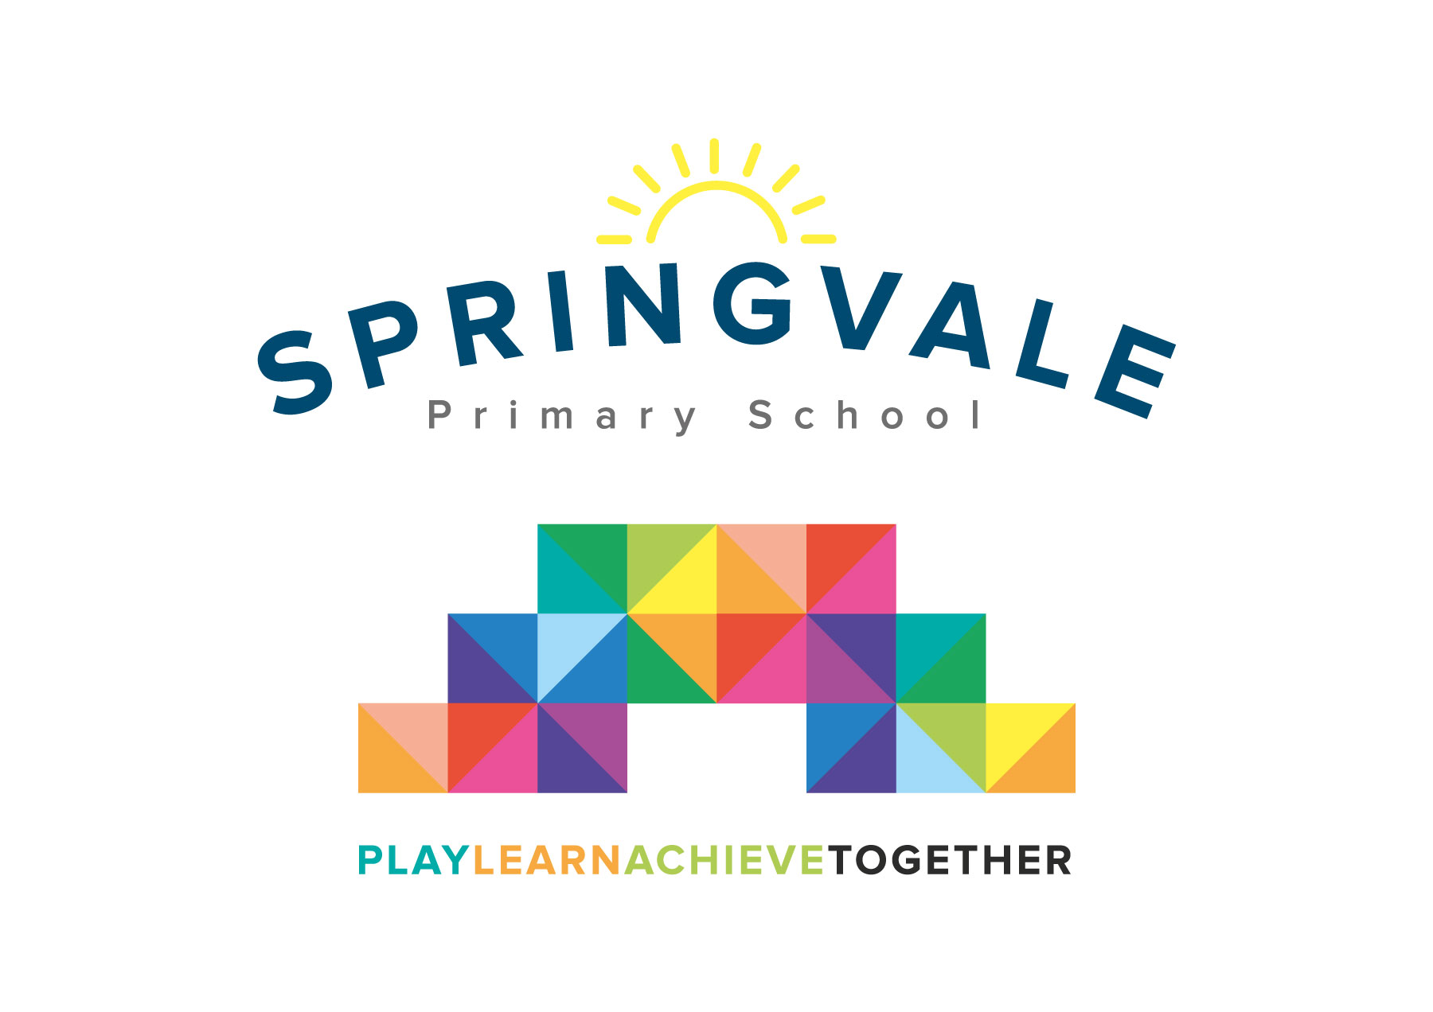
SPRINGVALE PRIMARY SCHOOL
01226 760930
Headteacher: Mr L McClure
l.mcclure@springvaleprimary.org
www.springvaleprimary.org
@SpringvalePS

Sports Awards 2018

Dear ___________________________
Congratulations! You have been nominated for a Springvale Sporting Award! Our awards have been arranged through nominations sent in by club leaders, coaches, teachers and sports leaders. The nominations have been made based on talent, development, achievement or sporting attitudes. You will need to attend to find out what you have done to impress everyone!
We would like to invite you and one guest of your choice to our inaugural Sports Awards event. The event will be held in our hall on Thursday 12th July between 6pm and 7.30pm.
Please email your RSVP and the name of person attending with you to l.mcclure@springvaleprimary.org by Friday 29th June 2018.
Please let us know if you can attend the evening and if you would like refreshments to be ordered whilst making us aware of any specific dietary needs. The menu is listed below. There is no cost to secure your place at this amazing event. However, due to tight school budgets, we will have a raffle and a collection on the evening to pay for the cost of refreshments as this cannot be funded through sports budgets.
Regards
Mr McClure, Mrs Exley and Mr Crossfield

Menu: Either:
- Beef Burger
- Cheese Burger
- Chicken Burger
- Pork Hot Dog
Vegetarian options:
Quorn Burger or Quorn Hot Dog
(all are served with potato wedges, salad and sauces)
Hot drinks are available for adults and water for children.

