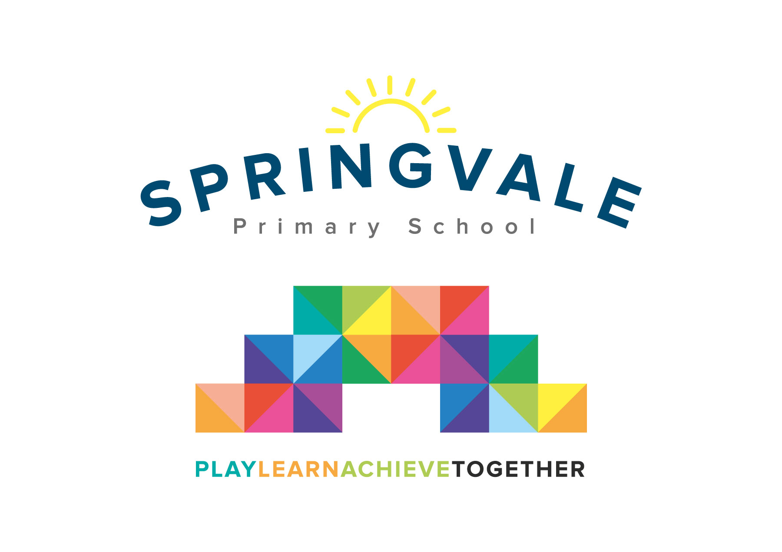
SPRINGVALE PRIMARY SCHOOL
01226 760930
Headteacher: Mr L McClure
l.mcclure@springvaleprimary.org
www.springvaleprimary.org
@SpringvalePS

Newsletter- Week 34 Monday 11th June 2018
Dear families,
Welcome to our latest newsletter!

Sports Day: Well, we got there in the end! The weather stayed dry(ish) and we had a fabulous day. I was so impressed by the children and their talents. They have worked so hard and tried their best to improve and thrive. Thank you to Mrs Exley for leading the event so expertly and to all staff for their hard work in ensuring a smooth and successful event. Many thanks to parents and volunteers who gave us their support and helped to make the day a huge success! Well done to Red Oak team who were worthy winners!

Sports Kit: We will be providing all children with their first Springvale sports kit next year! Look out for a letter very soon to help us to collate the whole-school order before the end of June so that we can give out the shirts in July ready for the new school year.

Mayor’s Parade: We all had a great time on the Springvale float and we loved being Mary Poppins for the day! The costumes and backdrops were amazing and we stole the show in terms of creativity and effort, and we took 2nd place in the Mayoral Float competition! A huge well done and thank you to the SPACE group who have worked tirelessly for many weeks including early starts and late finishes! The children sang and performed beautifully- you are all stars! We’re looking forward to next year already!

Diary Dates: Please ensure that you haven’t missed our latest list of diary dates. The list is now online too. Please keep a regular eye on our texts and emails this half-term as there are so many events going on that we will need to keep in touch with you about regularly. I’m sure there will be many slips to return to school too so please keep an eye on book bags and if anything isn’t clear please drop me an email or give the office a call. We have added 2 additional dates; Y2 synagogue visit (this Wednesday) and a Y6 sports challenge day against another school (Monday 25th June), both of which have been sent out on text messages to parents. EYFS parents have also had a text about an upcoming visit.

Club Update: All of our clubs will be up and running again by the end of this week, many started straight away after the Spring Bank break. The uptake at the moment is absolutely fantastic! I am delighted that we can now offer such a number and breadth of clubs to cater for so many interests. Please take a look at the end dates online for each club and look out for texts about when clubs finish. On the final week of term we will not have any clubs running at all, except cartoon club, tennis and Thursday creation station.

Learning Journal: Our latest learning journal has been emailed out and is now online. This is the final version for this year but it will return next year. We hope that parents have found it a useful way to keep up to date with what is happening in classes and to enjoy your child’s topics and learning themes with them.

Reading at home: The impact of reading regularly at home on a child’s progress is significant. As the year draws to a close we hope to ensure that children, of all ages and abilities, continue to enjoy reading. The key is reading little and often, at key times of the day (before bedtime being particularly beneficial) and to read a wide range of materials and genres. We will be introducing a Summer Reading Challenge in due course as well as a Spelling Bee for the end of the year. We are adapting our timetables too in lower school in an attempt to ensure that all children read more regularly in school too with adult support. Any adults who can offer an afternoon or two of reading support should contact us ASAP so that we can make plans for next year. All help will be very gratefully received!
Thank you, as always, for your wonderful support. Have a great week!
Kind Regards, Mr L McClure, Headteacher
Week 33 Information | 2017/18 Average | Week 34 Diary Dates
Attendance: 93.5%  Late marks: 3  GREEN LIGHTS: 99.7% | Attendance: 97.0%  Late marks: 1  GREEN LIGHTS: 99.3% | Monday 11th: Phonics Screening in Y1 all week, F2 new starters meeting at 6pm (hall)  Tuesday 12th: Y4 visit to Old Moor, Nature Reserve  Wednesday 13th: Last day for Y6 hoodie order, Springvale World Cup 6.15-8.30pm  Wednesday 13th: Parent drop-in 3.15 to 4.45pm (access through classroom doors)  Thursday 14th: Y5 visit to Sheffield, Y4 talent show at 11am  Friday 15th: Y5 swimming, Y5/6 football event (all day), Y6 athletics PM
Classes of the Week: Y5 Wonderful Welsh with 97.8%!

