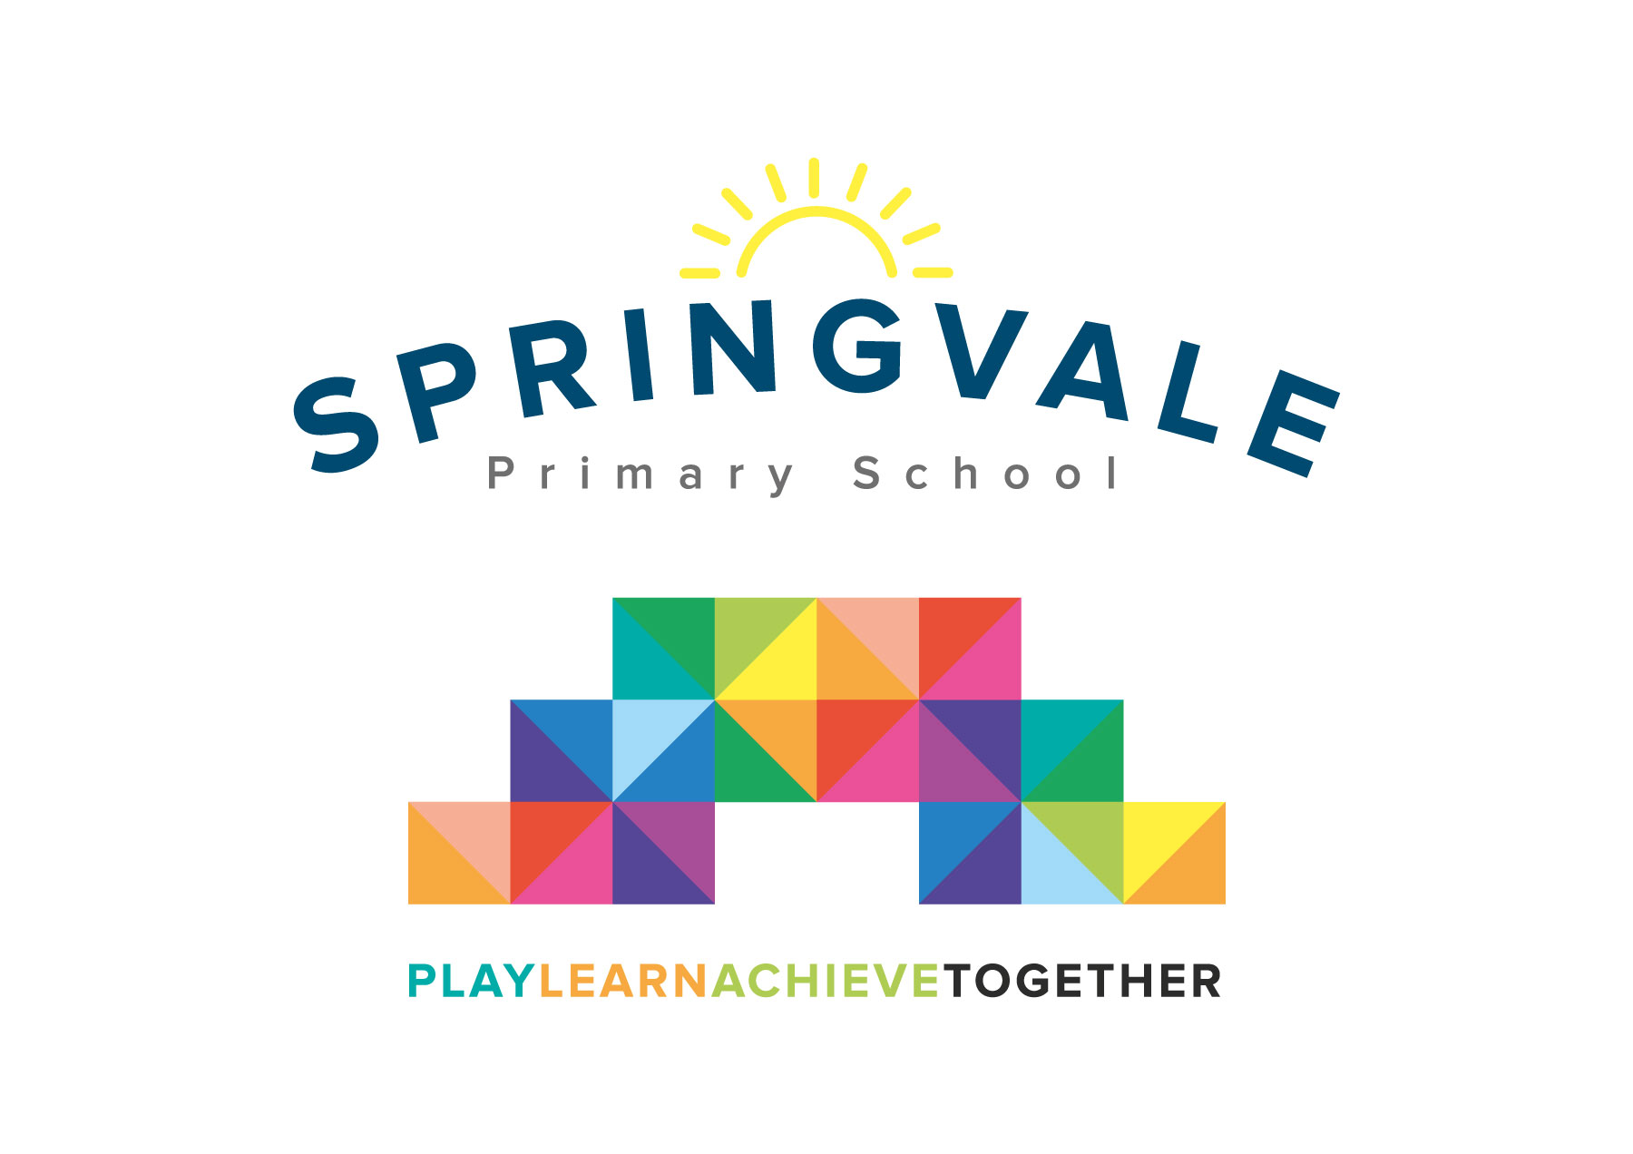
SPRINGVALE PRIMARY SCHOOL
01226 760930
Headteacher: Mr L McClure
l.mcclure@springvaleprimary.org
www.springvaleprimary.org
@SpringvalePS

Newsletter- Week 35 Monday 18th June 2018
Dear families,
Welcome to our latest newsletter!
Recent and Upcoming Events: Well done to all of our amazing pupils who have done so well at sports events recently! Our Y5/6 boys and girls cricket teams both qualified for the Barnsley Final events later in the month with superb performances. Our Springvale World Cup was incredible with 71 pupils of all ages and abilities involved! The event was won by Yellow- Brazil! Well done! Thank you to everyone who came along and enjoyed the evening and to all of the staff who gave up their time to make it work! We raised £230 on the evening which will go directly back into sport here at Springvale! This week we focus on local good causes and charities in assemblies and on Friday we have a special dress down event for Cystic Fibrosis (family donations kindly received). Good luck to our Y4-6 cyclists who are taking part in an amazing relay cycle ride that covers the whole of Yorkshire this week too! Please note that all families are welcome at Penistone CC’s fun day on Sunday 8th July from 11am. The event starts with a charity 20:20 match between school and the club!

Sports Kit: Please complete the slip below (for all children in each family who are in F2-Y6 next year) giving their name, team colour and the correct size so that we can order them all for September. A size sample is available in reception. We offer 3-4 (small reception), 5-6 (reception to small Y2s) 7-8 (Y2 to small Y4) 9-11 (small Y4 to Y6) 12-13 (small Y6 upwards). They can also be ordered as a small adult. We need the sports kit order by Friday 29th June so that we can order them all for drop off for September.

Uniform Update: Our uniform order list has been updated and from next year we will offer branded sky blue shirts and t-shirts through Vortex. Children can now wear white, sky blue or navy blue. Please continue to support our high standards by ensuring that no jewellery or nail polish is worn at school and that all shoes are appropriate. Even shoes with signs, symbols and different coloured trim aren’t appropriate. We will email out the full policy soon so you have the details in good time for September 2018 preparations!

Reading Army: Please look out for our new posters asking for members of a new ‘Reading Army!’ We need the help of any parents or grandparents who have any spare time due to retirement, flexible, lifestyle, etc and people who would like to give up an afternoon or two to help our amazing children to read more regularly 1:1 with an adult. We are adapting our timetables in lower school in an attempt to ensure that all children read more regularly in school with adult support but due to budgets (as well documented in the national media) we cannot afford to staff our desired systems. Any adults who can offer an afternoon or two of reading support should contact us in person, by telephone or via email ASAP so that we can make plans for next year. Support and training will be provided and all help will be very gratefully received! Ewe plan to start in September!
Thank you, as always, for your wonderful support. Have a great week!
Kind Regards, Mr L McClure, Headteacher
Week 34 Information | 2017/18 Average | Week 35 Diary Dates
Attendance: 98.4%  Late marks: 0  GREEN LIGHTS: 98.3% | Attendance: 97.2%  Late marks: 1  GREEN LIGHTS: 99.2% | Monday 18th: Y6 Springvale Gardens visit, ongoing cycling events  Tuesday 19th: Cycling relay (Y4-6 selected pupils all AM)  Wednesday 20th: New F2 story sessions and Y3 music event at Metrodome (1-3.30)  Friday 22nd: Wear bright or yellow for Cystic Fibrosis (family donation) & Y5 swimming,
Classes of the Week: Y3 and Y5 with 100%!

PE Shirt orders
Name ______________________________________ Size________________ Colour__________
Name ______________________________________ Size________________ Colour__________
Name ______________________________________ Size________________ Colour__________

