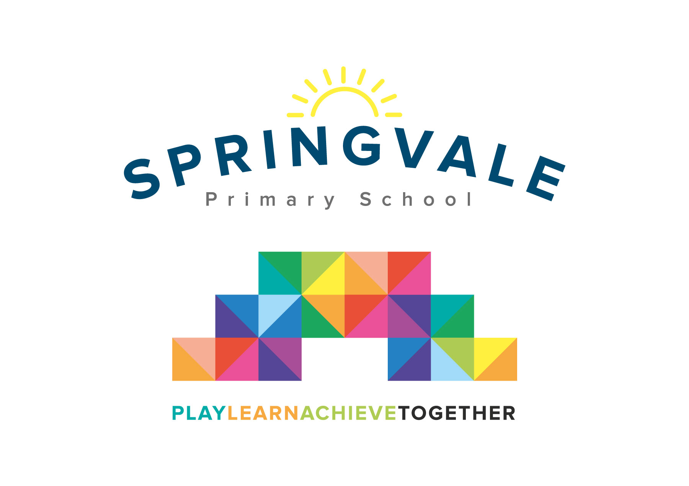
SPRINGVALE PRIMARY SCHOOL
01226 760930
Headteacher: Mr L McClure
l.mcclure@springvaleprimary.org
www.springvaleprimary.org
@SpringvalePS

Newsletter- Week 36 Monday 25th June 2018
Dear families,

Welcome to our latest newsletter! There is so much to report back on and so much to look forward to, shall we get started?

Recent and Upcoming Events: Thank you to everyone who supported our dress down event for Cystic Fibrosis on Friday, we raised an excellent £180 (approximately) for a fabulous cause! We have created a fundraising plan for next year that covers a range of global, national and local causes to help to support issues that touch the lives of our families and our community. Your support is vital and always appreciated. It has been a really busy few weeks and there are so many congratulations to offer! Well done to the amazing performances of the Y4-6 Collaboration Cup team who made the quarter finals, the Y6 athletics team who came 4th at the Barnsley athletics finals (our girls’ relay team brought home the gold with an outstanding team effort) and the fabulous cyclists who have loved their recent input...their progress is amazing! One, very lucky, band of cyclists enjoyed the Yorkshire Schools relay on Monday and Tuesday with Mr Venus and Mrs Beresford! It is amazing to see so many children enjoying cycling and scooting!

Sports Kit: Last week we had a reply slip on our newsletter to allow parents to give their child’s name, team colour (if known- we can give this information if needed) and the correct size so that we can order them all for September. Sample sizes remain in reception for trying on! A reminder that we need the sports kit order by Friday 29th June so that we can order them all for drop off for September. If a response is not received we will order based on our own judgement. Lastly, just to confirm that the first shirt is being provided by school, any extra (branded or unbranded) can be ordered from Vortex in the normal way.

Sexual Relationships Lessons (Y5/6): This week we will start to introduce SRE lessons to the Y5/6 pupils in school. Mrs Fearn, Mrs Mayston and I lead the teaching and it focuses on the human body, growing up, human biology and caring relationships. Children have the opportunity to ask questions in a whole class situation, a gender group or through a private question box. Naturally, we want to make parents aware so that they understand if their child asks questions at home. We are very happy to discuss or share resources that we use, any parents who would like more information should email me as soon as possible.

Transition Plans: At this busy time of year our teachers start to complete final assessments and reports. Teachers also start to meet regularly about transition as pupils prepare to move classes. Our staff have three transition meetings/sessions coming up to ensure that all key information (academic, medical, pastoral, social, etc) is passed on effectively. We then have our transition day on Tuesday 3rd July. Pupils need to line up at their new classroom door to meet their new teacher. (More information about this will be shared next week, along with your child’s new teacher’s name- NB. No staff are changing classes from their current positions). They should then be collected from their new classroom door at home-time! Please note that at the end of the transition day classes Y1-Y6 will hold parent information sessions at 2.45 and 3.15pm (the same meeting repeated). This will allow parents with more than two pupils to visit each class. The meetings are really important as they will give out lots of information about your child’s next class and any early news about topics, visits, etc. If parents cannot attend we will add any information to our school website. Reports will be given out very soon too- on Wednesday 11th July. We must have permission to send information home with your child on the recent media/information request letter.

Y6 Hoodies: Y6 hoodies have now been given out in class, just a reminder of the pattern that was agreed. ‘…they will be allowed in school for break times until the final week when children in Y6 will be allowed to wear them in class. We will also offer the opportunity to sign a school shirt on the final afternoon.’
Thank you, as always, for your wonderful support. Have a great week!
Kind Regards, Mr L McClure, Headteacher
Week 35 Information | 2017/18 Average | Week 36 Diary Dates
Attendance: 95.9%  Late marks: 2  GREEN LIGHTS: 98.7% | Attendance: 97.2%  Late marks: 2  GREEN LIGHTS: 99.1% | Monday 25th: Y6 Sporting Challenge 10am-3.15pm, Sports Awards invites out  Wednesday 27th: Y6 PGS taster day, New F2 story sessions  Thursday 28th: KS2 Hindu Day (children sign up to activities) KS1 creative activities  Friday 29th: Y5 swimming, football v Churchfield (H) girls, KS1, development squad
Classes of the Week: Y5 Wonderful Welsh with 99.6%!

