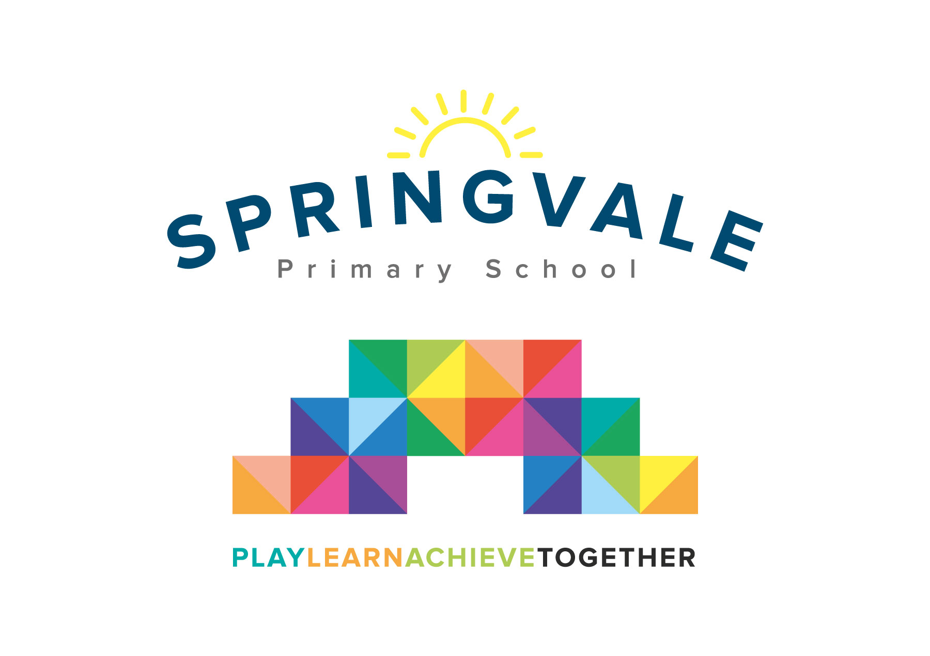
SPRINGVALE PRIMARY SCHOOL
01226 760930
Headteacher: Mr L McClure
l.mcclure@springvaleprimary.org
www.springvaleprimary.org
@SpringvalePS

Y5 Friendship Work Wednesday 27th June 2018

Dear families,

Following several discussions with children, parents and our Y5 staff this week I think it is a good time to communicate with all Y5 parents, particularly those with girls in class, about some work that we plan to do in class in the coming days and weeks.

We will be teaching special lessons about friendship, appropriate behaviours online and in the ‘real world’ and, as our most recent newsletter stated, the early stages of how our body changes/relationships.

Due to a small number of recent reports about ‘falling out’ in class, and more specifically the children from class falling out online, we thought it might be wise to engage some specialist teaching input too. Social and emotional aspects of learning are vital to children feeling safe and secure as individuals and learners and as our children progress through Y6 and into later life we need to ensure that we have provided them with the foundation skills and the tools to be good communicators who are secure in their behaviours and judgements. We also strive to ensure that our children are model citizens in our local community and the online community that will play such a large part in their future too!

We are planning a small series of circle time activities and one-off PHSCE sessions with the help of our school counsellor, Mrs Prescott. You may have seen on recent newsletters that she is working with some of our children in a 1:1 capacity (with very pleasing results and feedback so far!) We are keen to involve Mrs Prescott in some large group sessions but wanted our parents to be aware of this and have the opportunity to seek further details if they wish. The sessions would involve the whole class but in smaller groups.

As I have stated, much of the ‘falling out’ appears to begin online or on mobile phone calls/messages. Whilst some schools simply state that children are too young to have such devices I understand the pressures on modern parents with technology. If I could ask for your support on this matter though I would stress that parents are encouraged to check regularly what is being said/done on the devices and that if children do not show themselves to be mature enough to use said device safely, fairly and appropriately then they should not be allowed access to it. We have spent lots of time and money on eSafety lessons this year so I am saddened to hear of examples of misuse of technology in a way that is intended to upset other children.

I should stress that I think this cohort of children are a very talented, polite and sincere set of young people with great potential. This is why I want us to work together to ensure that they enjoy their school life and extra-curricular activities and focus on reaching that potential rather than dealing with friendship issues and the emotional challenges that these issues bring.
Kind Regards,

Mr L McClure,

Headteacher

