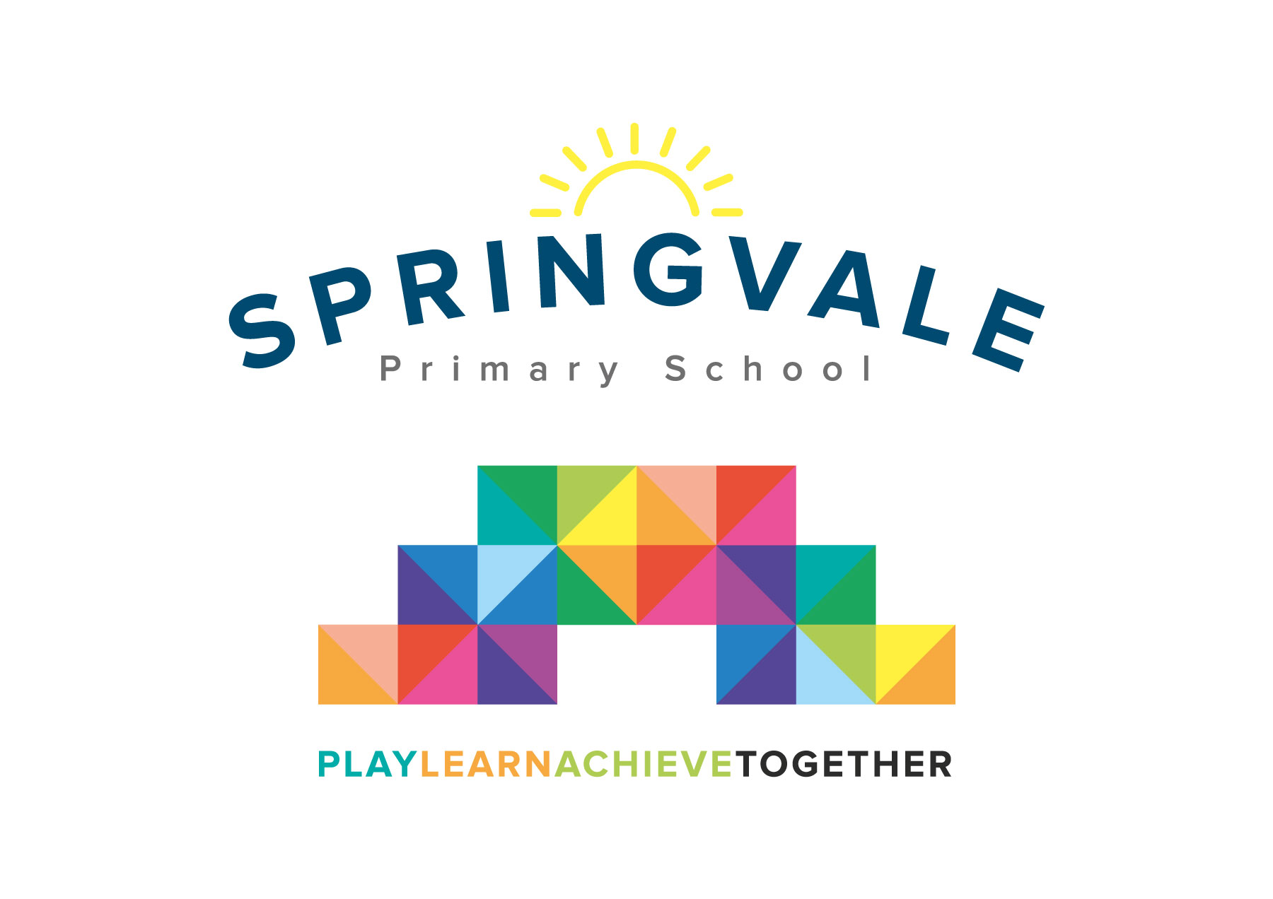
SPRINGVALE PRIMARY SCHOOL
01226 760930
Headteacher: Mr L McClure
office@springvaleprimary.org
www.springvaleprimary.org
@SpringvalePS

Dear Parent/Carer,

As part of our ‘Green’ topic we are studying outdoors and nature. We have two different activities planned for both the Year 1 and Year 2 classes.

Activity 1
The ‘Magic Woods’ workshop will take place in school on Thursday 28th June. We will be joined by local artist Rosie Pearsall, who will take us through a series of crafts, which will be linked to the Trans Pennine Trail and hopefully displayed there at a later date.
There is a £3 cost for this.

Activity 2
On Friday 6th July, classes 1 and 2 will be visiting Springvale Community Gardens.
The cost of this visit is £1, which covers the cost of the vegetables and fruits that the children will be tasting. We plan on leaving school after registration and taking our lunch with us. .

You will receive an email & text notification shortly with information about how to pay for this trip on the ‘Schoolmoney’ system. Please follow the link on this message to login to your account. If you have any account login or payment queries, please do not hesitate to contact the school office. You will also be asked to give your parental consent online as well.

We are required to inform you that the trip has to be paid for by voluntary contributions, but if insufficient funds are available then the trip will not go ahead.

Please ensure your child has the appropriate clothes for the weather e.g. raincoats if wet, sun cream and hats if sunny.

Please complete the slip below if your child would like a grab bag and return to school by.

Kind Regards,

Mrs. Evans and Mrs. Royston
_____________________________________________________________________

Please tick your child’s lunch option and return to school by Friday 29th June:

Child’s Name: ________________________ Class: ______________

Date of Trip: Friday 6th July 2018

Own Sandwiches Grab a bag

Grab a Bag Flavour

Ham Cheese Tuna Mayo

