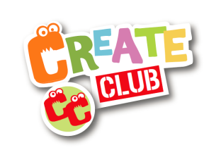
A HUGE THANK YOU!

Dear parents/carers,
Thank you all for booking your children on to create club this year. And I am so pleased to announce that create club will be back at your school next year! In September, I will once again come to the school and lead an assembly to tell all the new children about create club and remind all the current children what we will be getting up to. Plus, I will be able to tell the children of any improvements to the club.

competition
Remember, the crafts that your child make at create club, are truly unique and personal to them. So, to celebrate all this years’ work, please send me a photo of a display of all your child’s crafts, and the winner, chosen by me, will win a craft pack worth £25. Please send photos as a post via facebook (The creation station Penistone) or via email to the address below. Just include the child’s name.

Once again thank you! And please keep an eye out for all information regarding the creation station via my facebook page, or twitter!

Please get in touch!
Web: www.thecreationstation.co.uk/brad-thompson
mail: bradthompson@thecreationstation.co.uk
Facebook: thecreationstationpenistone twitter:@tcspenistone

