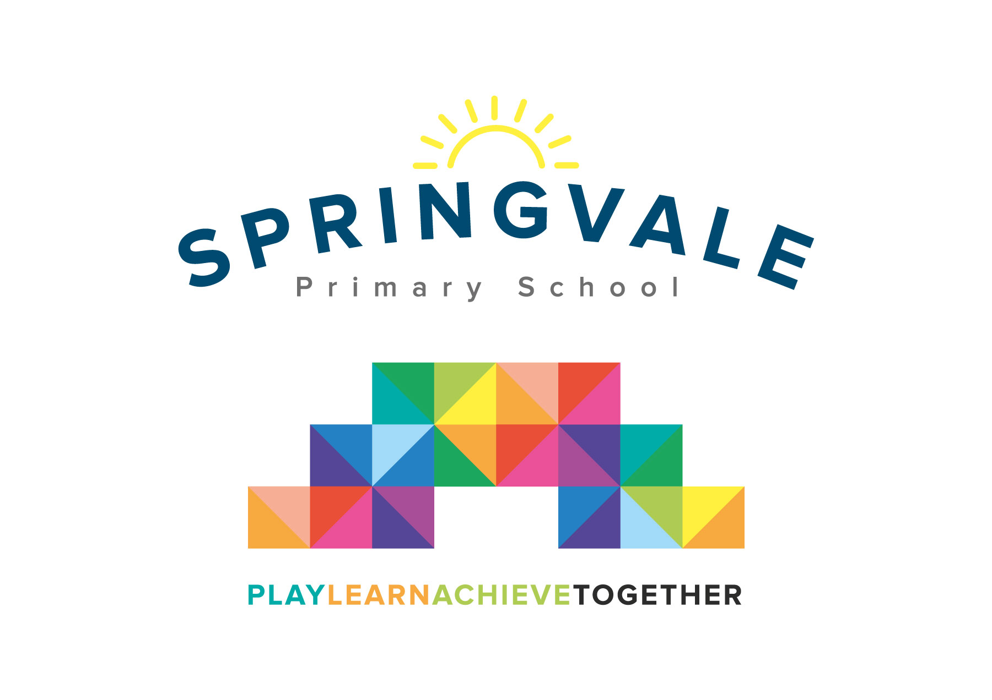
SPRINGVALE PRIMARY SCHOOL
01226 760930
Headteacher: Mr L McClure
l.mcclure@springvaleprimary.org
www.springvaleprimary.org
@SpringvalePS

Newsletter- Week 38 Monday 9th July 2018
Dear families,

Welcome to our latest newsletter! This newsletter shares lots of information about the last few weeks and about the start of next year!
Recent Events: What a busy week! First of all, congratulations to all of our children for their brilliant work and efforts on transition day. From the Y6 pupils at their new school to the new families joining us in EYFS I was very proud of you all! Everyone settled beautifully and had a great day, we can’t wait to get started for real! Congratulations to so many groups of pupils for their fabulous achievements of late; the Y3/4 and Y5/6 football teams (an amazing 4-0 win and 2-2 draw respectively), our maths stars at Rock Wrangle last week, the brilliant tennis teams recently who did so well, all of our amazing cyclists including Y6 who cycled to Dunford Bridge last Friday and our brilliant athletics squad in Y4 who came fifth from eight fabulous schools well done! Thank you, also, to everyone who supported the Fun Run for Jack and Paul or who came to an amazing Fun Day at Penistone Cricket Club yesterday…it was great fun and a fabulous game! Both events demonstrate the amazing community spirit in the area! We’ll let you know how much money was raised in due course at both events. Please note that this Wednesday will now be a World Cup dress down day for England’s semi-final fixture!

Class Names 2018/19:
Nursery: Buttercups Reception: Amazing Acorns Y1: Waterlilies
Y2: Sunflowers Y3: Wildflowers Y4: Beautiful Bluebells
Y5: Tropical Orchids Y6: Yorkshire Roses

Clubs finishing this week: Running, football, Bruce Dyer, Pop Shop, Patchwork, Table Tennis, Netball, Cricket, Athletics and Fencing
Clubs finishing next week: Cartoon Club (Weds PM), Tennis (Thursday AM) and Creation Station (Thurs PM)

Mad Hatter’s Tea Party: On Wednesday 18th July we have a special event that all families can enjoy. At 12.30pm we will open our gates to a special picnic (weather permitting) for all family members to enjoy. Bring a picnic and a blanket and help us to enjoy the last week of an amazing year together! Everyone must wear a hat- there are prizes for the most creative hats! Children can order a special picnic plate (P.T.O for details) or choose to bring your own food (no nuts or seeds please). We will not be offering any other food option on the day! From 2pm children can be signed out up at the top gates but this is totally optional, children will still be supervised until the end of the school day and Cartoon Club will run as normal that night. On the day you can relax, talk, play, whatever you like! Children who do not have a parent present will picnic with their teachers and join in the fun from start to finish. Throughout the afternoon we will have some games, a raffle and some challenges including penalty shoot-out and a ‘wet the owl’ game where you can get Mr McClure with a sponge!
Kind Regards, Mr L McClure, Headteacher
Week 37 Information | 2017/18 Average | Week 37 Diary Dates
Attendance: 96.2%  Late marks: 2  GREEN LIGHTS: 99.0% | Attendance: 97.0%  Late marks: 2  GREEN LIGHTS: 99.1% | Monday 9th: Go Ride Cycling F2-Y2 and Y5-Y6  Tuesday 10th: Transition Day for Y6 pupils, New nursery starters meeting (6pm)  Tuesday 10th:Please return firefighter packs, Pop Shop Show at 4pm  Wednesday 11th: Sports Days (9.15am F2, 10.30am F1 AM, 2pm F2 PM)  Wednesday 11th: World Cup dress down, outdoor Disco at lunch. All reports out (F2 to Y6)  Thursday 12th: Y2 athletics (PM) collect from event at 3.00pm, school at 3.50pm or after clubs! Sports Awards at 6pm  Friday 13th: Y5 swimming AM
Classes of the Week: Y5 Wonderful Welsh with 100%!
_________________________________________________________________________________
Mad Hatter’s Tea Party- Wednesday 18th July 12.30pm onwards (order must be received by Friday 13th July)
Name(s):
Class(es):
______ adults will be attending the afternoon
I would like to order:
No lunch __________ Tuna picnic plate _______ Ham picnic plate ______ Cheese picnic plate______

