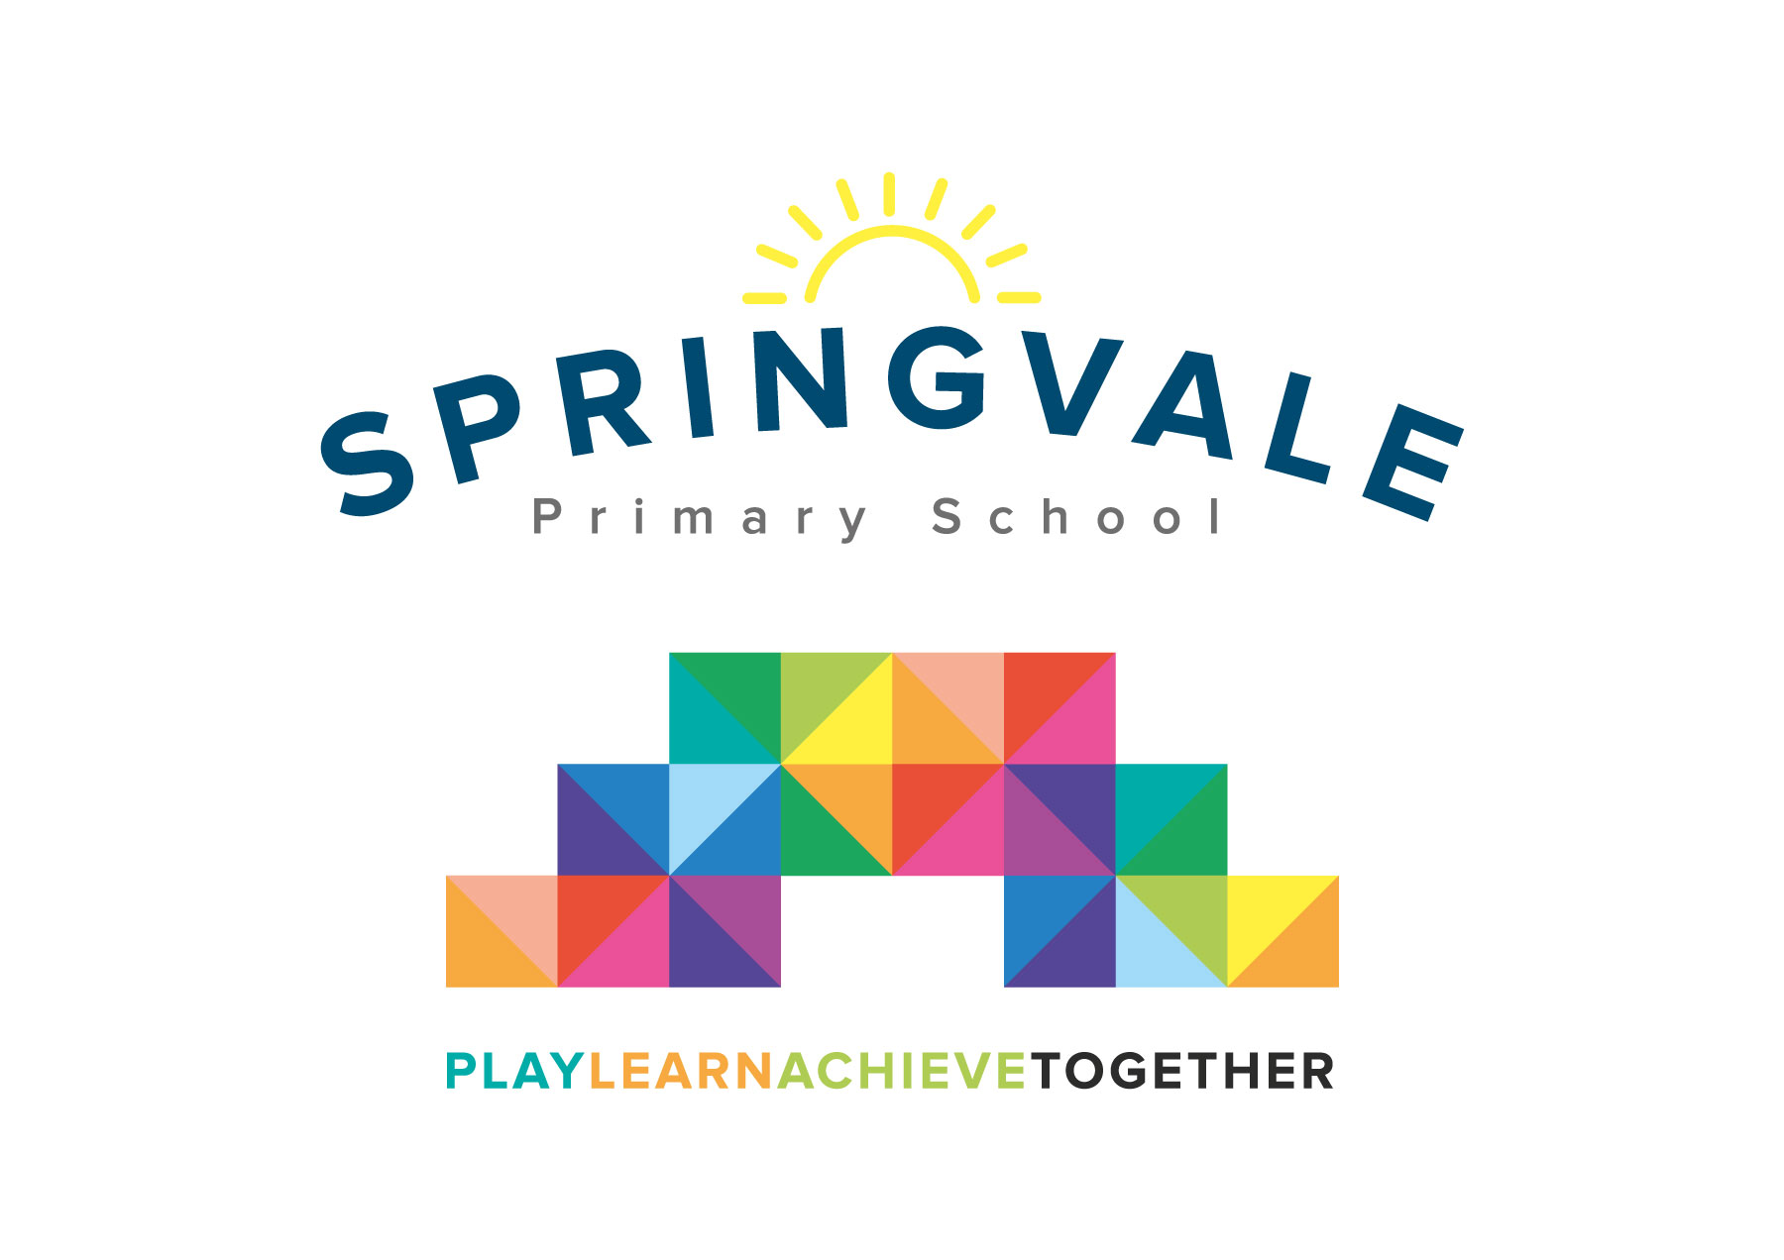
SPRINGVALE PRIMARY SCHOOL
01226 760930
Headteacher: Mr L McClure
l.mcclure@springvaleprimary.org
www.springvaleprimary.org
@SpringvalePS

Newsletter- Week 39 Monday 16th July 2018
Dear families,

A warm welcome to the final newsletter of a fantastic year here at Springvale. It has been a pleasure to lead the school over the last year, and I am delighted with the current standards and provision that is consistently being delivered by everyone. It has been a really busy and exciting year, and I am so proud of all our achievements over the last twelve months. We have achieved very positive academic outcomes, children at all stages are making progress, and we are working incredibly effectively to manage behaviour positively, in order to keep our children and families safe. It is very important to everyone at Springvale that we offer a range of experiences for the children, and this year the experiences that the children have enjoyed include a wide range of: music, the arts, sports, visits and clubs. We think it is vital that the children continue to access this range of activities, and on behalf of myself and the staff I would like to thank you for your continued support. I would also like to say a special thank you to staff, governors, pupils and parents for working as a team to deliver our ethos by playing, learning and achieving together!

Springvale is a very special place to work and learn, and I am increasingly positive about what we can achieve together in the future.

Y6 Outcomes: Congratulations to our amazing Y6 pupils on their SATS results!
Reading: 90% pass and 31% greater depth (several reviews ongoing so these figures may go up)
Writing: 86% pass and 24% greater depth
Maths: 93% and 34%
Spelling, punctuation and grammar: 97% and 41%
Combined subjects: 80% and 14%
These outcomes are significantly above local and national averages and demonstrate the excellent provision across our teaching profile. We are so proud of the children, and we thank the staff and families who have supported the children so well! We will be really sad to see a very special bunch of children leave us this Friday, but we know and accept that the children are ready to move on to the next stage of their educational development. We are sure that they are leaving here as well rounded and talented young people, who will be positive participants in our local community for the rest of their lives. A big well done to all children in school who have taken any kind of Government assessment or measure, remember our assessments in lower school are to ensure that staff know what the children need in the future. Our staff know that our goal is to work together to give children what they require to be a well-rounded learner, so that they can achieve by the end of their time with us here at Springvale.

Sports Awards: I am thrilled with how well our first ever Sports Award evening went. Overall we had 150 children, parents and staff involved, and managed to present 25 awards throughout the night. It was an amazing showcase of all that we offer here at Springvale, and another big congratulations to all of the children who attended.
I would like to add a special mention for Fleur in Y6 who won the Paul Sykes Award, and Sam in Y6 who won the leadership award for being an outstanding playtime team leader. We found out on the evening from Team Activ (who organise all competitions across the region) that Sam also won the award for sports leadership across the whole of the Barnsley area. Our school has also won an award for its sports provision across the year! Keep an eye on Twitter for these accolades being presented in assembly soon!

Finance Update: You may have seen in the local press that many local schools are suffering financial pressures in the local area. I have attended meetings throughout the year to ensure that I am kept fully abreast of the latest positions and developments from either the educational or political members in attendance. When I joined the school I could immediately see that the school had been very well led in regards financial probity. It is worth noting that our school was one of the two best placed at the meeting, which included all ten local primaries.

However, I am very keen to represent our area, and add my views, as research into the new funding formula clearly shows that Barnsley is the second most underfunded area in England. Furthermore, due to a lack of deprivation in Penistone, it is currently the lowest funded area within Barnsley Local Authority. I am also concerned that staffing and premises/utility costs continue to rise and our budget from central Government each year does not reflect these rises; it is a ‘real terms’ budget cut in essence. SEND income per pupil has fallen this year and several areas of spending have risen, due to external decisions and national rising costs, despite us managing them carefully. As the report suggests some schools have even accepted direct debits from supportive parents, news which I find very disturbing! Staff do often buy some things from their own finances, as suggested in the report, but that is more out of a sense of love for the children and their job.

Our budget is balanced and all I would ask is that our amazing parents continue to support any fundraising that we do and continue to be as community spirited as you always are. I will keep you updated throughout, but I wanted parents to rest assured that we will always be transparent about our finances. As stated at the start of this letter, I am thrilled at the opportunities that we offer our pupils and our standards of provision across the school. The meeting we held was to fight for greater funding so that these standards can continue to rise as, like anything in life, good quality costs money! I am available to talk to any parents who have further questions on this matter and will be around most mornings and after school this week if required.

Clubs finishing this week: Cartoon Club (Weds PM), Tennis (Thursday AM) and Creation Station (Thurs PM)

Final Week Events: Our disco this evening (Monday) will be outdoors, if the weather stays dry. We will text all parents if the plan changes due to rain! The event will go ahead, but it might be moved indoors. All are welcome, but please note that all EYFS children must be accompanied by an adult. We will ask that KS1 pupils come to collect at 6.20pm, Y3/4 at 6.25pm and Y5/6 at 6.30pm to avoid confusion! On Wednesday 18th July we have a special event that all families can enjoy. At 12.30pm we will open our gates to a special picnic (weather permitting) for all family members to enjoy. Bring a picnic and a blanket to help us to enjoy the last week of an amazing year together! Remember- no nuts, seeds or sharing food with other children!
Throughout the afternoon we will have some games, a raffle and some challenges including penalty shoot-out and a ‘wet the owl’ game where you can get Mr McClure with a sponge! AM Nursery pupils are very welcome to attend with an adult, and any families who attend Toddlers, or local childcare groups.PM Nursery parents can you please bring your child to nursery, so that they can be registered, before they are taken up to the field to join in the fun!

Staffing 2018/19: I am delighted to say that we have no changes to our staffing for next year. Our staff are a fabulous team, who work well together to maintain consistently high standards, but who also strive to make Springvale the best that it can be.
On behalf of everyone here at Springvale I would like to wish Miss Goodyear best wishes for her forthcoming marriage this weekend, please note that she will not be in school on Friday, and we look forward to welcoming her back as Mrs Wildsmith in September!
Have a great Summer everyone, stay safe!
Kind Regards, Mr L McClure, Headteacher
Week 38 Information | 2017/18 Average | Week 39 Diary Dates
Attendance: 94.5%  Late marks: 2  GREEN LIGHTS: 98.0% | Attendance: 97.0%  Late marks: 2  GREEN LIGHTS: 99.0% | Monday 16th: Go Ride Cycling F2-Y2 and Y5-Y6, EYFS Visit to Cannon Hall (AM)  Monday 16th: Disco- 6 to 7.30pm- all welcome (EYFS with an adult), Nursery Parents’ Evening  Tuesday 17th: Y5 Bike Ride (9-2) and talent show final 2pm  Wednesday 18th: Yellow team house point reward event (11am) TBD  Wednesday 18th: Mad Hatter’s Tea Party- starts 12.30pm  Thursday 19th: Y6 versus staff rounders match at 2pm  Friday 20th: Y6 Leavers’ Assembly at 9.15am, break-up for Summer Holidays
Classes of the Week: Y5 Wonderful Welsh with 99.1%!

