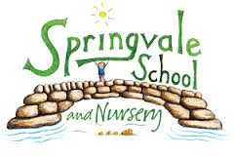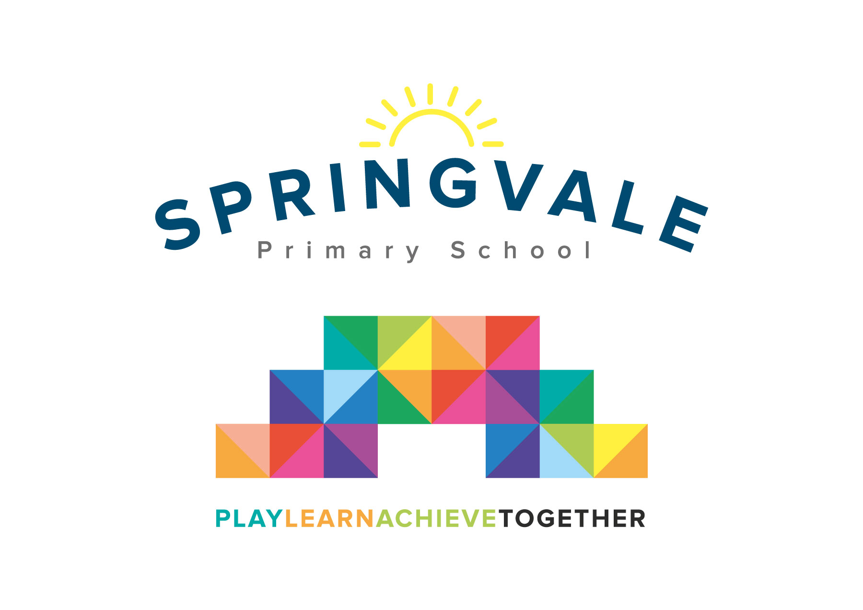
SPRINGVALE PRIMARY SCHOOL
01226 760930
Headteacher: Mr L McClure
l.mcclure@springvaleprimary.org
www.springvaleprimary.org
@SpringvalePS

Friday 13th July

Dear Parent/Carers

Swimming Certificates and Badges

During the course of swimming lessons all the children have attained a level of competence which offers them the opportunity of obtaining a certificate. Some children have also completed distance challenges, which entitles them to apply for a distance award -consisting of a cloth badge, certificate and sticker.

These certificates and awards are available to purchase:

Certificate of competence - £1.50
Distance award - £3.50

Please return the slip below, by Tuesday 17th July, if you would like to purchase any of these items.

Kind regards

Mrs Henstock / Mrs Fearn

-------------------------------------------------------------------------------------------------------------------

Name of child: _________________________________

I would like to purchase a competence certificate, at a cost of £1.50

I would like to purchase a distance award, at a cost of £3.50

I would like to purchase a competence certificate and a distance award, at a cost of £5

I enclose: £___________________

Signature of parent/carer: ____________________________________________

