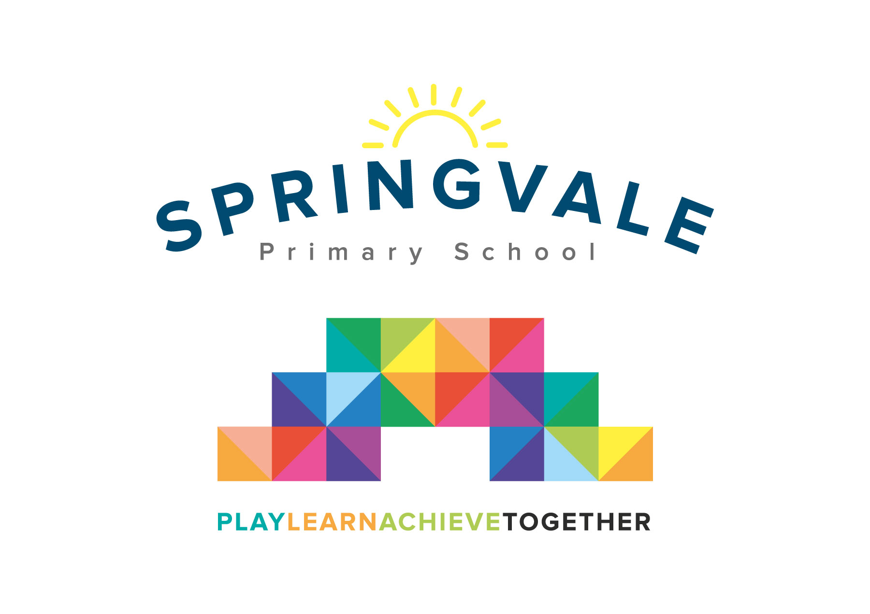
SPRINGVALE PRIMARY SCHOOL
01226 760930
Headteacher: Mr L McClure
l.mcclure@springvaleprimary.org
www.springvaleprimary.org
@SpringvalePS

Newsletter- Week 1 Wednesday 5th September 2018
Dear families,

A warm welcome back after the summer break! I hope everyone is well rested and has enjoyed the good weather around the world…or just here in Penistone! I would like to wish our pupils who left recently the best of luck as their new chapter begins and extend a very warm welcome to all of our new pupils in EYFS and one or two exciting additions in older classes too. We are all very excited about the year ahead so let’s get started!

Staffing: We are delighted to confirm that we managed to get through the latest ‘transfer window’ and kept all of our amazing staff at Springvale! We are all working together to deliver our school ethos and we continue to aspire to be the best school that we possibly can be. One minor change is that Miss Goodyear is now Mrs Wildsmith after her wedding this summer, we all pass on our best wishes to Mr and Mrs Wildsmith after their very happy day.

Diary Dates: We are currently collating our Autumn Term diary dates and finalising our whole school annual calendar for key events like Christmas shows and Sports Days, etc. These will be with you next week so that you can plan ahead for the term and the rest of school year!

Reading Army: We have had an excellent response to our requests for reading support from parents, grandparents, etc, and we have had two very positive meetings where parents have started to sign up to come in and help children to read. If anyone else is interested please contact us so that you can join the team! Special thanks to Mrs Royston, Mrs Gale and everyone who attended the meetings for their time and support.

How to stay informed about school business: As we have so many new parents I thought it would be worthwhile to recap the best ways to stay in touch with school. The most important thing is that we have parent details (and any other emergency contacts’) address and telephone number. If children are ill or we are concerned about a child we need to have adequate means of contact at all times. Please consider this when moving house or changing mobile phone/email provider, etc. We send newsletters weekly; these give positive updates about school business and what is going on in and around school. We also share stats for attendance and key dates for the week ahead. Our learning journal comes out every few weeks and this gives parents details about class topics and any key skills being covered just in case you want to talk about it at home or learn as a family. We also use texts and emails to keep parents regularly informed about school business. We also use social media to bring fast and fun updates straight to your devices!
We will bring updates to our Twitter followers each day (and night!) with school news, snippets about classroom learning and pictures of children learning and playing together throughout the day and at their various clubs and additional activities. Parents voted Twitter as their favourite new development from last year and many use it to keep up to speed with the school whilst busy at work or with family commitments. If you need help on how to access the feed please let us know. The account is locked which means that we will need to approve parents and grandparents to ensure that our images are safe and secure. Please note that we must have media release permission for your child to appear on the feed. Please let us know if you have any concerns about how we use images; some parents are happy for them to appear on Twitter but not on wider publications like our website or the local press.

Safeguarding Lists: Last year we brought in new safe collection systems to ensure that all children are safely collected by a responsible grown-up at the end of the day or after sports clubs. These systems worked perfectly and we will be running them again. New parents should please read the letter and respond with their own collection plans. Parents who have seen this previously should only contact us if their circumstances have changed or they wish to add or delete people from their safe collection list. Parents of children in Y5/6 may choose to give us permission for their child to leave school without an adult. Please note that all staff have been trained to keep children in school with us if there is any doubt whatsoever about who is collecting a child. We would rather keep the child and contact a primary carer for confirmation than take any risk. This can sometimes cause confusion as parents offer to collect other pupils from time to time for play dates, tea at a friend’s house or a birthday party, for example. Please note that any ad hoc collections do not need to be added to the list but a parent must inform the class teacher at drop off or contact the school office during the day to give their permission for said arrangement to take place. Passwords on collection may be used where requested and/or necessary.

School Meal Prices and Payments: Our school continues to offer a range of hot and cold meal options each day priced at £2 per day (£10 for a full school week). We work very closely with our catering team to make improvements to the service and we will keep you informed of any developments on our weekly newsletters. School meals are free to children in F2, Y1 and Y2 but need to be paid for online by parents of children who have a school meal in our KS2 classes. New parents who require help with the system (this may just be for club/visit payments in lower school) are quite welcome to call us for guidance.

Milk Orders: If you would like your child to have milk at school please log on to the payment/ordering system at www.schoolmilkuk.co.uk. Please note that you will need to select your child’s new class. Y3 parents should note Mrs Wildsmith is still recorded in the system as Miss Goodyear for the time being. Payments can be made for the whole year or for each term. The cost is 22p a day which means this term is around £15. Specialist milks are also now available for children who prefer them or have dietary needs; if you order specialist milks please ensure that your child’s teacher is aware so that they keep them separate!

Clubs: We are very proud of the range and quality of our before and after school clubs and we have sent out a separate letter with the club options listed. Please note that all clubs start in week 3 except Mrs Walker’s JAM club which starts in week 4. We have introduced a small cost for football club as we constantly require new footballs for what is our busiest and most over-subscribed club! We may remove the cost when we improve our shooting and the balls stop going over the fence! Our ‘Creation Station Club’ is priced at £5 rather than £4 as it is now slightly longer (finishes at 4.30pm) and the school initially subsidised this club to get more children engaged in art and craft activities alongside our sports clubs. Please note that the clubs will be launched on Monday 10th September for online booking and payment (where applicable) before the clubs begin from Monday 17th September.

Class Names: I am delighted to confirm our new class names for the year ahead; we use these names to ensure that classes have a greater sense of identity. I’m sure you will agree that the Y4 name is pretty amazing!
- Nursery- Buttercups Reception- Amazing Acorns Year 1- Waterlilies
- Year 2- Sunflowers Year 3- Wildflowers Year 4- Venus’ Fly Traps
- Year 5- Tropical Orchids Year 6- Yorkshire Roses

INSET Days: Thank you for your understanding and support during the recent INSET days- we understand that extra days after a 6 week holiday aren’t ideal but they are crucial to allow staff to work together to ensure that children are welcomed into a safe and stimulating environment. We took the second INSET day this year due to the building work that happened over the summer. If the work had any delays or snags then we wanted 2 days to ensure that our EYFS start date wasn’t affected. Some schools in Barnsley have started to take their INSET days as a block of a full week in either October or June to allow parents to explore cheaper holiday options. This could have a very positive impact on our attendance as it would mean far fewer families take term time holidays. Conversely, we are concerned about adequate preparation and meeting times if we removed the current INSET days at the start of a term and some staff are worried about the impact it will have on progress at key assessment points of the year! With this in mind I just wanted to start a period of consultation for all staff and parents to share their views on the possibility of an INSET block taken as a full week in October or June (added to the half term holiday at those points). Naturally it could cause problems for parents with children at secondary schools or colleges so all different circumstances need to be considered before we explore the idea any further!

EYFS Building: Our F2 classroom has been developed significantly over the Summer Holidays to extend the classroom into the corridor area. Storage in the EYFS has also been improved and we have opened up existing spaces by removing restrictive glass panels. We are delighted to provide our EYFS children with a fresh and open space to learn for the future! Thank you to everyone involved in the project and to our EYFS staff and cleaners who worked really hard to ensure that the room was ready for the children on their return. We are so pleased with the new space and look forward to the continued success of our EYFS team for many years to come.

Names in uniform: It’s that time of year again! I must say the children all look very smart indeed! To avoid a constantly full-to-brimming lost property box please ensure that your child’s name and class are clearly marked in all items of uniform including shoes and PE kit. Please also help us to increase independence by asking children to check their bags and pegs as they leave each day so that they have everything they need.
Kind Regards, Mr L McClure, Headteacher
Week 39 Information | Final 2017/18 Stats | Week 1 Diary Dates
Attendance: 94.8%  Late marks: 0  GREEN LIGHTS: 99.7% | Attendance: 97.1%  Late marks: 2  GREEN LIGHTS: 99.1% | Monday and Tuesday: INSET Days  Wednesday 5th: Return to school  Wednesday 5th: Reading Army meeting 2.30pm  Thursday 6th: Reading Army meeting at 9am  Friday 7th: New F2 pupils meeting (Literacy support) at 1.30pm
Classes of the Week: Y6 Amazing Azerbaijanis and Cool Colombians with 100%!
Class of the Year: Y4 Cool Columbians with 98.8%

