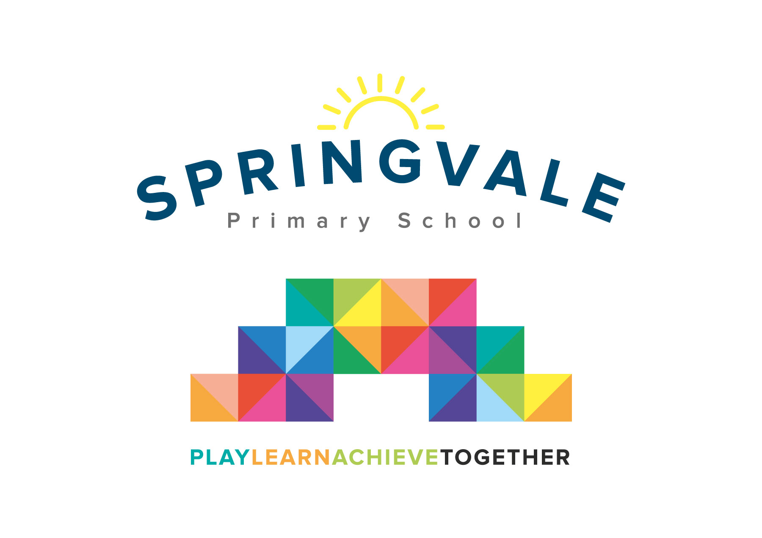
SPRINGVALE PRIMARY SCHOOL
01226 760930
Headteacher: Mr L McClure
l.mcclure@springvaleprimary.org
www.springvaleprimary.org
@SpringvalePS

Newsletter- Week 3 Monday 17th September 2018
Dear families,

We are well and truly back into the swing of school life now and, I have to say, it has been an incredibly smooth and positive start to the year. This week our clubs and visits begin too…have a great week everyone and keep on working with us as we strive to be the best school we can be!

Captain’s Table: Last Friday saw the return of Captain’s Table. Captain’s Table sees 12 different children chosen each week by our fabulous SMSA team for a range of reasons including excellent manners, healthy eating, supporting others and good manners, amongst other great qualities! We alternate the reward between lower school (F2 to Y2) and upper school (Y3-6) each week. This year staff are logging their choices to ensure that the reward is shared out fairly and we are making sure that all children are very clear why they have been invited so that they can feel proud of their achievement! Look out for a picture of the full table each week on Twitter!

Star of the Week: Every Friday we ask that teachers select 2 children from their class who have ‘gone the extra mile’ and deserve recognition for their efforts and/or achievement during the week. Children receive a certificate, a prize from the ‘Good to be Green’ cupboard and have their picture taken for Twitter. Staff record their choices and the children are called out in assembly to celebrate their special moment. We also capture stars each day and little snippets of class news on our Twitter rounds!

Clubs: Our clubs all launch this week with the exception of JAM Club (Jesus and Me) which starts next Tuesday. Sadly, due to low interest, we have had to cancel our Monday AM Archery/Fencing club and Wednesday PM KS1 Multi-skills. We are delighted to offer such a wide range of clubs to so many children at excellent costs. Apologies for the issues we had on the day the clubs were launched. We have decided to simplify the launch by sending just one message to inform you that club bookings have opened and then let parents log in to peruse the options available to your child. Parents with children attending football club should take a look at their emails/our website for the special letter explaining how that particular club will work as it is so oversubscribed!

Guitars in Y3: Children in Y3 will have free guitar tuition and instrument hire this year as part of our extended service to music provision. Parents just need to sign the letter that came home last week and return to allow the guitar to come home. Please make every effort to ensure that guitars are in school every Monday to allow children to take part. As our Y6 children who left last year were so musical we now have lots of additional tuition spaces up for grabs; please contact Miss Chapman if you are interested! Lastly on musical instruments…remember, practice makes perfect!

Diary Dates: Last week we included lots of diary dates on our newsletter and email updates. All of these dates are now online at our website too. Please make sure you take time to get the key dates in diaries, phones, calendars and planners so that you can be part of our exciting year ahead! We love it when parents come along and get involved! We are always trying to be creative and taking feedback from active parents on new projects and plans. This year we have added a science week and a special DT project day too!

Standards: Just look at the amazing statistics below…let’s keep that up all year please! Amazing!
Have a great week everyone!
Kind Regards, Mr L McClure, Headteacher
Week 2 Information | Average 2018/19 Stats | Week 3 Diary Dates
Attendance: 97.9%  Late marks: 0  GREEN LIGHTS: 100% | Attendance: 97.7%  Late marks: 0  GREEN LIGHTS: 100% | Monday 17th: Y6 Visit to Weston Park, clubs begin, Reading Army begins  Tuesday 18th: 9am Macmillan Coffee Morning meeting (Community Room)  Thursday 20th: Y1 Parent meeting- Literacy (slides available)  Friday 21st: KS2 Captain’s Table and Star of the Week, Y5 v Y6 football 3.15 to 4pm
Classes of the Week: Y3 Wildflowers with 99.3%

