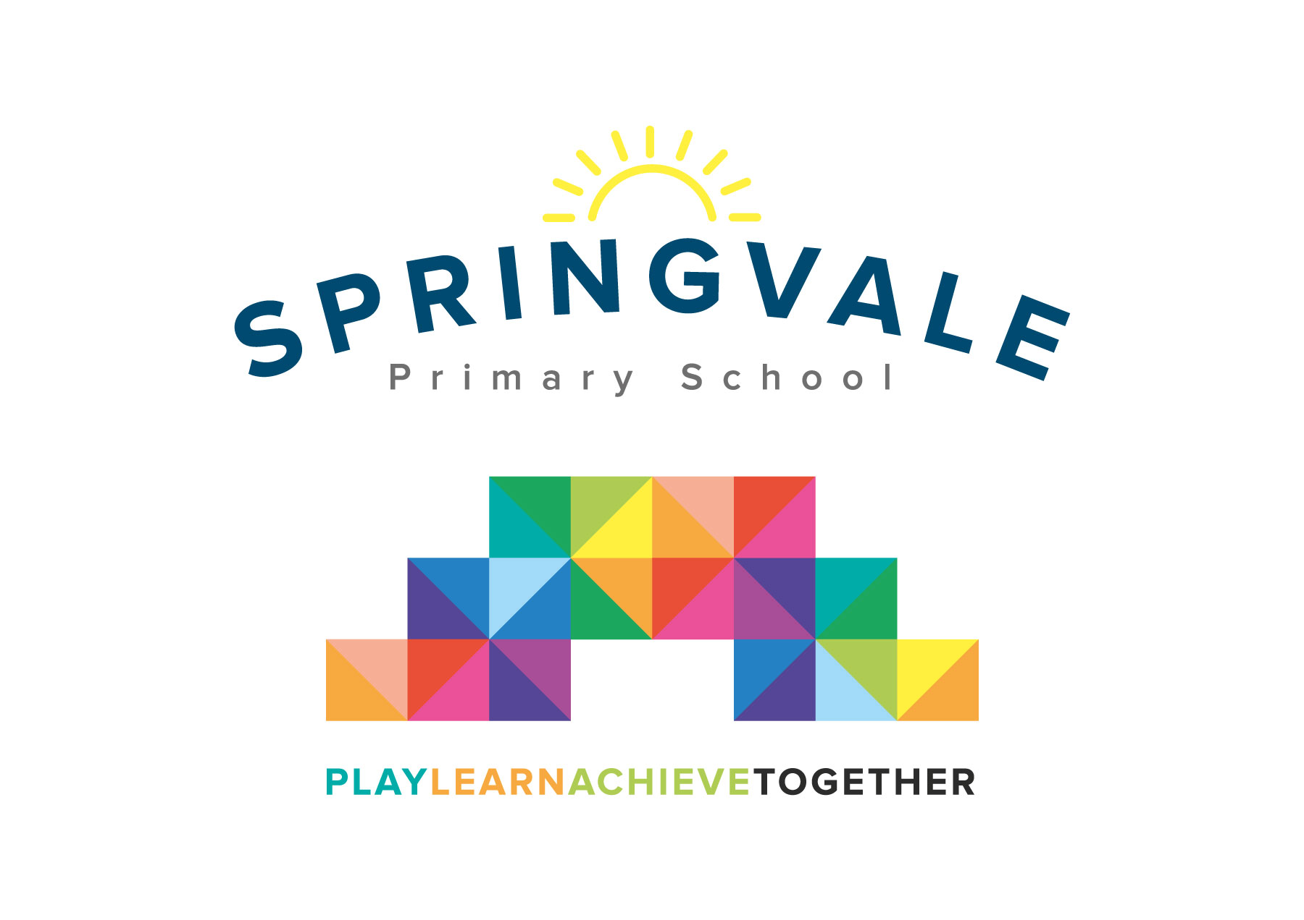
SPRINGVALE PRIMARY SCHOOL
01226 760930
Headteacher: Mr L McClure
l.mcclure@springvaleprimary.org
www.springvaleprimary.org
@SpringvalePS

Newsletter- Week 4 Monday 24th September 2018

Dear families,
Welcome to our latest weekly update. Remember, the best way to stay up to date with our busy and thriving school is our amazing Twitter feed (@SpringvalePS) but if you catch up with our newsletter (out on email/paper/online) EVERY Monday you will know all of the key details!

Upcoming Events: On Friday we have our first fundraising/dress down day. Children can wear any of their casual clothes and pay a small family donation (suggested £1) to our fundraising drive. This week we are focussing on supporting cancer charities with a dress down collection for Marie Curie and a coffee afternoon at the end of the day for Macmillan. I am sure you will agree these are fantastic causes that touch our lives and mean the world to many of our community members. The coffee afternoon will be in the hall immediately after school…everyone is welcome to come along. Volunteers to help are encouraged to contact Mrs Walker!

Sports Update: Our clubs have started very well and last Friday we had our first ‘friendly’ football match. Y5 beat Y6 3-2 in an excellent game that saw 27 pupils take part! We have lots of tournaments and fixtures coming up soon so look out for letters or texts home if your child is involved. Last year was such a great year for sport that saw us raise participation and progress in a wide range of sports for boys and girls of all interests and abilities. We are already looking for the next award winners for our revamped Sports Awards 2019! The main sports this half term are cross-country, multi-skills and football. Mr Crossfield is working hard with all children to support their progress and he will be working with children in the build up to tournaments to encourage them and guide them to achieve their personal best!

Independence and Toileting: As a school with a very proud record for being inclusive we appreciate that some children have medical or learning needs that affect their independence. We have noticed that a more considerable number of children are starting nursery or school without the necessary independence skills around toileting, washing hands, etc. Our nursery team is experienced and incredibly skilled but with only 2 staff they are not able to teach if children have regular toileting incidents. We are currently organising a meeting for any parents with support needs for pupils in our school or with toddlers in the community. We would really appreciate your support in prioritising toilet training before nursery/school admissions so that our teachers can fulfil their role as high-quality educators for the benefit of the whole class.

Harvest Festival: As featured on the recent diary dates and annual calendar we will have our annual Harvest Festival at 10am on Tuesday 23rd October. Please note that this is for grandparents and the elderly only as is tradition at Springvale. We have opened up a guest list so please e-mail office@springvaleprimary.org to book grandparent places. We gather harvest donations, display them to our children and the community and then we deliver them to elderly residents in the local community. It is a fabulous day that helps us to celebrate the joy and importance of helping others to our children. We will update you closer to the time about potential donations. The Harvest festival will be captured and shared with parents through social media. We will be starting to practice the singing and reading next week so children may come home with some song lyrics to learn, your support with these is greatly appreciated as always. If you know anyone in the local community who would appreciate a Harvest package please let me know or if you know someone who did receive one and has moved house please let us know! We got some very bemused looks last year when we gave sprightly new residents at certain houses bags of fruit and vegetables!

Music Tuition: We are delighted to see so many new children sign up for musical instrument tuition. We do have a few spaces left, please contact Miss Chapman ASAP for details. Be quick to avoid disappointment as bookings are coming in thick and fast!
Have a great week everyone!
Kind Regards, Mr L McClure, Headteacher

Week 3 Information | Average 2018/19 Stats | Week 4 Diary Dates
Attendance: 96.8%  Late marks: 0  GREEN LIGHTS: 98.7% | Attendance: 97.3%  Late marks: 0  GREEN LIGHTS: 99.2% | Monday 24^{h}: Y5 Visit to Cadbury World (8.30am-5pm)  Monday 24th: Y1 Parent meeting (Maths) slides to be emailed after  Tuesday 25th: JAM Club begins  Thursday 27th: Y4/5 enterprise project all day  Friday 28th: KS2 Captain’s Table and Star of the Week  Friday 28th: Dress Down Day- no theme, coffee afternoon at 3.15pm (Macmillan)
Classes of the Week: Y1 Water Lilies with 99%

