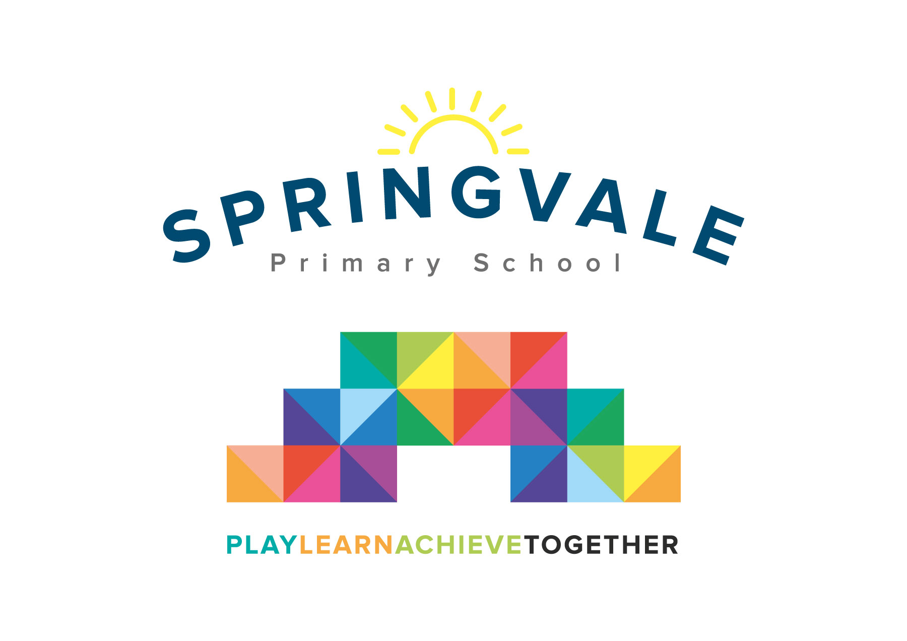
SPRINGVALE PRIMARY SCHOOL
01226 760930

Headteacher: Mr L McClure
l.mcclure@springvaleprimary.org
www.springvaleprimary.org
@SpringvalePS

Football Club Reward Visit Monday 8th October 2018

We are delighted to see so many children now engaged with our football training and matches. Last year we ran a very successful visit to Sheffield Wednesday (ignoring the result of the match!) and this seemed to inspire the pupils to get even more involved in sport.

On Saturday 3rd November we have pre-booked 50 places to see Barnsley play Southend United at 3pm. The children have the opportunity to engage with the following activities.

- Meet at school between 10.30 and 10.40am for departure by private coach
- Tour of the stadium at 11.00am including the pitch, changing rooms, etc
- Professional football coaching session 12noon to 1.15pm
- McDonalds Happy Meal delivered to the ground
- Match day ticket
- Transfer back to school for 5.30/5.45pm

We can offer all of the above, including the transport, at a cost of £20.

Children would just require very warm clothing, a PE/football kit underneath their warm clothing (so that an extra heavy bag isn’t required), a drinks bottle and any spending money they may want for further refreshment/merchandise, etc. As we are eating at approximately 1.30pm we wouldn’t take the children for further food but they can bring a snack along for half-time.

We have now opened up online payment for you to complete as soon as possible.

You will receive an email & text notification shortly with information about how to pay for this trip on the ‘Schoolmoney’ system. Please follow the link on this message to login to your account. If you have any account login or payment queries, please do not hesitate to contact the school office. You will also be asked to give your parental consent online as well.

#PlaytogetherLearntogetherAchievetogether

Kind Regards

Mr L McClure and Mr L Crossfield

Springvale FC

