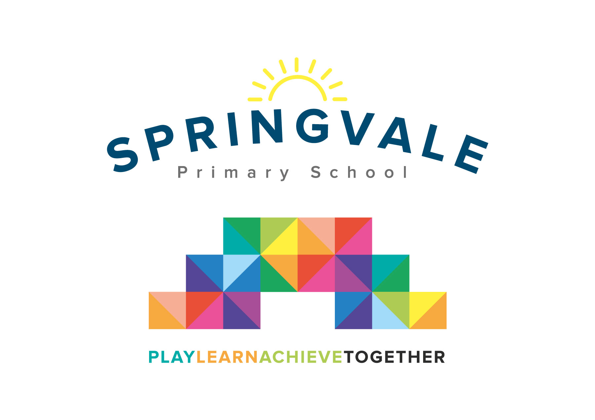
SPRINGVALE PRIMARY SCHOOL
01226 760930
Headteacher: Mr L McClure
l.mcclure@springvaleprimary.org
www.springvaleprimary.org
@SpringvalePS

Therapy Dogs Wednesday 24th October 2018

Dear families,

As we continue to think of new and engaging ways to build the confidence of our young learners we have developed another exciting opportunity!

A specially trained therapy dog called Keegan, supported by her experienced owner Julie, will visit us once a fortnight. They will only access my office so that Keegan cannot alarm any children who do not like dogs and that the classrooms/learning environment are not affected by any children with allergies to pet hair, etc.

The principle is that Julie and Keegan will listen to children to read and allow them to pet and talk to Keegan about their day, their hobbies, etc. The project is working well in some other schools and we are keen to let our children see the benefit!

If you have received this letter then your child has been invited to read to Keegan but we need your permission! They will read for 10-15 minutes each visit.

Kind Regards,

Mr L McClure,

Headteacher

I give permission for my child _____________________________ to read with a therapy dog.
My child does not have allergies or a fear of dogs.

Child’s Name___________________________________ Parent signature ____________________________

