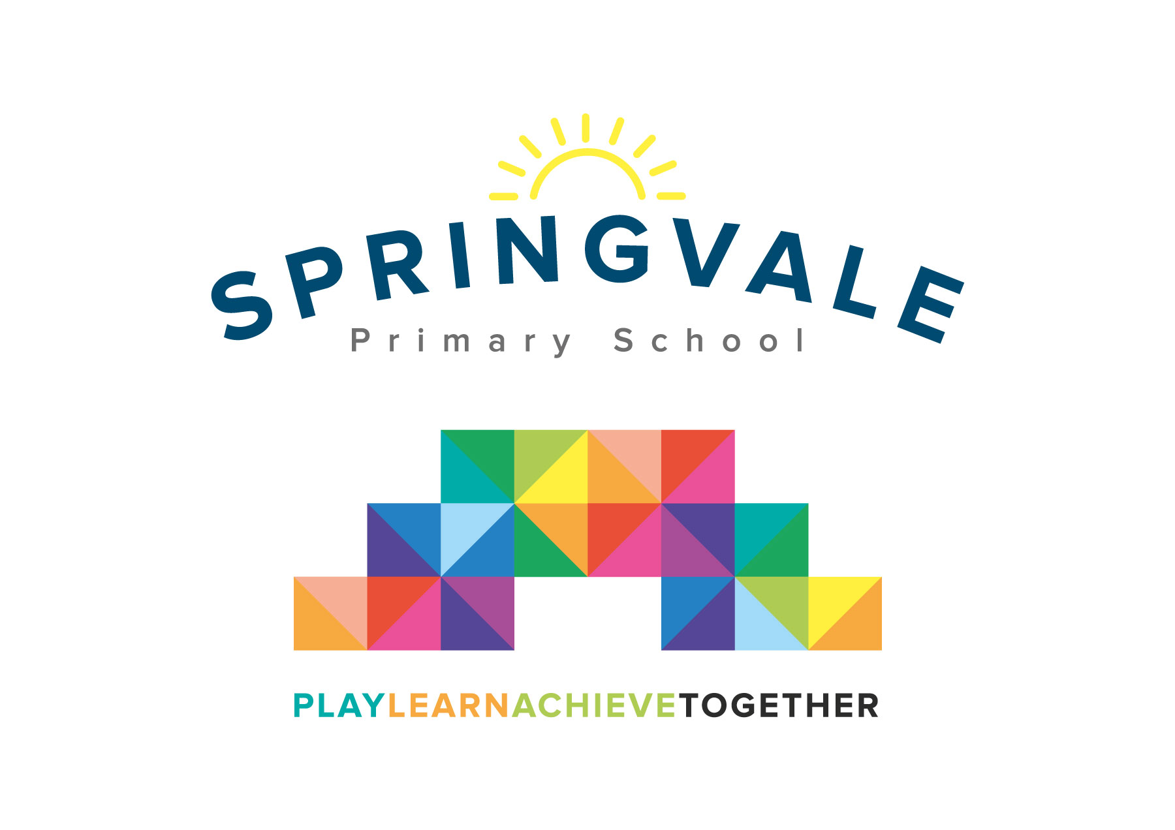
SPRINGVALE PRIMARY SCHOOL
01226 760930

Headteacher: Mr L McClure
l.mcclure@springvaleprimary.org
www.springvaleschool.org.uk
@SpringvalePS

Eden Camp Trip 06/11/2018

Dear Parent/Guardian,

On Monday 19th November, we will be visiting Eden Camp, a modern war museum as part of our World War Two topic.

The bus will leave school at 9am and return by 3:15pm. However, any delays will be passed on via school. Children will need to wear school uniform and suitably warm clothing for the weather, as much of the museum is outside. Children will also need to bring a packed lunch or can order a grab-a-bag using the slip below.

Mr McClure has kindly agreed to subsidise the cost of the trip, bringing the voluntary contribution down to £15. This will pay for the coach and the admission fee.

You will receive an email & text notification shortly with information about how to pay for this trip on the ‘Schoolmoney’ system. Please follow the link on this message to login to your account. If you have any account login or payment queries, please do not hesitate to contact the school office. You will also be asked to give your parental consent online as well.

If you would like to order a school packed lunch, please fill out the slip below and return it by Wednesday 14th November. Please also note that your child will be unable to come if consent is not received by the day of the trip.

If you have any questions or concerns, please contact me.

Kind regards,

Mr. Venus

Grab-a-bag choice

Please tick your child’s lunch option

Child:____________________________ Class:__________

Grab-a-bag options (please circle):

Ham Cheese Tuna mayo

